What is Continuous Integration?
- Developers commit code to a shared repository on a regular basis
- Version control system is being monitored. When a commit is detected, a build will be triggered automatically.
- If the build is not green, developers will be notified immediately.

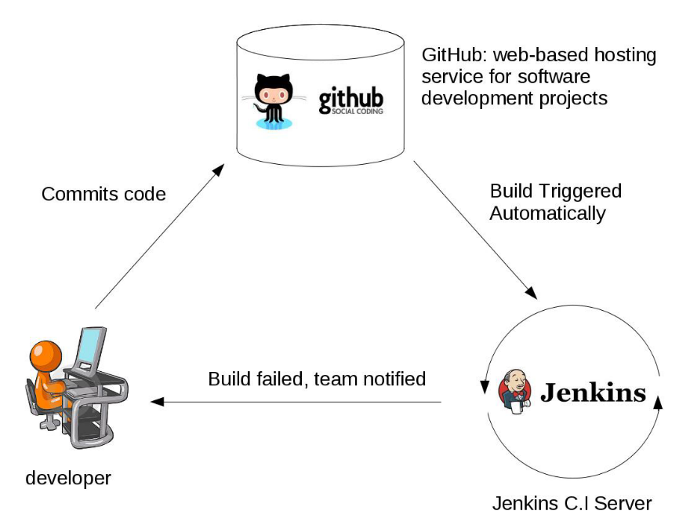
from above Diagram,
- Automated builds are scheduled on a regular basis.
- Build script compiles the application and runs a set of automated tests.
- Developers now commit their changes regularly.
- A build is triggered whenever new code is committed to the central repository.
- Build servers would alert the team members in case of build failure.
- Broken builds are usually treated as a high priority issue and are fixed quickly.

Continuous Integration
The practice of merging development work with the main branch constantly.

Continuous Delivery
Continual delivery of code to an environment once the code is ready to ship. This could be staging or production. The idea is the product is delivered to a user base, which can be QAs or customers for review and inspection.
Continuous Deployment
The deployment or release of code to production as soon as it is ready.
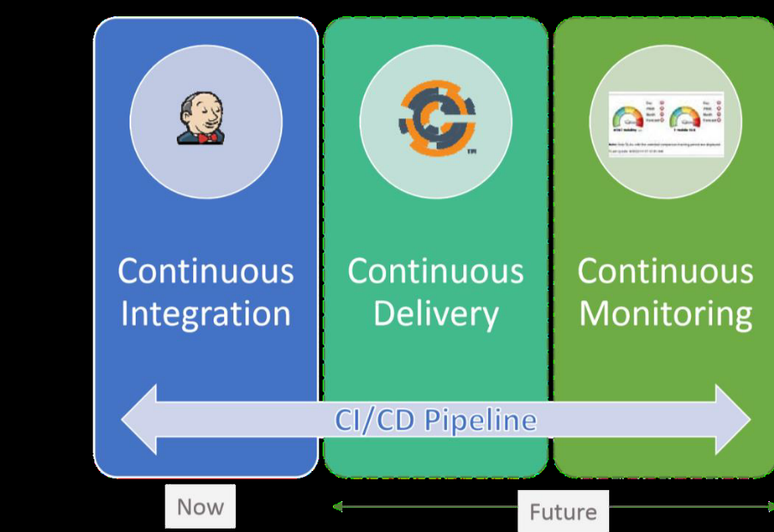

What is Jenkins
- Jenkins is a continuous integration and build server.
- It is used to manually, periodically, or automatically build software development projects.
- It is an open source Continuous Integration tool written in Java.
- Jenkins is used by teams of all different sizes, for projects with various languages.
Features
- Easy to use
- Support different version control systems
- Code quality metrics
- Build notifiers
- UI customization

Jenkins’ Master and Slave Architecture
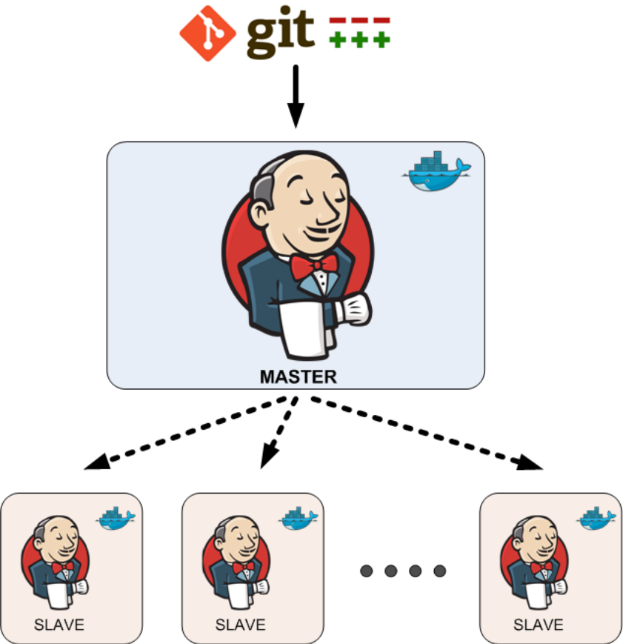

Master:
- Schedule build jobs.
- Dispatch builds to the slaves for the actual job execution.
- Monitor the slaves and record the build results.
- Can also execute build jobs directly.

Slave:
- Execute build jobs dispatched by the master.

