## Install WebSphere

Install IBM Installation Manager Install Kit for all x86_64 Windows versions supported by version 1.8.9.1 fix.[agent.installer.win32.win32.x86_64_1.8.9001.20180709_1302.zip (166.24 MB)](https://ak-delivery04-mul.dhe.ibm.com/sdfdl/v2/sar/CM/RA/07pti/0/Xa.2/Xb.jusyLTSp44S02UcEFKoopssAGebqfJikHttuq_-E9pFkQXuMwKQMLJCtBno/Xc.CM/RA/07pti/0/agent.installer.win32.win32.x86_64_1.8.9001.20180709_1302.zip/Xd./Xf.LPR.D1VC/Xg.9903253/Xi.habanero/XY.habanero/XZ.tonONkfAkVqWjXd4pN7h_scy1Fo/agent.installer.win32.win32.x86_64_1.8.9001.20180709_1302.zip)

Extract it & Install it. 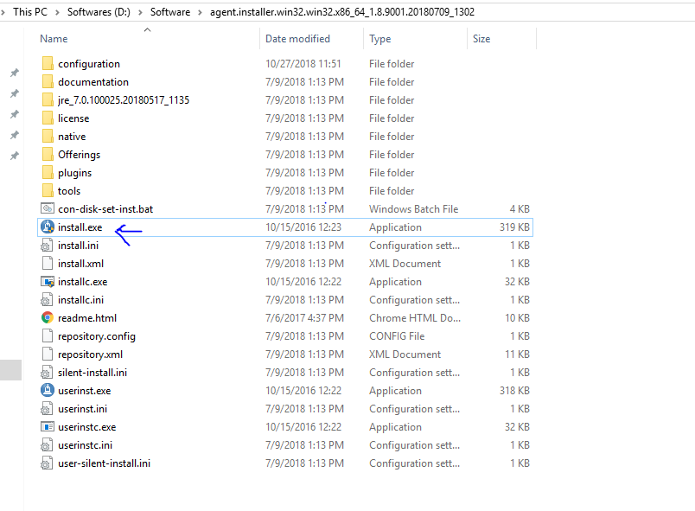

After Installation Manager is installed, configure the IBM-hosted repository.

1. In Installation Manager, go to **File > Preferences**.
2. In the Repositories panel, click the **Add Repository** button. Enter the repository URL for the version of WebSphere Application Server that you want to install:
   * Version 9.0: https://www.ibm.com/software/repositorymanager/V9WASILAN
   * Version 8.5: https://www.ibm.com/software/repositorymanager/V85WASDeveloperILAN

If prompted, authenticate with the IBM-hosted repository using your My IBMid credentials.  
When Installation Manager connects to the repository URL, the connection status icon turns green.

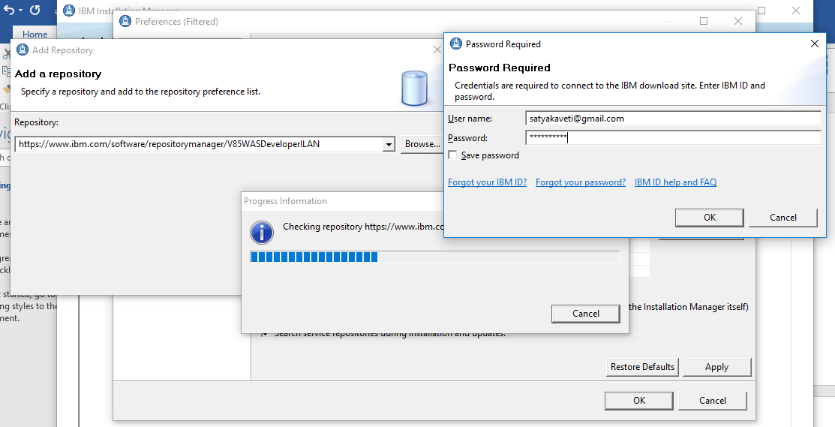

Installation will take time , after install open eclipse to configure WebSphere in eclipse.

Eclipse > Help > Market Place > Search for ‘websphere’ developer tools, based on your eclipse version install them.

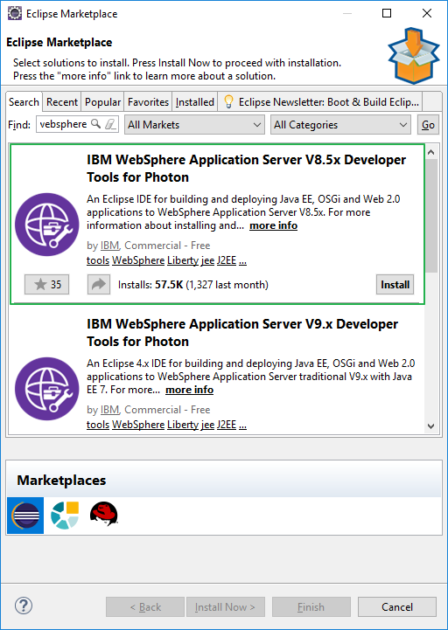

Create WebSphere Profile

After install Open Eclipse > Windows menu > Preferences > Server > WebSphere Application Server> Run Profile Management Tool.

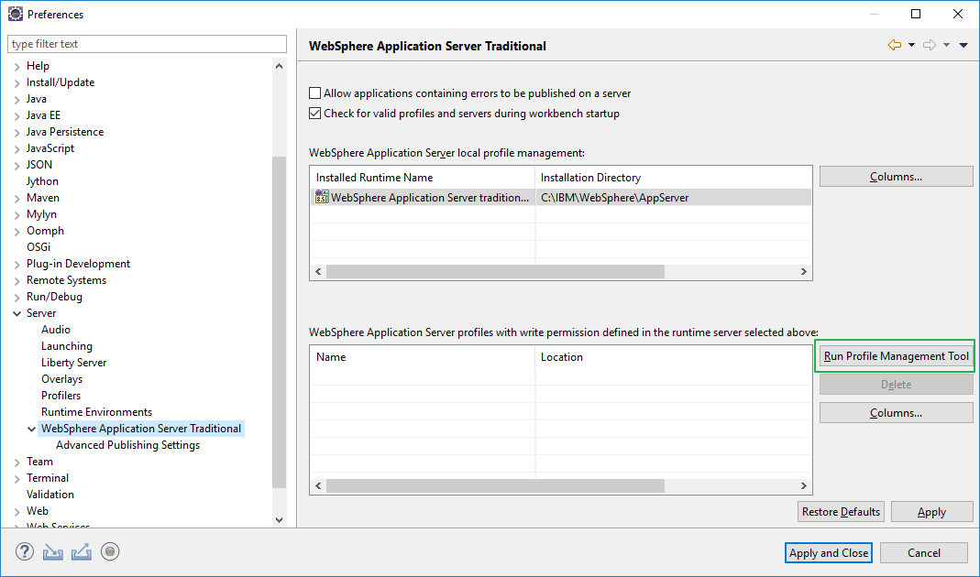

Select Profile Management Tool > Create >Application Server > Advanced Profile, follow steps

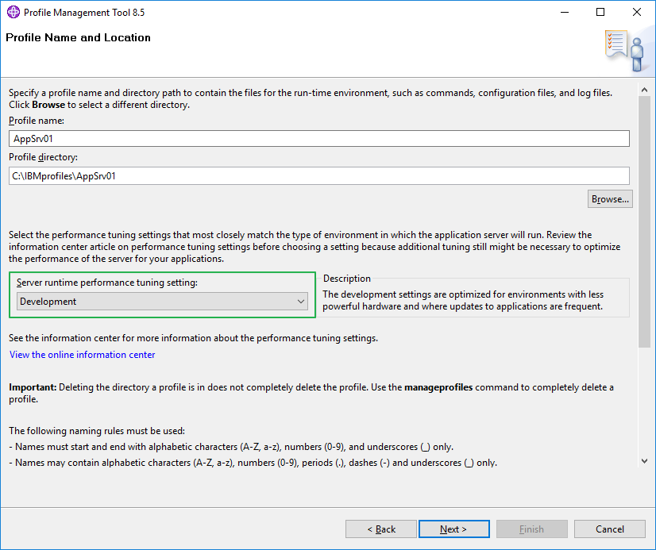

Next, uncheck: Enable Admin login things for dev environment & Run as Windows Service, create!!

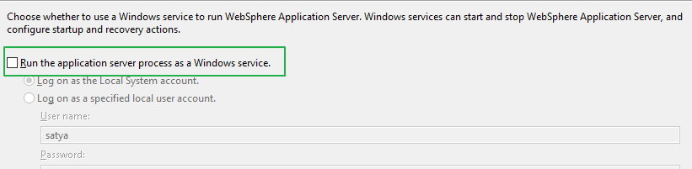

Adding Server to Eclipse

Open Eclipse > Servers Tab > New > Server & Follow Below Screens

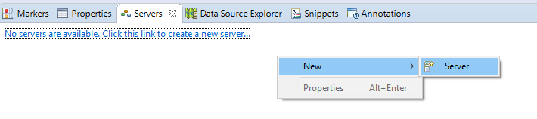

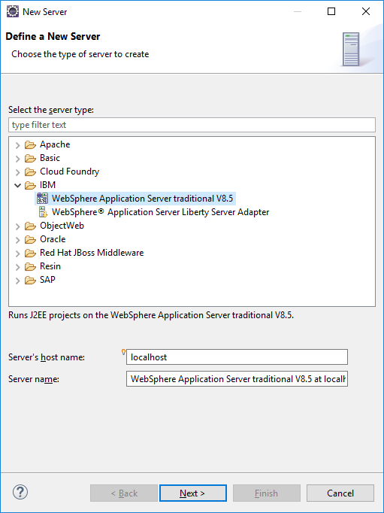

Then Seelect AppServer location, C:\IBM\WebSphere\AppServer

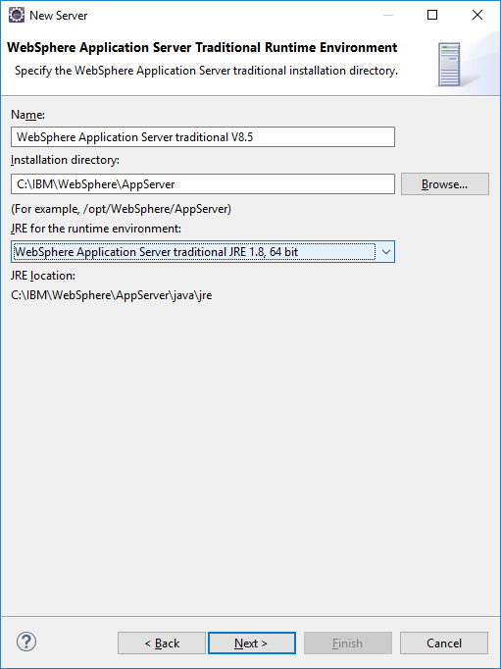

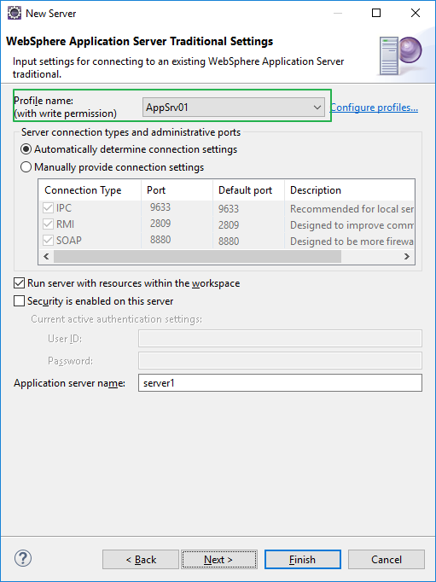

Finish, Right Click on Server & Run it

************ Start Display Current Environment ************

WebSphere Platform 8.5.5.14 [BASE 8.5.5.14 cf141830.01] [IBMJAVA7 7.0.10.25 cf141829.02] running with process name DESKTOP-I4LP77BNode01Cell\DESKTOP-I4LP77BNode01\server1 and process id 8968

Host Operating System is Windows 10, version 10.0

Java version = 1.8.0_171, Java Runtime Version = 8.0.5.17 - pwa6480sr5fp17ifix-20180726_01(SR5 FP17+IJ08001), Java Compiler = j9jit29, Java VM name = IBM J9 VM

was.install.root = C:\IBM\WebSphere\AppServer

user.install.root = C:\IBMprofiles\AppSrv01

Java Home = C:\IBM\WebSphere\AppServer\java\jre

ws.ext.dirs = C:\IBM\WebSphere\AppServer/java/lib;C:\IBMprofiles\AppSrv01/classes;C:\IBM\WebSphere\AppServer/classes;C:\IBM\WebSphere\AppServer/lib;C:\IBM\WebSphere\AppServer/installedChannels;C:\IBM\WebSphere\AppServer/lib/ext;C:\IBM\WebSphere\AppServer/web/help;C:\IBM\WebSphere\AppServer/deploytool/itp/plugins/com.ibm.etools.ejbdeploy/runtime

Classpath = C:\IBMprofiles\AppSrv01/properties;C:\IBM\WebSphere\AppServer/properties;C:\IBM\WebSphere\AppServer/lib/startup.jar;C:\IBM\WebSphere\AppServer/lib/bootstrap.jar;C:\IBM\WebSphere\AppServer/lib/jsf-nls.jar;C:\IBM\WebSphere\AppServer/lib/lmproxy.jar;C:\IBM\WebSphere\AppServer/lib/urlprotocols.jar;C:\IBM\WebSphere\AppServer/deploytool/itp/batchboot.jar;C:\IBM\WebSphere\AppServer/deploytool/itp/batch2.jar;C:\IBM\WebSphere\AppServer/java/lib/tools.jar

Java Library path = C:\IBM\WebSphere\AppServer/lib/native/win/x86_64/;C:\IBM\WebSphere\AppServer\java\jre\bin\compressedrefs;C:\IBM\WebSphere\AppServer\java\jre\bin;C:\WINDOWS\system32;C:\WINDOWS;C:\IBM\WebSphere\AppServer\lib\native\win\x86_64;C:\IBM\WebSphere\AppServer\bin;C:\IBM\WebSphere\AppServer\java\bin;C:\IBM\WebSphere\AppServer\java\jre\bin;C:/Program Files/Java/jdk1.8.0_181/bin/../jre/bin/server;C:/Program Files/Java/jdk1.8.0_181/bin/../jre/bin;C:/Program Files/Java/jdk1.8.0_181/bin/../jre/lib/amd64;C:\WINDOWS\system32;C:\WINDOWS;C:\WINDOWS\System32\Wbem;C:\WINDOWS\System32\WindowsPowerShell\v1.0\;C:\Program Files\Git\cmd;C:\WINDOWS\System32\OpenSSH\;E:\Instls\Vagrant\bin;C:\apache-maven-3.0.5\bin;C:\Program Files\Java\jdk1.8.0_181\bin;C:\Program Files\PuTTY\;C:\Program Files\Java\jdk1.8.0_181/bin;D:\Software\eclipse;.;

Orb Version = IBM Java ORB build orb80-20180617.00

Max file descriptor count = --

**To show Complete Log, Eclipse > Window > Preferences > Run/Debug > Console > Uncheck Limit lines**

To access Admin Console , Right click on server, Run Administrative Console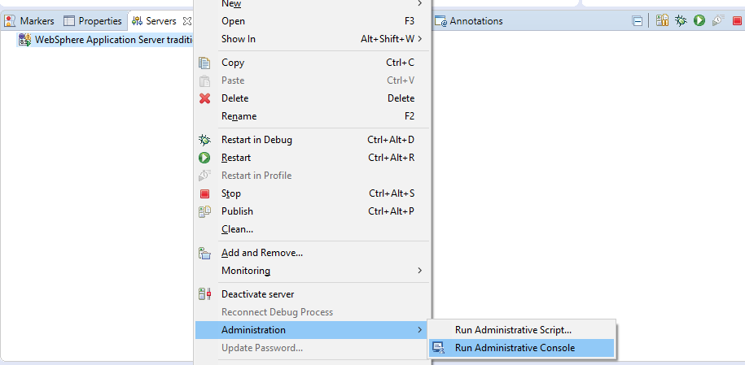

Or by open in browser : <http://localhost:9060/ibm/console/>, & you can give any username/even empty to login.

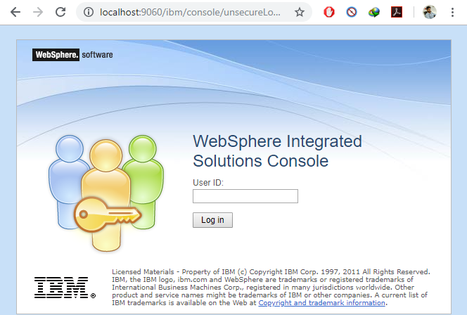

**Java Installation :** [**Application servers**](http://localhost:9060/ibm/console/navigatorCmd.do?csrfid=-1602647283&forwardName=ApplicationServer.content.main&WSC=true)**>**[**server1**](http://localhost:9060/ibm/console/applicationServerCollection.do?csrfid=-1602647283&EditAction=true&contextId=cells%3ADESKTOP-I4LP77BNode01Cell%3Anodes%3ADESKTOP-I4LP77BNode01%3Aservers%3Aserver1&resourceUri=server.xml&perspective=tab.configuration)**> Java SDKs**

Eclipse + WebSphere + Java EE Application Example

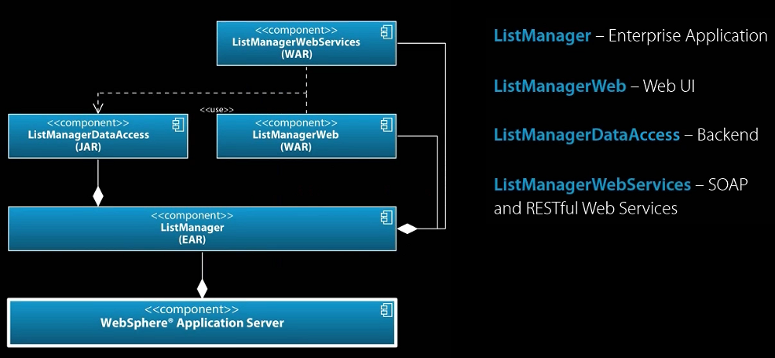

How to setup a DataSource in Websphere Application server for MySQL

Basically, there are 3 steps to create a DataSource on Websphere:

* Create a JDBC Provider
* Create a J2C
* Create the DataSource

Download MySQL JDBC driver JAR file from [Download Connector/J](http://dev.mysql.com/downloads/connector/j/)

**Set up the JDBC provider:**

1. In the WebSphere Application Server console, click **Resources** > **JDBC** > **JDBC Providers**.
2. Select the appropriate scope from the **Scope** combination box.
3. Click **New**.
4. Create a **JDBC provider** named **MySQL**.
5. Set **Database type** to **User defined**.
6. Set **Scope** to **Cell**.
7. Set **Implementation class** to **com.mysql.jdbc.jdbc2.optional.MysqlConnectionPoolDataSource**. But from MySQLConnector/J 8.0 onwords class name changed to com.mysql.cj.jdbc.MysqlConnectionPoolDataSource
8. For **database class path information**, Extract MySql connector J zip, locate .jar path & paste it in textbox ex: D:\Java\mysql-connector -8.0.13\mysql-connector-java-8.0.13.jar
9. Save your changes.

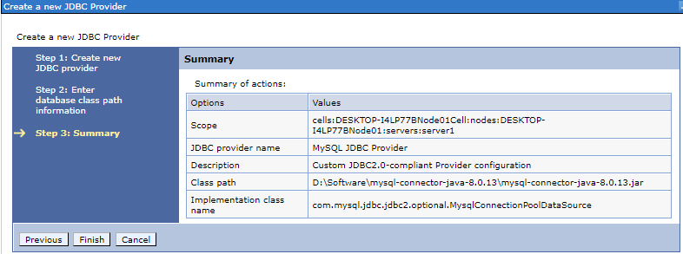

**Go to** [**Global security**](http://localhost:9060/ibm/console/com.ibm.ws.console.security.forwardCmd.do?csrfid=2031393875&forwardName=AdminSecurity.config.view)**> Java AAS - J2C authentication data, provide Mysql credencials**

**Create a data source for the administration database:**

1. Select **Resources** > **JDBC** > **Data Sources**.
2. Select the appropriate scope from the **Scope** combination box.
3. Click **New** to create a data source.
4. Type any name : MySQLDataSource
5. Set **JNDI Name** to jdbc/MySQLDataSource
6. Use the existing **JDBC Provider MySQL**, defined in the previous step.
7. **Setup security aliases,** select J2C Alias in Component-managed , Container managed

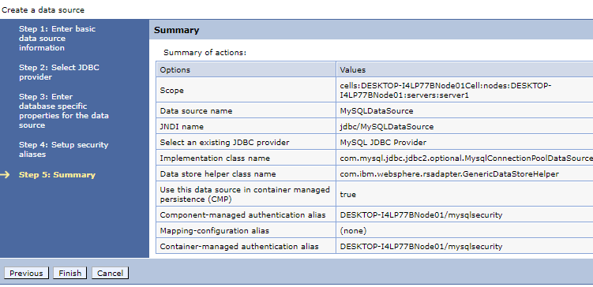

Click on Created Datasource > [Custom properties](http://localhost:9060/ibm/console/com.ibm.ws.console.resources.forwardCmd.do?csrfid=2031393875&forwardName=DataSourceProperty.ds.valueEditable.content.main&sfname=propertySet&resourceUri=resources.xml&parentRefId=DataSource_1540667612887&contextId=cells%3ADESKTOP-I4LP77BNode01Cell%3Anodes%3ADESKTOP-I4LP77BNode01%3Aservers%3Aserver1&perspective=tab.configuration) > Add field by field by creating

portNumber = 3306

relaxAutoCommit=true

databaseName = WLADMIN

serverName = the host name of the MySQL server

user = the user name of the MySQL server

password = the password associated with the user name

That’s All, Test Connection

To configure in Web.xml

