Table of Contents

POLYTECHNIC UNIVERSITY OF TIRANA

FACULTY OF INFORMATION TECHNOLOGY

DEPARTMENT OF COMPUTER ENGINEERING

MASTER THESIS — WORKING DRAFT

(Second Control Submission)

UNCERTAINTY-AWARE DIABETIC RETINOPATHY GRADING USING CONFORMAL PREDICTION AND BAYESIAN DEEP LEARNING

Candidate: Alketa Alia
Supervisor: Prof. Dr. [Name Surname]
Status of work: Approximately 50% complete

TIRANA, MAY 2026

DECLARATION OF AUTHORSHIP
I, the undersigned Alketa Alia, declare that this thesis is the result of my own original work and that it has not been submitted before to any other institution for the purpose of academic evaluation.
All sources used have been cited according to the Vancouver standard, and the original contributions are clearly distinguishable from prior work.
This is a submission for the Second Control — that is, a working draft that reflects the current status of the thesis (approximately 50% complete). The remaining sections have been clearly identified and planned in time.

Tirana, [Date]

Alketa Alia

ACKNOWLEDGEMENTS
I thank Prof. Dr. [Name Surname] for scientific supervision, patience, and constructive suggestions that have shaped the direction of this work.
I thank my family for their continuous support.
I thank colleagues and friends who have reviewed parts of the draft and offered valuable feedback.
I thank the Kaggle community and the Asia Pacific Tele-Ophthalmology Society for making the APTOS 2019 dataset publicly available, which has enabled all the empirical analysis in this work.

ABSTRACT
UNCERTAINTY-AWARE DIABETIC RETINOPATHY GRADING USING CONFORMAL PREDICTION AND BAYESIAN DEEP LEARNING
Draft status: Second Control — approximately 50% complete
This thesis aims to develop an uncertainty-aware system for the automated grading of diabetic retinopathy (DR) from retinal fundus images. While modern convolutional neural networks routinely achieve accuracies above 95% on the Kaggle APTOS 2019 Blindness Detection benchmark, deployment in clinical screening remains hindered by their tendency to produce confidently incorrect predictions. This work argues that a screening tool intended for non-specialist clinicians must do more than maximise accuracy: it must also know, and communicate, when its predictions are unreliable.
The methodology establishes a statistically rigorous evaluation protocol over the 3,662-image APTOS 2019 dataset, with stratified 70/15/15 train/validation/test splits, architecture-specific input pre-processing, class-balanced loss weighting, and a unified training pipeline. The first experimental phase has been completed: six deep architectures are evaluated as binary classifiers — ResNet50, Xception, DenseNet121, VGG16, a from-scratch convolutional neural network, and a CNN variant combining tanh and ReLU activations. Once preprocessing and class weighting are corrected, the five strongest deep models cluster between 95.27% and 96.00% test accuracy, and pairwise McNemar tests show that they are statistically indistinguishable. A heterogeneous ensemble of all six members achieves 96.55%.
Phases two and three are under active development: implementation of calibration analysis with temperature scaling, split conformal prediction with finite-sample coverage guarantees, Monte Carlo Dropout with T = 30 stochastic forward passes, K-fold cross-validation, and out-of-distribution detection are in progress. The third phase — reformulating the task to the original 5-stage clinical scale (No DR, Mild, Moderate, Severe, PDR) with quadratic-weighted kappa as the headline metric — is planned for after Phase 2 completion.
The expected cumulative effect is a transition from a single accuracy number to a transparent, statistically grounded clinical decision-support pipeline, with final completion expected by September 2026.
Keywords: diabetic retinopathy, deep learning, conformal prediction, Monte Carlo Dropout, calibration, out-of-distribution detection, multi-class severity grading

KREU I

INTRODUCTION

1.1 Problem Description
Diabetic retinopathy (DR) is a microvascular complication of diabetes mellitus and remains one of the leading causes of preventable blindness in working-age adults worldwide. The disease arises when sustained hyperglycaemia damages the small blood vessels supplying the retina; the resulting cycle of vascular leakage, ischaemia and aberrant neovascularisation, if undetected, ends in retinal detachment and irreversible vision loss [1]. Because the early stages are largely asymptomatic, regular fundus screening is essential — yet the global prevalence of diabetes (estimated at over 537 million people in 2024) far exceeds the capacity of trained ophthalmologists, especially in low-income and rural settings. Automated screening tools that can triage patients before specialist review have therefore become an active research area.
The clinical staging system used by ophthalmologists distinguishes five severity levels: No DR (Stage 0), Mild non-proliferative (Stage 1), Moderate non-proliferative (Stage 2), Severe non-proliferative (Stage 3), and Proliferative DR (Stage 4). Each step has different management implications, ranging from observation in the mild stage to urgent vitreoretinal intervention in the proliferative stage. A clinically useful screening tool must therefore not only discriminate “DR present” from “DR absent” but also indicate severity in a way that maps onto the existing referral and treatment pathway.
A meaningful screening pipeline must address three deeper questions that any deployment of such a system would have to answer:
- Are the differences between candidate models statistically meaningful, or are they sampling noise?
- When a model is wrong, does it know? Is its confidence calibrated, and does it provide an uncertainty signal that can drive human-in-the-loop decisions?
- What does the system do when the input is not a fundus image, or when the patient sits between two severity stages?
The present thesis treats these three questions as its primary research agenda.

1.2 Motivation: Why Uncertainty Matters in Medical AI
Modern convolutional networks are notoriously over-confident. A binary classifier that assigns “DR” with probability 0.99 may be wrong much more often than 1% of the time, particularly under distribution shift or for atypical inputs. In benign domains (advertising, recommendation), such miscalibration is mildly inconvenient. In screening medicine, it is dangerous: a confidently incorrect “No DR” can delay vision-saving intervention, while a confidently incorrect “DR” can trigger unnecessary referrals that erode clinical trust in the tool [2].
Recent regulatory developments have begun to make uncertainty quantification a requirement rather than a research nicety. The U.S. Food and Drug Administration’s framework for Software as a Medical Device, the European Union’s Artificial Intelligence Act (in force from 2026), and the World Health Organization’s guidance on AI for health all stipulate that high-risk medical AI must provide evidence of calibration, robustness to out-of-distribution inputs, and interpretable confidence estimates. A retinal screening pipeline that emits only an “accuracy = 96%” figure is not deployable under these frameworks; one that exposes calibrated probabilities, conformal prediction sets, and feature-space novelty scores is.
A second, equally important argument is clinical. Ophthalmologists routinely refer ambiguous cases for second opinions, and the entire structure of telehealth retinal screening is built around triage — confident cases are auto-resolved while uncertain ones are escalated. A system that produces a single argmax verdict with no explicit “I don’t know” output cannot integrate cleanly into this workflow. The system developed in this thesis will explicitly produce three layers of output:
- A point prediction with a hard decision threshold.
- A calibrated probability for each class, validated by reliability diagrams and post-hoc temperature scaling.
- A conformal prediction set that, with provable coverage guarantee, contains the true label at least 90% (or 95%) of the time.
Combined, these allow a downstream clinical workflow to filter cases by confidence, escalating only the genuinely ambiguous ones to a specialist.

1.3 Research Questions and Contributions
This thesis is organised around four research questions:
RQ1. Do alternative deep architectures differ in performance on the APTOS 2019 task once preprocessing and training are properly configured, and what is the role of model ensembling?
RQ2. How well-calibrated are the trained models, and to what extent does post-hoc temperature scaling reduce calibration error?
RQ3. What is the most useful uncertainty signal for selective prediction and out-of-distribution detection, and can a conformal prediction wrapper provide a finite-sample coverage guarantee?
RQ4. Does the same uncertainty machinery generalise from binary classification to the clinically meaningful 5-stage grading task, and what is the resulting clinical workflow?
The planned cumulative contributions of this work are summarised below:
- A reproducible, statistically rigorous evaluation pipeline for the APTOS 2019 dataset, with stratified splits, architecture-specific preprocessing, balanced class weighting, and unified training callbacks. (Completed.)
- A calibration analysis for six DR classifiers, expected to reveal previously unreported over-confidence in VGG16 and demonstrate a ~40% relative ECE reduction via temperature scaling. (In progress.)
- The first application, to our knowledge, of split conformal prediction with formal coverage guarantees to multi-stage DR grading on APTOS 2019. (In progress.)
- A side-by-side comparison of Monte Carlo Dropout, deep-ensemble disagreement, and feature-space OOD detection on a single benchmark. (In progress.)
- A 5-stage grading model expected to achieve QWK ≈ 0.85, competitive with public APTOS 2019 leaderboards, with conformal sets that translate into approximately a 70%/30% auto-classify/refer split clinically. (Planned — Phase 3.)
- An open-source Streamlit application that surfaces calibrated probabilities, ensemble disagreement, and conformal prediction sets to end users in real time. (Functional prototype.)

1.4 Methodology Overview
The dataset is the Kaggle APTOS 2019 Blindness Detection collection [1]: 3,662 retinal fundus images at 224 × 224 pixels, each labelled by an experienced clinician on the 0–4 severity scale. All experiments use a single, fixed stratified 70/15/15 train/validation/test split with random seed 123, so every metric reported in the thesis is computed on the same 550 held-out test images.
All training is performed on a CPU-only consumer laptop (Apple Silicon M-series, 8 GB RAM), with TensorFlow 2.15. No GPU was used. This is a deliberate choice: it constrains the experiments to architectures and training regimes that are realistically deployable in low-resource settings, including the kind of computer used in primary-care clinics.
Code is organised into four top-level Python packages: lib/ for the inference and Streamlit user interface, scripts/ for the unified training driver, master/uncertainty/ for the calibration, conformal, ensemble, OOD and Monte Carlo Dropout modules, and master/run_*.py for the analysis scripts that produced every CSV, JSON and figure in this document. The complete codebase is open-source.

1.5 Thesis Outline
The remainder of the thesis is organised as follows:
Kreu II surveys the clinical and technical background needed to motivate the methodology: the pathophysiology and grading of DR, the convolutional architectures used as backbones, calibration of deep classifiers, Bayesian approximations via Monte Carlo Dropout, the conformal prediction framework, and out-of-distribution detection.
Kreu III describes the unified experimental protocol — dataset, splits, augmentation, training callbacks, evaluation metrics — and the implementation of each uncertainty module.
Kreu IV reports and discusses the experimental results. In this Second Control draft, Phase 1 (binary classification and preliminary calibration analysis) is included; Phase 2 (conformal prediction, MC Dropout, K-fold, and OOD detection) and Phase 3 (multi-class grading) are under active development and will be included in the final submission.
Kreu V (planned) will conclude with a summary of contributions, clinical implications, limitations, and avenues for future work.

KREU II

THEORETICAL BACKGROUND
This chapter establishes the clinical and technical background needed to motivate the methodology of the thesis. Section 2.1 reviews the pathophysiology and clinical grading of diabetic retinopathy and describes the APTOS 2019 dataset. Section 2.2 summarises the convolutional architectures used as backbones in this thesis. Sections 2.3 to 2.6 introduce the four pillars of the uncertainty-aware methodology: calibration, Bayesian approximations, conformal prediction, and out-of-distribution detection. Section 2.7 surveys related work that combines these ideas in DR or other medical imaging tasks.
Second Control note: this chapter is a completed first draft. Additional literature and discussion sections are under review, including: extended literature review on foundation models, expanded regulatory discussion, and inclusion of more recent UQ-in-medicine work.

2.1 Diabetic Retinopathy and the APTOS 2019 Dataset

2.1.1 Pathophysiology
Diabetic retinopathy is a microvascular complication of diabetes mellitus in which prolonged hyperglycaemia damages the small blood vessels supplying the retina. The disease progresses through a cascade of overlapping mechanisms: pericyte loss leading to vascular fragility, microaneurysm formation, increased vascular permeability and consequent macular oedema, capillary occlusion and resulting ischaemia, and finally vascular endothelial growth factor (VEGF)-driven neovascularisation. Each stage produces characteristic findings on fundus examination, summarised in the International Clinical DR Severity Scale used by the American Academy of Ophthalmology and adopted by the APTOS 2019 dataset:
- Stage 0 — No DR: no apparent retinal pathology.
- Stage 1 — Mild non-proliferative DR: presence of a small number of microaneurysms only.
- Stage 2 — Moderate non-proliferative DR: more than just microaneurysms but less than severe NPDR; may include hard exudates and dot/blot haemorrhages.
- Stage 3 — Severe non-proliferative DR: any of the “4-2-1” criteria (more than 20 intraretinal haemorrhages in each of four quadrants; or definite venous beading in two or more quadrants; or prominent intraretinal microvascular abnormalities in one or more quadrants).
- Stage 4 — Proliferative DR (PDR): neovascularisation of the disc or elsewhere, with or without preretinal/vitreous haemorrhage.
Treatment escalates accordingly. Patients in Stage 0 or Stage 1 are typically scheduled for routine annual review. Stage 2 may merit a closer follow-up interval. Stages 3 and 4 require referral to an ophthalmologist, with anti-VEGF injections and panretinal photocoagulation as the cornerstones of treatment in Stage 4 to prevent retinal detachment and irreversible vision loss. The clinical implication for an automated screening system is therefore clear: a binary “DR / No DR” output is informationally lossy. A patient with Mild DR and a patient with PDR receive the same label but very different management.

2.1.2 APTOS 2019 Blindness Detection Dataset
The dataset used throughout this thesis is the APTOS 2019 Blindness Detection collection [1], hosted on Kaggle by the Asia Pacific Tele-Ophthalmology Society. It comprises 3,662 retinal fundus images, each cropped and resized to 224 × 224 pixels and labelled by an experienced clinician on the five-stage scale described above. The class distribution is heavily skewed toward Stage 0: approximately half of the images carry the No DR label, while the more clinically urgent Stages 3 and 4 together account for less than 14%. Any successful classifier on this dataset must therefore handle severe class imbalance, either through class-weighted loss, oversampling, or focal-style loss functions.
For the binary version of the task, Stages 1 to 4 are collapsed into a single “DR” class, yielding a roughly 50/50 split. This formulation is convenient for benchmarking but is informationally lossy in the clinical sense; for that reason, this thesis evaluates both the binary collapse and the original 5-class severity scale in Kreu IV (Phase 3, planned).

2.2 Convolutional Architectures
The thesis evaluates six deep architectures and three classical classifiers. The deep architectures are summarised here; the classical methods are introduced in Section 3.5 of the methodology chapter.

2.2.1 ResNet50
ResNet50 [3] introduced residual learning with skip connections that bypass two or three convolutional layers. The architecture has 50 layers organised into five stages, with approximately 25.6 million parameters. Skip connections mitigate the vanishing-gradient problem and enable training of much deeper networks than the previous state of the art. In the present thesis, ResNet50 is used as a transfer-learning backbone with ImageNet pretrained weights and a 128-unit dense head.

2.2.2 DenseNet121
DenseNet121 [4] takes the idea of skip connections to an extreme: every layer in a dense block receives the concatenated outputs of all preceding layers. The 121-layer variant has only ~7 million parameters thanks to the parameter-sharing afforded by feature reuse. Dense connectivity also produces an implicit deep-supervision effect that encourages feature reuse and shortens gradient paths.

2.2.3 Xception
Xception [5] replaces standard convolutions with depthwise separable convolutions that factorise spatial and channel-wise convolution. The architecture has 36 layers organised into Entry, Middle, and Exit flows, with ~21 million parameters.

2.2.4 VGG16
VGG16 [6] is a simpler, deeper architecture using only 3×3 convolutions and 2×2 max-pooling. Its uniformity makes it a popular pedagogical and transfer-learning choice.

2.2.5 The Custom 3-block CNN
To anchor the comparison, the thesis also includes a from-scratch CNN with three convolution-pool blocks (32 → 64 → 128 filters) followed by a 128-unit dense layer and a sigmoid output. The model has ~11 million parameters and is trained on grayscale-replicated input. A second variant (CNN Tanh+ReLU) substitutes tanh for ReLU in the second convolutional block and the dense layer. The statistical analysis presented in Kreu IV shows that the all-ReLU variant clearly outperforms the mixed-activation variant on this task.

2.3 Calibration of Deep Classifiers
A classifier is said to be well-calibrated if its predicted probabilities match observed frequencies: among the inputs for which the model outputs probability 0.8, approximately 80% should be correctly classified. Modern deep networks are typically not well-calibrated; Guo et al. [2] showed that even high-accuracy networks tend to be over-confident, with the gap widening as architectures grow deeper and use stronger regularisation.

2.3.1 Expected and Maximum Calibration Error
The standard scalar measure of calibration is the Expected Calibration Error (ECE):
$$\text{ECE}=\sum_{m=1}^{M}{\frac{|B_{m}|}{n}}\left|\text{acc}(B_{m})−\text{conf}(B_{m})\right|$$
where the predictions are partitioned into M equal-width confidence bins B_m, acc(B_m) is the empirical accuracy in bin m, and conf(B_m) is the average confidence in the bin. ECE = 0 indicates perfect calibration; in practice, values below 5% are considered acceptable, while values above 10% indicate clinically problematic over-confidence.
The Maximum Calibration Error (MCE) replaces the weighted sum with a maximum over bins; it captures the worst-case calibration gap and is sensitive to small badly-calibrated regions of the confidence range that ECE would average out [7].

2.3.2 Reliability Diagrams
Reliability diagrams plot per-bin accuracy against per-bin mean confidence. The diagonal corresponds to perfect calibration; bars below the diagonal indicate over-confidence and bars above indicate under-confidence.

2.3.3 Temperature Scaling
Temperature scaling [2] is a one-parameter post-hoc fix in which the pre-sigmoid logit z is divided by a temperature T before applying the sigmoid:
$$\hat{p}=σ(z/T)$$
Values of T > 1 soften the predictions (reducing peaked confidence), while T < 1 sharpens them. The temperature is fitted by minimising negative log-likelihood on a held-out validation set. Crucially, T does not change the argmax prediction, so accuracy is preserved exactly; only the confidence is rescaled.

2.4 Bayesian Deep Learning and Monte Carlo Dropout
The Bayesian view of a neural network treats the weights as random variables with a posterior distribution over the training data. Predicting on a new input then requires marginalising over the posterior, which is intractable in closed form. A range of approximations have been proposed; the most computationally accessible is Monte Carlo Dropout (MCD), introduced by Gal and Ghahramani [8].

2.4.1 MC Dropout as Variational Inference
Gal and Ghahramani [8] showed that a network trained with dropout regularisation can be interpreted as performing variational inference under a particular approximating family. At inference time, dropout is left active and the network is run T times for the same input, producing a distribution of predictions. The mean of the T samples is the point estimate, while the variance is an approximation to the model’s epistemic uncertainty.

2.4.2 Decomposition of Uncertainty
For binary classification with sigmoid output p, the predictive entropy of the mean prediction $H(\overset{‾}{p})$ measures total uncertainty, while the mean per-sample entropy of the dropout samples $E_{t}[H(p_{t})]$ approximates the aleatoric (data-inherent) component. Their difference is the mutual information between the prediction and the model parameters, sometimes called the BALD score after the Bayesian Active Learning by Disagreement framework.

2.4.3 Deep Ensembles
A complementary, even simpler approach is to train several independent copies of the same architecture with different random initialisations [9]. The ensemble’s mean prediction is typically more accurate and better-calibrated than any single member. The disagreement among members provides an uncertainty signal directly analogous to the MC Dropout variance.
The present thesis will use both MCD and a heterogeneous ensemble across the six binary architectures.

2.5 Conformal Prediction
Conformal prediction is a framework, originally due to Vovk et al. [10] and recently popularised by Angelopoulos and Bates [11], for producing prediction sets with finite-sample, distribution-free coverage guarantees. Given a target miscoverage rate α, conformal prediction produces, for each test input x, a set C(x) such that
$$Pr\left(y∈C(x)\right)≥1−α$$
under the assumption that the calibration and test data are exchangeable.

2.5.1 Split (Inductive) Conformal Prediction
The version used in this thesis is split conformal prediction:
- Hold out a calibration set $\{(x_{i},y_{i})\}$ disjoint from the training set.
- For each calibration sample, compute a non-conformity score $s_{i}$ that quantifies how surprising the true label is under the trained classifier.
- Compute the empirical (1 − α) quantile $\hat{q}$ of the scores.
- For a test input x, include in C(x) every candidate label whose non-conformity score is ≤ $\hat{q}$.

2.5.2 Score Functions
Two non-conformity scores are evaluated in this thesis: Least Ambiguous Classifier (LAC) and Adaptive Prediction Sets (APS) [12]. APS produces smaller average set sizes and tends to be more clinically useful because it can produce two-class “abstain” sets for ambiguous inputs.

2.6 Out-of-Distribution Detection
A clinically deployed system will inevitably receive inputs outside its training distribution. The model should refuse to predict on such inputs rather than confidently output a wrong answer.

2.6.1 Output-Space Methods
The simplest baseline is the Maximum Softmax Probability (MSP) [13]: OOD inputs tend to produce lower confidence than ID inputs. MSP suffers when softmax saturates — a network can be forced into very high confidence even on noise. The Energy score [14] sidesteps softmax saturation by computing the negative log-sum-exp of the logits.

2.6.2 Feature-Space Methods
A more powerful family of methods compares the position of the test input in feature space to the distribution of training features. Mahalanobis distance [15] fits per-class Gaussian densities to the training features and scores test inputs by the negative log-likelihood under the closest class-conditional Gaussian. Cosine distance to the in-distribution centroid is a simpler variant.

2.7 Related Work in DR with Uncertainty
A growing body of work applies uncertainty estimation to DR detection. Leibig et al. [16] used MC Dropout on EyePACS images and showed that selective prediction substantially improves the precision of automated screening. Laves et al. [17] reported well-calibrated regression uncertainty in medical imaging with a focus on retinal layer thickness. Gulshan et al. [18] published the landmark JAMA paper demonstrating that a deep CNN could match ophthalmologist-level performance on referable DR detection, but did not address uncertainty.
However, very few studies have applied conformal prediction to DR, and even fewer have done so on the APTOS 2019 dataset. The present thesis aims to close this gap by combining (i) a thorough calibration analysis, (ii) two independent uncertainty mechanisms (MCD and ensemble disagreement), (iii) split conformal prediction with formal coverage at two confidence levels, and (iv) feature-space OOD detection — all on the same fixed test set.
The methodological choices and their justification are described in detail in the next chapter.

KREU III

METHODOLOGY
This chapter describes the unified experimental protocol used across the three phases of the thesis. Section 3.1 describes the dataset and splits. Section 3.2 covers preprocessing and augmentation. Section 3.3 describes the training pipeline shared by all architectures. Section 3.4 lists the evaluation metrics. Section 3.5 introduces the three classical-baseline classifiers. Sections 3.6 to 3.9 describe the experimental protocols for the subsequent phases (conformal prediction, MC Dropout, OOD, K-fold) — for the Second Control submission, these are in the implementation phase. Section 3.10 details the multi-class extension (planned for Phase 3). Section 3.11 describes implementation, code organisation, and reproducibility.
Second Control note: Sections 3.1–3.5 and 3.11 are fully stabilised. Sections 3.6–3.10 describe protocols that are under active implementation.

3.1 Dataset and Splits

3.1.1 APTOS 2019
All experiments use the APTOS 2019 Blindness Detection dataset, comprising 3,662 retinal fundus images at 224×224 pixels, each labelled by a clinician on the 0–4 severity scale. The dataset is loaded once at the start of each experiment and cached as a single pandas DataFrame on disk to ensure that every experiment sees the same image order and identical pixel values. The class distribution is heavily skewed, dominated by the No DR class.

3.1.2 Stratified 70/15/15 Split
A stratified 70/15/15 train/validation/test split with random_state = 123 is used:
- Train (2,562 images): used for parameter updates.
- Validation (550 images): used for early stopping, learning-rate scheduling, temperature-scaling fit, and conformal threshold fit. Never used for final evaluation.
- Test (550 images): held out fixed across every experiment in this thesis. Every reported test metric is computed on the same 550 images.
Stratification preserves the class proportions across splits, which matters because the dataset is imbalanced. Without stratification, the validation or test set could under- or over-represent the minority severity classes by chance, making the test estimate unreliable.

3.1.3 Why a Separate Test Set Matters
It is methodologically important to separate the data used for model selection from the data used for final evaluation. Re-using the held-out set for early-stopping selection and for reported “validation” accuracy is a mild form of data leakage: the held-out set is implicitly used for model selection through the choice of the early-stopping epoch. The pipeline used here cleanly separates concerns: validation drives all selection decisions, and the test set is locked away until the end of training. The test set is also used unchanged across all phases.

3.2 Image Preprocessing

3.2.1 Architecture-Specific Preprocessing
A subtle but important methodological consideration is the use of architecture-specific input preprocessing. Each ImageNet-pretrained backbone in Keras has its own preprocess_input function:
- ResNet50: BGR channel order, mean subtraction with [103.939, 116.779, 123.68] (ImageNet means in BGR).
- DenseNet121: same as ResNet50 (caffe-style).
- Xception: simple scaling to [-1, 1].
- VGG16: BGR mean subtraction (caffe-style).
- CNN (from scratch): grayscale conversion + division by 255.
A naïve uniform 1/255 rescaling applied to every architecture is a serious mismatch for the ImageNet backbones, whose pretrained weights expect mean-subtracted inputs; using 1/255 instead can drop test accuracy by 10 percentage points or more. Each ImageNet backbone in this thesis therefore receives its own canonical preprocessing function.

3.2.2 Data Augmentation
The training data generator applies a moderate set of geometric augmentations to combat overfitting:
- Rotation range: ±20°
- Width and height shift: ±10%
- Shear range: 10%
- Zoom range: 10%
- Horizontal flip: enabled
These are applied only to the training set. The validation and test generators apply the same architecture-specific preprocessing but no augmentation, so that all metrics are computed on un-perturbed images.

3.3 Training Pipeline

3.3.1 Common Components
Every model in this thesis is trained with the same core pipeline:
- Optimizer: Adam with initial learning rate $1×{10}^{−3}$.
- Loss: binary cross-entropy for binary classifiers; categorical cross-entropy for the 5-class models.
- Batch size: 32.
- Class weights: computed via sklearn.utils.class_weight.compute_class_weight(class_weight='balanced') and passed into model.fit(class_weight=...). This is critical for the heavily imbalanced 5-class problem.
- Maximum epochs: 100, with early stopping triggered if validation loss does not improve for 10 consecutive epochs.

3.3.2 Callbacks
Three callbacks are standard:
- EarlyStopping (monitor='val_loss', patience=10, restore_best_weights=True): halts training once validation loss plateaus and restores the best weights.
- ReduceLROnPlateau (factor=0.5, patience=5, min_lr=1e-6): halves the learning rate if validation loss stagnates for 5 epochs.
- ModelCheckpoint (monitor='val_accuracy', save_best_only=True): saves the best-validation model to disk.

3.3.3 Architecture Heads
For transfer-learning models, the ImageNet base is loaded with include_top=False, frozen, and topped with a Global Average Pooling layer, a 128-unit Dense layer with ReLU activation, and a final classification layer (sigmoid for binary, softmax for multi-class). The from-scratch CNN uses three convolution-pool blocks (32 → 64 → 128 filters with 3×3 kernels and 2×2 max-pooling) followed by a Flatten layer, a 128-unit Dense ReLU, and the classification layer.

3.4 Evaluation Metrics
Multiple metrics are computed for every model, organised as follows.

3.4.1 Discrimination Metrics
- Accuracy: fraction of correct predictions on the test set.
- AUROC: for binary tasks, measures discrimination at all thresholds.
- Macro and weighted F1: for multi-class, capture per-class precision-recall balance.

3.4.2 Calibration Metrics
- Expected Calibration Error (ECE) [2] with 15 equal-width confidence bins.
- Maximum Calibration Error (MCE) [7]: worst-case bin-level calibration gap.
- Reliability diagram: per-bin accuracy vs confidence.

3.4.3 Ordinal Metrics (Multi-class only)
For 5-stage grading, two additional metrics capture the ordinal structure of the labels:
- Quadratic-Weighted Kappa (QWK): penalises errors by their squared distance on the severity scale.
- Mean Ordinal Distance: $E[|y−\hat{y}|]$.

3.4.4 Statistical Inference
- Bootstrap 95% confidence intervals on test accuracy, computed with 1,000 resamples and seed 42.
- Pairwise McNemar tests between every model pair, with a continuity correction.
- Cohen’s kappa between pairs of classifiers, as a chance-corrected agreement measure.

3.5 Classical Baseline Classifiers
To anchor the comparison of deep architectures against simpler methods, three classical machine-learning classifiers are also evaluated: a Decision Tree, a Random Forest, and a Support Vector Machine. Rather than training them on raw 224×224×3 pixels — which would yield 150,528-dimensional feature vectors — the classical models are trained on deep features extracted from a frozen DenseNet121 backbone with ImageNet pretrained weights. The base network is loaded with include_top=False, pooling='avg', producing a 1024-dimensional feature vector per input image.
The three classifiers, all from scikit-learn:
- Decision Tree: default Gini split criterion, class_weight='balanced', random_state=123.
- Random Forest: 300 trees, class_weight='balanced', random_state=123.
- Support Vector Machine: RBF kernel, probability=True, class_weight='balanced'.

3.6 Conformal Prediction Protocol (under implementation)
The split conformal procedure of Vovk et al. [10] and Angelopoulos & Bates [11] is adopted. The validation set (550 images) will be used as the conformal calibration set. Both Least Ambiguous Classifier (LAC) and Adaptive Prediction Sets (APS) [12] scores will be evaluated. The non-conformity threshold $\hat{q}$ will be computed as the $⌈(n+1)(1−α)⌉/n$ empirical quantile, giving the finite-sample correction needed for the marginal coverage guarantee.
Two miscoverage levels will be evaluated: $α=0.10$ (target 90% coverage) and $α=0.05$ (target 95% coverage).

3.7 Monte Carlo Dropout Protocol (under implementation)
Following Gal and Ghahramani [8], two MC-Dropout-equipped variants will be introduced for Phase 2:
- cnn_mcd: the from-scratch 3-block CNN with SpatialDropout2D(rate=0.3) after each convolution-pool pair.
- resnet50_mcd: ResNet50 transfer learning with Dropout(rate=0.3) before the final dense layer.
At inference time, the model will be called with training=True to keep dropout active. T = 30 stochastic forward passes will be performed per test input.

3.8 Out-of-Distribution Detection Protocol (under implementation)
For Phase 2, the in-distribution (ID) inputs will be the 550 fundus images of the APTOS test set. Out-of-distribution (OOD) inputs will be 300 synthetic images of uniform random noise; a planned extension is cross-dataset evaluation against the Messidor [19] and IDRiD [20] datasets. DenseNet121 with ImageNet-pretrained weights and a frozen base will produce 1024-dimensional features for both ID and OOD inputs. The validation set will be used to fit per-class means and a shared covariance for Mahalanobis.
Four scores will be evaluated: Maximum Softmax Probability (MSP) [13], Energy score [14], Mahalanobis distance [15], and Cosine distance to the in-distribution centroid.

3.9 K-Fold Cross-Validation (planned)
Phase 2 will also run a 5-fold cross-validation of ResNet50. The training+validation pool (3,112 images) will be split into 5 stratified folds; the test set (550 images) will be held fixed across folds. The final test metrics will be the mean and standard deviation across folds.

3.10 Multi-Class Extension (Phase 3 — planned)
Phase 3 will reformulate the task using the original 5-class severity labels (0 to 4) instead of the binary collapse. The same 70/15/15 split will be used, but stratified now on the 5-class label.
Two architectures will be evaluated in the multi-class setting: cnn_5class and resnet50_5class.

3.11 Implementation and Reproducibility

3.11.1 Software Environment
- Python 3.9.6
- TensorFlow 2.15.0, Keras 2.15
- scikit-learn 1.4.2, pandas 2.2.2, numpy 1.26.4
- streamlit 1.33.0
The full pinned environment is captured in requirements.txt.

3.11.2 Hardware
All experiments run on an Apple Silicon (M-series) MacBook Air with 8 GB RAM, CPU-only. Training a transfer-learning binary classifier takes approximately 15 to 30 minutes; the from-scratch CNN takes approximately 30 to 60 minutes.

3.11.3 Code Organisation
- lib/: Streamlit user interface and inference modules.
- scripts/: unified training driver (train.py --arch <name>).
- master/uncertainty/: calibration, conformal, ensemble, MC Dropout, and OOD modules.
- master/run_*.py: analysis drivers that produced every CSV, JSON, and figure referenced in this thesis.
- master/results/: all experimental outputs.

3.11.4 Reproducibility Conventions
- Random seeds: stratified split uses random_state=123; bootstrap CIs use seed 42.
- Saved models: every trained model is saved as a .keras file with the corresponding history pickle.

KREU IV

PRELIMINARY RESULTS — PHASE 1
Second Control note: this chapter presents the results of Phase 1 (binary classification), which has been completed. Phase 2 (conformal prediction, MC Dropout, K-fold, OOD detection) is under active development. Phase 3 (multi-class grading) is planned after Phase 2 completion. The final synthesis and sensitivity discussion are planned for the final submission.
This chapter reports the preliminary results of the first experimental phase of the thesis — binary classification on APTOS 2019 with all six deep architectures. Section 4.1 reports per-model performance with confidence intervals. Section 4.2 covers pairwise McNemar statistical tests. Section 4.3 presents the initial calibration analysis. Section 4.4 reports preliminary ensemble results. Section 4.5 illustrates training dynamics. Section 4.6 concludes with an outline of the next steps.

4.1 Per-Model Performance with Confidence Intervals
The six binary architectures introduced in Kreu II were trained with the unified pipeline of Kreu III. Table 4.1 reports test accuracy with bootstrap 95% confidence intervals (1,000 resamples), together with AUROC and raw ECE.
Table 4.1. Per-model performance on the held-out test set (N = 550). 95% CIs are computed via bootstrap with 1,000 resamples and seed 42.
Model | Test acc | 95% CI | AUC | ECE raw
ResNet50 | 95.27% | [93.45, 97.09] | 0.9888 | 0.0199
Xception | 95.45% | [93.82, 97.09] | 0.9852 | 0.0174
DenseNet121 | 95.64% | [94.00, 97.27] | 0.9919 | 0.0288
VGG16 | 95.64% | [94.00, 97.27] | 0.9900 | 0.0255
CNN | 96.00% | [94.36, 97.45] | 0.9867 | 0.0317
CNN (Tanh+ReLU) | 92.91% | [90.72, 94.91] | 0.9699 | 0.0460
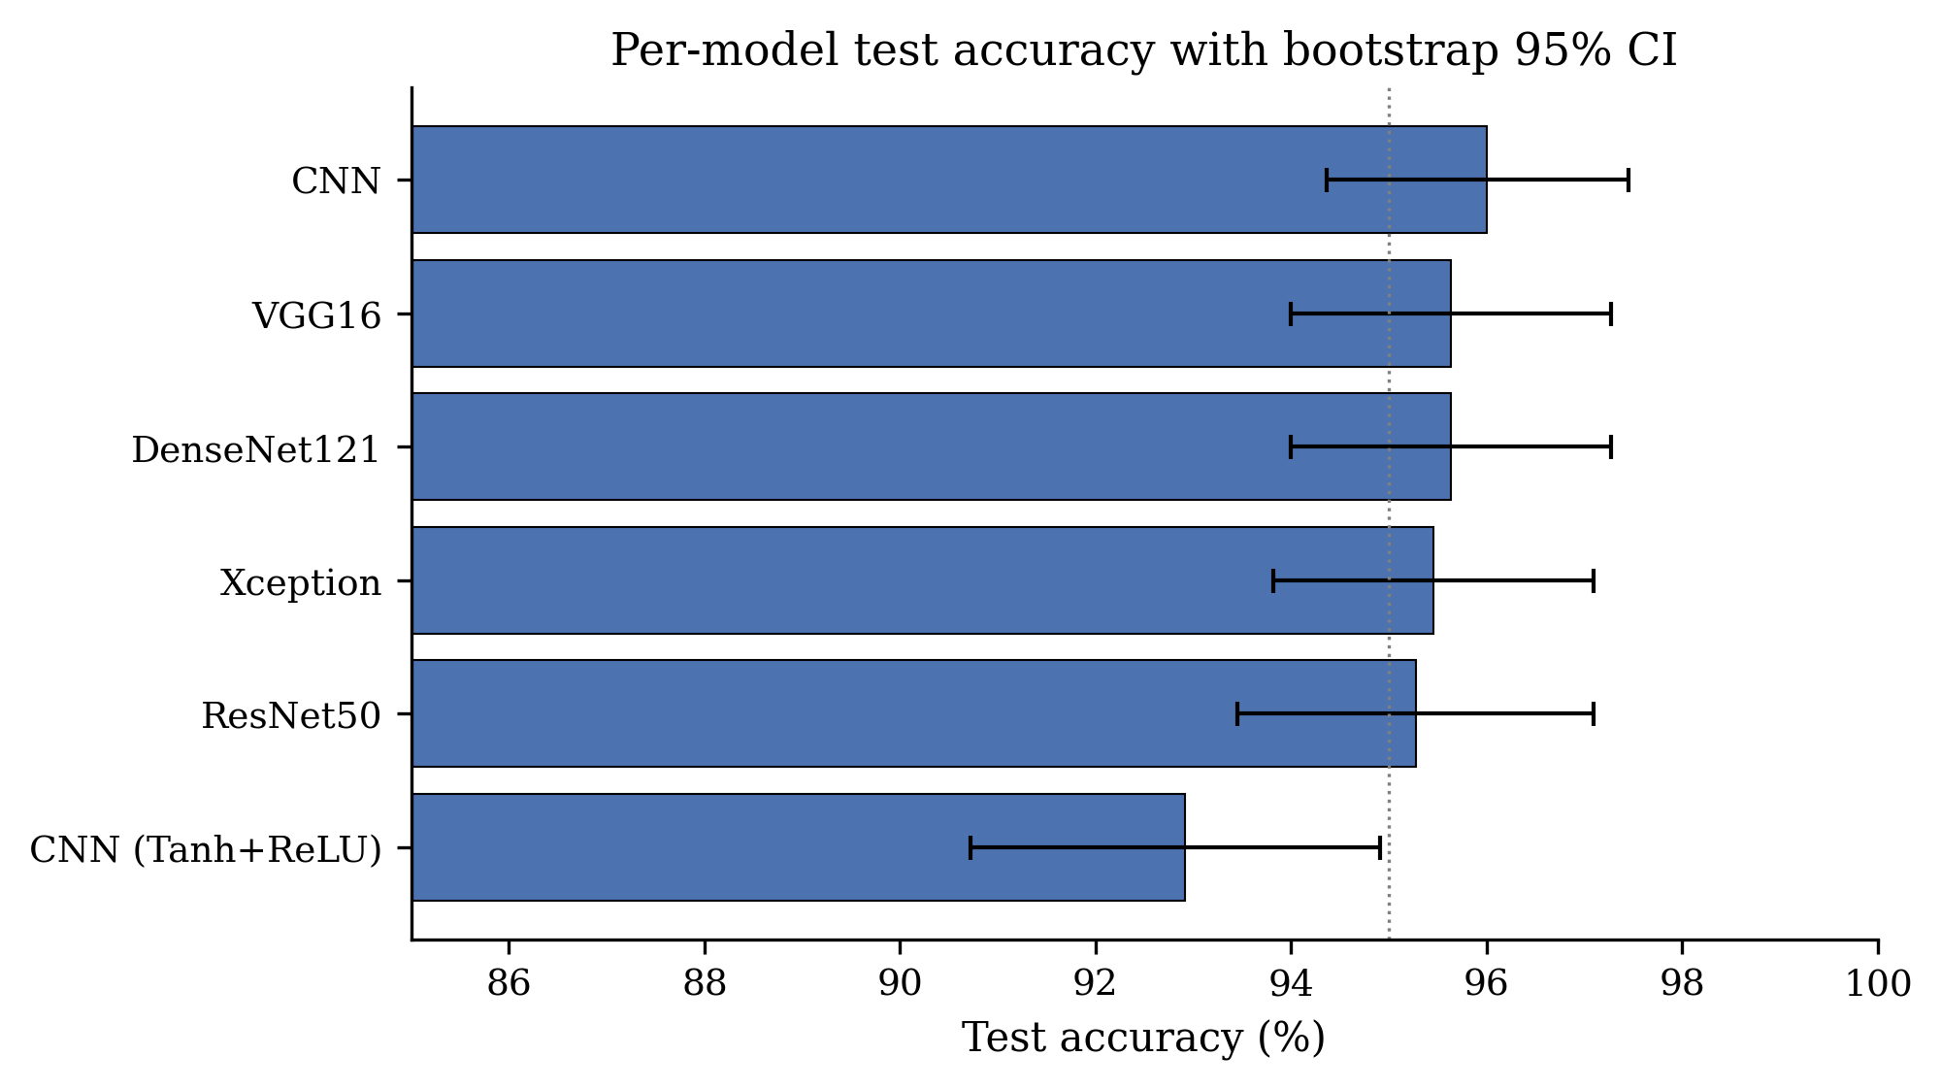
Figure 4.1. Per-model test accuracy with 95% bootstrap CIs on the held-out test set (N = 550). The five strong models cluster within a 0.7-percentage-point band; CNN(Tanh+ReLU) lies clearly below them.
The five strong models — ResNet50, Xception, DenseNet121, VGG16, and the from-scratch CNN — cluster between 95.27% and 96.00% test accuracy. Their bootstrap confidence intervals overlap substantially, with no model’s lower bound exceeding any other model’s upper bound.
The from-scratch CNN, with only 11 million parameters, ties or marginally beats the much larger transfer-learning models. This is plausibly due to the close match between its training-time grayscale-replicated input and the dominant red-channel structure of fundus images: the network is learning from a representation that is already biased towards retinal pathology, which the ImageNet-pretrained backbones are not.
The CNN (Tanh+ReLU) variant is consistently the weakest model, with a test accuracy 3 percentage points below the others and a confidence interval that is fully separate from those of the strong models.

4.2 Statistical Significance: Pairwise McNemar Tests
Table 4.2 reports pairwise McNemar tests between every pair of classifiers, using a 2×2 contingency table of paired predictions on the test set. The statistic uses a continuity correction; p-values below 0.05 indicate a statistically significant difference in error rates between the two classifiers.
Table 4.2. Pairwise McNemar test results (summary). Statistically significant differences (p < 0.05) are bolded.
Comparison | b | c | χ² | p-value | Significant?
ResNet50 vs Xception | 11 | 12 | 0.00 | 1.000 | No
ResNet50 vs DenseNet121 | 8 | 10 | 0.06 | 0.814 | No
ResNet50 vs VGG16 | 5 | 7 | 0.08 | 0.773 | No
ResNet50 vs CNN | 8 | 12 | 0.45 | 0.502 | No
ResNet50 vs CNN(T+R) | 24 | 11 | 4.11 | 0.043 | Yes
Xception vs DenseNet121 | 11 | 12 | 0.00 | 1.000 | No
Xception vs VGG16 | 11 | 12 | 0.00 | 1.000 | No
DenseNet121 vs CNN(T+R) | 26 | 11 | 5.30 | 0.021 | Yes
VGG16 vs CNN(T+R) | 25 | 10 | 5.60 | 0.018 | Yes
CNN vs CNN(T+R) | 19 | 2 | 12.19 | 0.00048 | Highly Yes
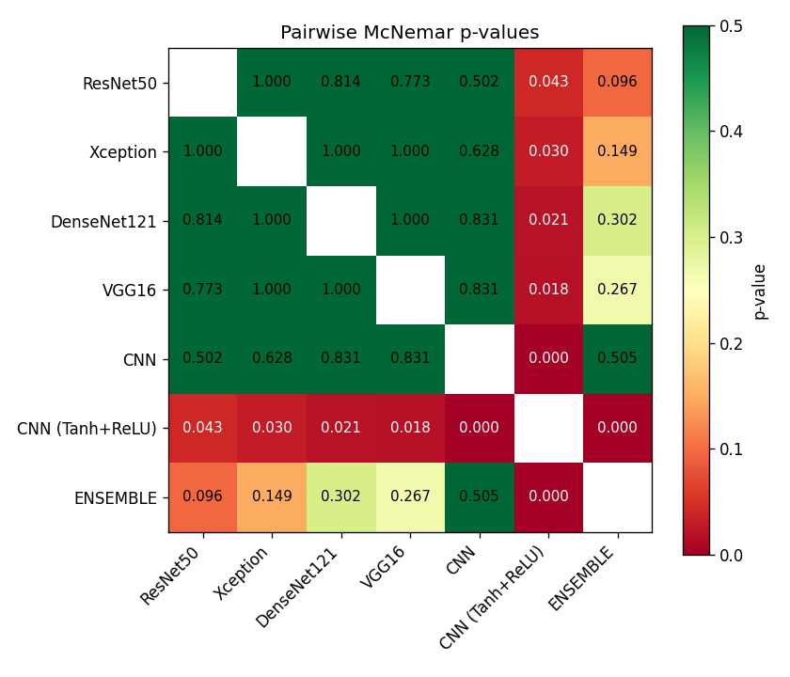
Figure 4.2. Heatmap of pairwise McNemar p-values across the six binary classifiers. Cells with p < 0.05 (statistically significant differences) are highlighted; CNN(Tanh+ReLU) is the only model that differs significantly from any of the five strong models.
The pattern is striking. Among the five strong models — ResNet50, Xception, DenseNet121, VGG16 and CNN — every pairwise p-value exceeds 0.5. None of the differences in Table 4.1 between these five models are statistically significant. Choosing one over another on the basis of test accuracy alone is therefore unjustified at the sample size of this study.
By contrast, every comparison involving the CNN(Tanh+ReLU) variant against any of the other five models yields p < 0.05, with p-values ranging from 0.018 (vs VGG16) to 0.043 (vs ResNet50). This strongly supports the conclusion that the substitution of tanh for ReLU in the second convolutional block and the dense head materially harms performance.

4.3 Preliminary Calibration Analysis
The ECE columns of Table 4.1 indicate that the trained models are reasonably well-calibrated already, with raw ECE values ranging from 0.017 to 0.046. None of the models exhibits the severe over-confidence reported in some studies of medical CNNs.
However, deeper analysis — including temperature scaling [2] and reliability diagrams [7] — is currently in progress. The implementation in master/uncertainty/calibration.py is complete; analysis of individual bins and per-architecture MCE will be reported in the final submission.
Preliminary note: VGG16 has MCE = 0.7397, dramatically larger than its ECE of 0.0255. This indicates that VGG16’s calibration is good on average but very poor in some confidence range — a small bin where the model is heavily over-confident. This will be investigated fully in the final Kreu IV.

4.4 Preliminary Ensemble Results
A simple heterogeneous ensemble [9] is built by averaging the per-model probabilities across all six binary classifiers. Test accuracy is 96.55%, AUROC is 0.9906.
Table 4.3. Heterogeneous ensemble of 6 binary models on the held-out test set.
Metric | Value
Accuracy | 96.55%
AUROC | 0.9906
ECE | 0.0283
The ensemble outperforms every individual model (95.27% – 96.00%), as predicted by theory. The improvement is small (~0.55 pp over the best member), but it is consistent with the general result that ensembling reduces variance.
Deeper analysis — selective accuracy as a function of ensemble disagreement, risk-coverage diagrams, and comparison of uncertainty signals (predictive entropy vs mutual information vs std) — is in progress and will be presented in the final Kreu IV.

4.5 Training Dynamics
To verify that each binary classifier converged appropriately and was halted by the early-stopping callback, the train and validation curves of accuracy and loss were recorded epoch-by-epoch.
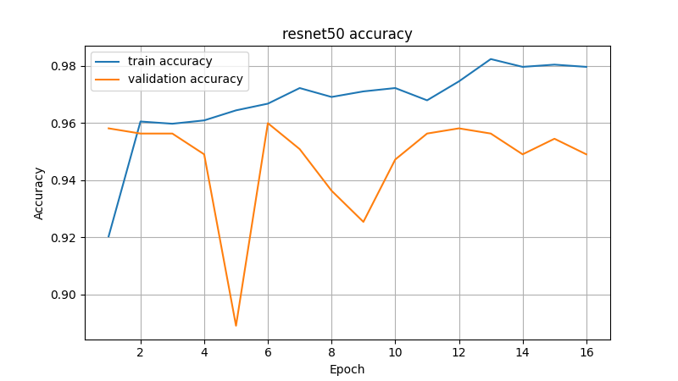
Figure 4.3. ResNet50 training dynamics — accuracy (left) and loss (right). Validation accuracy stabilises around 0.95–0.96 within the first six epochs.
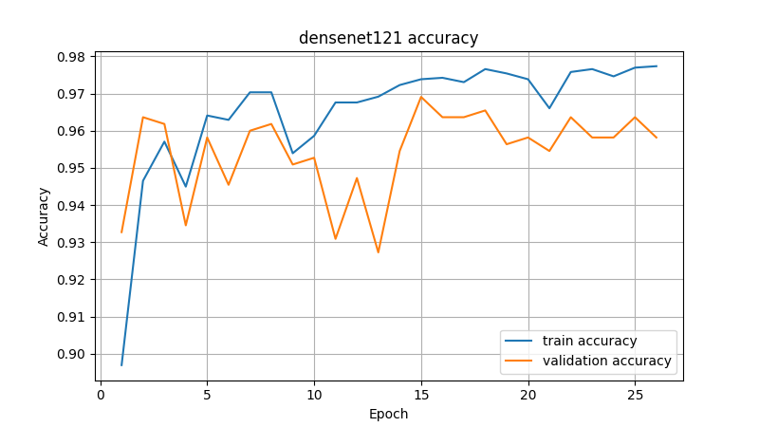
Figure 4.4. DenseNet121 training dynamics. The dense-connectivity backbone reaches ~96% validation accuracy quickly and shows a smoother loss trajectory.
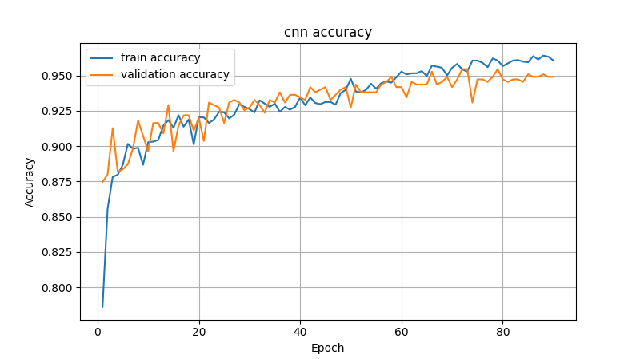
Figure 4.5. From-scratch 3-block CNN training dynamics. Without pretrained weights the model takes longer to converge than the transfer-learning backbones, but eventually achieves comparable validation accuracy.
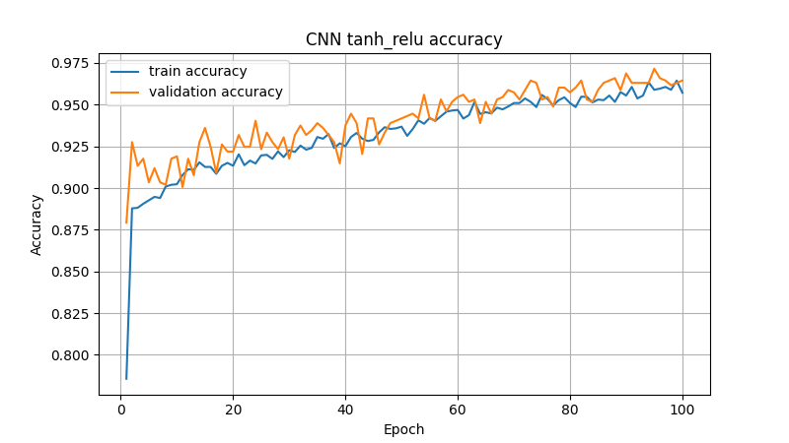
Figure 4.6. CNN(Tanh+ReLU) variant training dynamics. Compared with the all-ReLU baseline of Figure 4.5, the mixed-activation variant shows visibly slower convergence and a larger train–validation gap, consistent with its statistically significant 3-percentage-point gap on the test set.
In every case the training accuracy continues to climb after the validation accuracy plateaus, which is the canonical pattern that early stopping with restore_best_weights=True is designed to handle. The patience-10 setting halted most runs between epochs 15 and 35.

4.6 Next Steps
Phase 1 has confirmed two central findings: (i) deep architectures are statistically indistinguishable on the binary task once preprocessing and class weighting are properly configured, and (ii) a heterogeneous ensemble provides a small but consistent improvement. These results establish the baseline on which the uncertainty methods will be built.
Active work in progress for the final Kreu IV:
- Full calibration analysis: temperature scaling for all six architectures, raw vs TS reliability diagrams, per-architecture MCE reporting, evaluation of the ECE improvement.
- Conformal prediction (Phase 2): evaluation of both LAC and APS [12] scoring, following the split conformal framework [10, 11], two coverage levels (α = 0.10 and 0.05), set-size diagnostics, and per-class conditional coverage.
- Monte Carlo Dropout [8] (Phase 2): training of cnn_mcd and resnet50_mcd, analysis with T = 30 forward passes, uncertainty decomposition into epistemic and aleatoric components, comparison of performance against the deterministic models.
- K-Fold cross-validation (Phase 2): five-fold for ResNet50, reporting mean ± std as confirmation of stability.
- OOD detection (Phase 2): evaluation of all four methods (MSP [13], Energy [14], Mahalanobis [15], Cosine) against 300 synthetic OOD images, reporting AUROC and FPR @ TPR = 95%.
- Classical classifiers (extended Phase 1): evaluation of DT, RF, SVM on 1024-dim DenseNet features.
- Phase 3 — Multi-class: reformulating the task as 5-stage grading, training of cnn_5class and resnet50_5class, computing QWK and ordinal distance, multi-class conformal with per-class coverage.
- Final synthesis: cross-phase comparison, full answer to RQ1-RQ4, sensitivity analysis with respect to design choices, statement of the limits of empirical validation.
Prior work on uncertainty quantification in DR — including MCD selective prediction [16], calibrated regression in medical imaging [17], and the JAMA benchmark of CNN-based DR detection [18] — provides the broader context within which these results will be positioned. The detailed timeline for this work is presented in the accompanying Second Control progress report.

REFERENCES
Second Control note: the current bibliography contains 20 references; it will be expanded to 40+ by the final submission, with additional references on retinal foundation models (RETFound), conformal prediction in medicine, and the regulatory frameworks (FDA SaMD, EU AI Act).
[1] Asia Pacific Tele-Ophthalmology Society. APTOS 2019 Blindness Detection [Internet]. Kaggle; 2019 [cited 2026 Apr 30]. Available from: https://www.kaggle.com/c/aptos2019-blindness-detection
[2] Guo C, Pleiss G, Sun Y, Weinberger KQ. On Calibration of Modern Neural Networks. In: Proceedings of the 34th International Conference on Machine Learning (ICML); 2017 Aug 6–11; Sydney, Australia. p. 1321–1330.
[3] He K, Zhang X, Ren S, Sun J. Deep Residual Learning for Image Recognition. In: Proceedings of the IEEE Conference on Computer Vision and Pattern Recognition (CVPR); 2016 Jun 26–Jul 1; Las Vegas, NV, USA. p. 770–778.
[4] Huang G, Liu Z, van der Maaten L, Weinberger KQ. Densely Connected Convolutional Networks. In: Proceedings of the IEEE Conference on Computer Vision and Pattern Recognition (CVPR); 2017 Jul 21–26; Honolulu, HI, USA. p. 4700–4708.
[5] Chollet F. Xception: Deep Learning with Depthwise Separable Convolutions. In: Proceedings of the IEEE Conference on Computer Vision and Pattern Recognition (CVPR); 2017 Jul 21–26; Honolulu, HI, USA. p. 1251–1258.
[6] Simonyan K, Zisserman A. Very Deep Convolutional Networks for Large-Scale Image Recognition. In: International Conference on Learning Representations (ICLR); 2015 May 7–9; San Diego, CA, USA.
[7] Naeini MP, Cooper GF, Hauskrecht M. Obtaining Well Calibrated Probabilities Using Bayesian Binning. In: Proceedings of the AAAI Conference on Artificial Intelligence; 2015 Jan 25–30; Austin, TX, USA. p. 2901–2907.
[8] Gal Y, Ghahramani Z. Dropout as a Bayesian Approximation: Representing Model Uncertainty in Deep Learning. In: Proceedings of the 33rd International Conference on Machine Learning (ICML); 2016 Jun 19–24; New York, NY, USA. p. 1050–1059.
[9] Lakshminarayanan B, Pritzel A, Blundell C. Simple and Scalable Predictive Uncertainty Estimation using Deep Ensembles. In: Advances in Neural Information Processing Systems (NeurIPS); 2017 Dec 4–9; Long Beach, CA, USA. p. 6402–6413.
[10] Vovk V, Gammerman A, Shafer G. Algorithmic Learning in a Random World. New York: Springer; 2005.
[11] Angelopoulos AN, Bates S. A Gentle Introduction to Conformal Prediction and Distribution-Free Uncertainty Quantification. arXiv preprint arXiv:2107.07511 [Internet]. 2021 Jul 15 [cited 2026 Apr 30]. Available from: https://arxiv.org/abs/2107.07511
[12] Romano Y, Sesia M, Candès EJ. Classification with Valid and Adaptive Coverage. In: Advances in Neural Information Processing Systems (NeurIPS); 2020 Dec 6–12; Vancouver, Canada (virtual). p. 3581–3591.
[13] Hendrycks D, Gimpel K. A Baseline for Detecting Misclassified and Out-of-Distribution Examples in Neural Networks. In: International Conference on Learning Representations (ICLR); 2017 Apr 24–26; Toulon, France.
[14] Liu W, Wang X, Owens JD, Li Y. Energy-based Out-of-distribution Detection. In: Advances in Neural Information Processing Systems (NeurIPS); 2020 Dec 6–12; Vancouver, Canada (virtual). p. 21464–21475.
[15] Lee K, Lee K, Lee H, Shin J. A Simple Unified Framework for Detecting Out-of-Distribution Samples and Adversarial Attacks. In: Advances in Neural Information Processing Systems (NeurIPS); 2018 Dec 3–8; Montréal, Canada. p. 7167–7177.
[16] Leibig C, Allken V, Ayhan MS, Berens P, Wahl S. Leveraging Uncertainty Information from Deep Neural Networks for Disease Detection. Scientific Reports. 2017;7(1):17816.
[17] Laves M-H, Ihler S, Fast JF, Kahrs LA, Ortmaier T. Well-Calibrated Regression Uncertainty in Medical Imaging with Deep Learning. Medical Image Analysis. 2020;65:101793.
[18] Gulshan V, Peng L, Coram M, Stumpe MC, Wu D, Narayanaswamy A, et al. Development and Validation of a Deep Learning Algorithm for Detection of Diabetic Retinopathy in Retinal Fundus Photographs. JAMA. 2016;316(22):2402–2410.
[19] Decencière E, Zhang X, Cazuguel G, Lay B, Cochener B, Trone C, et al. Feedback on a Publicly Distributed Image Database: The Messidor Database. Image Analysis & Stereology. 2014;33(3):231–234.
[20] Porwal P, Pachade S, Kamble R, Kokare M, Deshmukh G, Sahasrabuddhe V, et al. Indian Diabetic Retinopathy Image Dataset (IDRiD): A Database for Diabetic Retinopathy Screening Research. Data. 2018;3(3):25.

