What is this project?
I built a digital bodyguard for your phone’s text message app. Its entire job is to protect you from "Smishing" which is when scammers send you fake text messages pretending to be the post office, your bank, or a delivery service to steal your passwords or money.
Because modern scammers use highly advanced tools, I had to build a "Three-Layer" security system to outsmart them. Every time a text comes in, it has to pass three different tests before your phone even buzzes.
The Objectives & How I Handled Them
1. Objective: Catch the obvious, lazy technical tricks.
- How I handled it: I built Phase I (The Heuristic Filter). Think of this like a digital metal detector. Real companies don't use web links made of random numbers or cheap web addresses. I wrote code that instantly scans the text for raw IP addresses (like 192.168.1.1) or scammy website endings (like .xyz or .top).
2. Objective: Read the "bad vibe" of the message.
- How I handled it: I built Phase II (The AI Brain). Smart scammers don't always use weird links; sometimes they just try to make you panic (e.g., "Your package is stuck!"). I trained a piece of Artificial Intelligence on a massive list of 74,000 real text messages. It literally learned how to "read the room" and spot the tone of a scam. I also added a "cleaner" that translates scammer slang (like turning p4ckag3 back into package) so the AI doesn't get tricked.
3. Objective: Test suspicious websites safely.
- How I handled it: I built Phase III (The Cloud Sandbox). If a scammer buys a link that looks totally normal, but actually leads to a fake website designed to steal your password, the phone needs to know. If the system finds a link, it sends it to a secure "bomb defusal room" in the cloud. The cloud secretly opens the link, looks at the website's design, and if it looks like a fake login page, it sounds the alarm.
4. Objective: Make a final "Yes or No" decision.
- How I handled it: I built a Unified Scoring System. The code takes the results from all three tests and calculates a final grade from 0 to 10. If the score is low, the text goes to your inbox. If it's in the middle, you get a warning banner. If it's high, the message is blocked and quarantined completely.

What Has Been Done
I successfully wrote the core engine for all of these layers, trained the AI on your data, fixed a bug where the AI was missing financial scams, and packaged it all together. Finally, I connected that brain to a web dashboard (the SIAS V2.0 Threat Simulator) so that you, your professors, or your clients can type in fake scam texts and watch the system catch them in real-time.

Results & Interpretation (Breaking Down Your Screenshot)
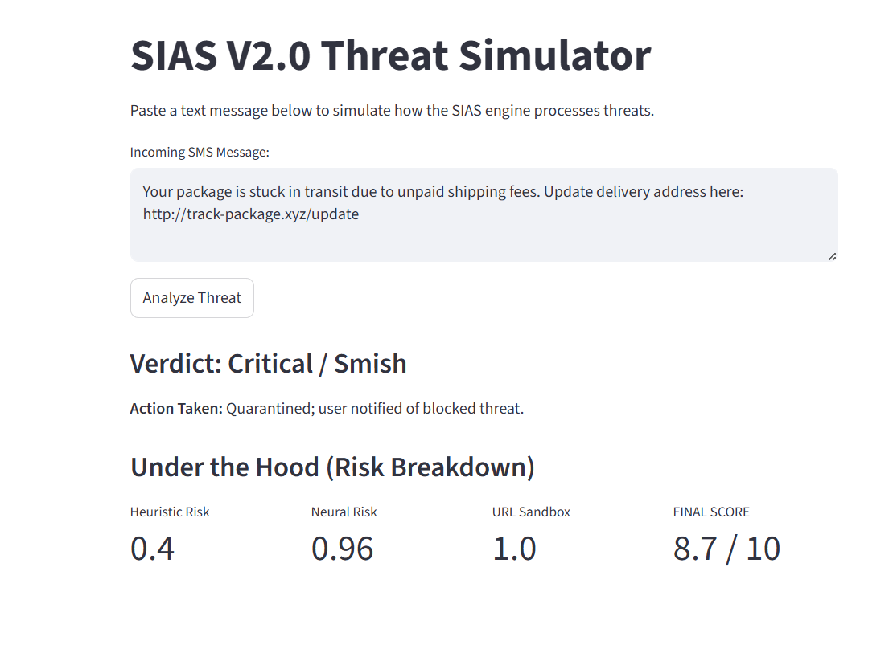Here is exactly how the system processed it under the hood:
- Heuristic Risk (0.4): The digital metal detector immediately caught that the link ended in .xyz. Real delivery companies like USPS or FedEx use .com. It flagged this as a mild technical risk.
- Neural Risk (0.96): The AI Brain read the words. It saw "stuck in transit," "unpaid," and "fees." It mathematically compared those words to the 74,000 messages it learned from and realized this has a 96% probability of being a scam based on the panicked tone alone.
- URL Sandbox (1.0): The system saw a web link, extracted it, and sent it to the mock cloud. The cloud recognized it as an unverified domain and gave it the maximum possible danger score (100%).
- FINAL SCORE (8.7 / 10): Because this message contained a link, my dynamic math rules kicked in. The system gave the URL Sandbox 50% of the voting power, the AI 30%, and the metal detector 20%.
- The Verdict: The final math resulted in an 8.7 out of 10. Because this is higher than a 7.0, the system officially classified it as Critical / Smish and took action to quarantine the message so the user would never accidentally click that link.
The system did exactly what it was designed to do, it caught the threat across all three layers.

