Murad Aliyev
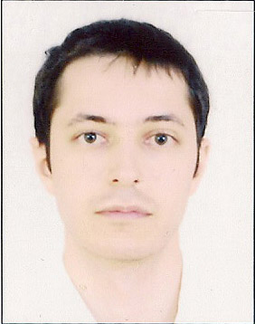

CONTACT INFORMATION:
Mobile: +994 (50) 672-01-57
Home phone: +99 (412) 492-55-76
E-mail: muradwu@gmail.com

PERSONAL INFORMATION

Age : 26
Birth date : 17 May, 1987
Resident of : Baku city, Republic of Azerbaijan
Citizenship : Republic of Azerbaijan
Nationality : Azerbaijanian
Marital status : Married

PROFESSIONAL EXPERIENCE:

01 – 30 June 2008 – Intern in “Mugan bank”
February – April 2009 – Intern in “AGBank”
30 November 2010– Present – Leading Accountant in “Azerenerji” OJSC (IFRS division)
Main responsibilities:
Review of accounting records
Preparation of Trial Balance
Preparation of Payables and Receivables reports
Monitor and perform daily financial and accounting records and assist in preparing financial statements in accordance with IFRS;
Reconcile all transactions and balances between group companies and make eliminating adjusting entries.
Analysis of statutory financial statements and accounting records;
Adjusting statutory accounting records to international standards;
Responsible for providing external auditors with any requested information and documents.

EDUCATION:

1994 - 2005 - Middle School №134, Baku, Azerbaijan

2005 - 2009 - Western University - Management – Bachelor.
2009 – 2012 - Azerbaijan State Economic University – Management – MBA.
2011 – Present – ACCA (F1, F3)

CERTIFICATES:
“Season of Financial Trainings” – by Qarant Invest (brokerage company)

Training on general banking certificate – by “AGBank”
“Universal” training courses – by “FOREX-AZ” (brokerage company)
ACCA F3

COMPUTER SKILLS:

Skill Level
MS Office (Excel, Word, Outlook etc.) Excellent
MS Windows Excellent
1C Excellent

LANGUAGES:

Language Level
Azeri (native) Excellent
Russian Excellent
English Advance

PERSONAL QUALITIES:

Well-organized, resourceful, reliable, work well under stress and pressure, driving for responsibility, results & improvement, take initiative and solve problems on my own, dynamic & extremely cheerful. No pernicious habits.

