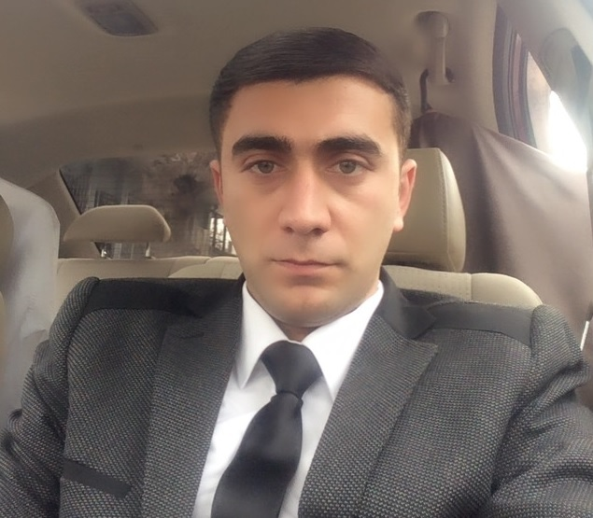
Nijat Salimov
PERSONAL INFORMATION
PERSONAL INFORMATION |  +994 55 835 88 13
PERSONAL INFORMATION |   salimov.n91@gmail.com
PERSONAL INFORMATION | Sex Male | Date of birth 11.03.1991 | Nationality Azerbaijani

WORK EXPERIENCE

2014- till now Tax inspector
Regional Tax Department №9
- Monitoring compliance with taxation legislation
- Control the flow of tax payments to the budget
- Conducting field tax inspection
- Verification of financial documents, accounting books, reports, cost estimates, etc..
- Forecasting and execution of annual and quarterly plans
- Application of financial sanctions to violators
- Preparation of protocols on administrative offenses

EDUCATION AND TRAINING

2007- 2011  2016 | Radio engineering and communications  Azerbaijan Technical University
2007- 2011  2016 | Taxes and Dues Seminar  The Ministry of Taxes (training)

PERSONAL SKILLS

Mother tongue(s) | Azeri
Other language(s) |  | Reading | Writing | Speaking
Other language(s) | Russian | excellent | excellent | excellent
 | English | good | good | weak
 | Turkish | good | good | good

Communication skills | - Knowledge of Tax legislation of Azerbaijan Republic  - Experienced in communicating with clients  - Experience of working with large volume of documents and information  - Strong problem-solving and analytical ability  - Negotiation skills on various levels of complexity

Organisational / managerial skills | - Highly organised; dynamic; excellent planning skills with great attention to detail and ability to prioritize work  - Accuracy and attention to detail

Computer skills | - Proficient user of Microsoft Office (Word, Excel, PowerPoint) developed through education and work experience

