CURRICULUM VITAE

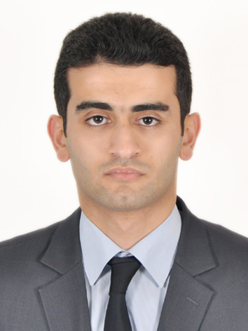
Name: Nihad
Surname: Akhundov

Patronymic: Nazim

Personal information:

Citizenship: Azerbaijan
City & country of residence: Baku, Azerbaijan
Date of birth: 09.01.1989

Contact Details:

Address: 36/3007, Tbilisi avenue, Baku, Azerbaijan
Mobil number: (+994 55) 657 49 17
Tel: 431 94 62
E-mail: nihad.akhundov@gmail.com

Work experience:

Employment: | Position | Period
“NEXIA EA LLC” member of Nexia International | Audit Assistant 3  (in-charge)  Job description:  - Auditing financial statements and other accounting records in accordance with International Standards of Auditing (ISA) and other applicable frameworks;  - Financial reporting in accordance with IFRS  - Preparation management letters regarding internal control weaknesses and proposed enhancements, irregularities identified during the audit, their implications and providing necessary recommendations;  - Performing audit planning, testing and financial reporting;  - Supervision audit staff at field work;  - Contacting and cooperating with client staff and representatives at all (top, mid, bottom labor) | 01 October, 2012 –  at present
“NEXIA EA LLC” member of Nexia International | Audit Assistant 2  (in-charge) | 01 July 2011 –  30 September 2012
“NEXIA EA LLC” member of Nexia International | Audit Assistant 1 | 10 February 2011 –  01 July 2011
SOCAR | Accounting experience – 2nd year probationer | 24 May 2010 –  21 June 2010
SOCAR | Accounting experience – 1st year probationer | 29 May 2009 –  24 June 2009

Education:

Education degree | Educational establishment | Speciality | Period
ACCA student | ACCA (Association of Chartered Certified Accountants) |  | 2012 – 2015 (expected)
Master degree | Azerbaijan State Economic University | Finance (MBA program; English section) | 2011 – 2013
Bachelor degree | Azerbaijan State Economic University | Accounting and audit | 2006 – 2010
School | Baku, Sabail district, School #190 |  | 1995 – 2006

Additional education:

Company name | Course name | Date
Lingva | General English – Upper intermediate level | March – May 2009
Headstart-International | Financial Accounting (ACCA F3) | February – June 2010
Headstart-International | TOEFL | January – May 2011
ACCA | F1 Accountant in Business – Exemption  F2 Management Accounting – Exemption  F3 Financial Accounting – Passed  F4 Corporate and Business Law – Exemption  F7 Financial Reporting – Passed | 2012 – 2015 (expected)

Language skills:

Languages | Speaking |  |  | Writing |  |  | Understanding
 | Fluent | Good | Fair | Fluent | Good | Fair | Fluent | Good | Fair
Azerbaijan | √ |  |  | √ |  |  | √
Russian |  | √ |  |  | √ |  | √
English | √ |  |  | √ |  |  | √

Computer skills:

- MS Office (Word; Excel; PowerPoint; Outlook)
- 1C accounting software

