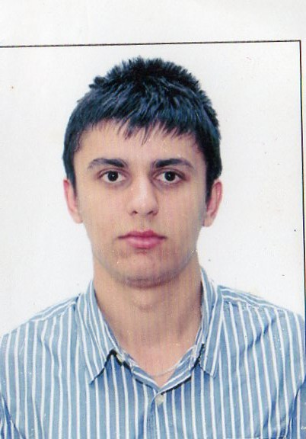
CV
Uzeyir Nabiyev
Baku, Nasimi district, Safaraliyeva 12.
Tel: (+99451) 887 77 66
(+99455) 580 00 64
Email: nabiyev.uzeyir@gmail.com

PERSONAL DETAILS
Nationality: Azerbaijani
Sex: Male
Place of birth: Azerbaijan, Baku
Date of birth: 22.05.1994
EDUCATION
2011-up to now Azerbaijan State Economic University
Special Talents Groups - Finance
Studies have given basic skills about finance, banking and accounting in
English.
University entrance point (TQDK) – 648
2001-2011 Baku school lisey with the number 252

ACHIVMENTS AND CERTIFICATES
06.11.2013- Member of “PWC Talents Club”
2013 Knowledge of Financial Accounting (ACCA F3)
2013 Knowledge of International Audit and Assurance(ACCA F8)

10.07.2013 - 26.07.2013 “Summer University” in Germany and Netherlands.
Several trainings at universities of Germany and Netherlands and in European Union Office.

25 June 2013 Diploma about completion 1 yearly ‘Azerbaijan Foresight’
Future Studies online course

30.05.2013 - 09.06.2013 Certificate about participation in the ‘Youth in Action’
Program called ‘Entepreneurship’ organized in Georgia.

07.05.2013 – 14.05.2013 Certificate about participation in the ‘Youth in Action’
Program called “Our shared village” in Georgia.
The project is about how to develop economy in rural areas.

27,28,29 November 2012 Certificate from Bank Standard
" Basics of the Stock market"
20,21,22 November 2012 Certificate from Bank Standard
"A detailed presentation of the Forex market"

November 2008- January 2009 Certificate about succesfull completion of “Microsoft Office
Programs” in Caspian Education Centre
Work Experience
- “Komtec” LTD
Period: 01.02.2014- up to date
Responsible for financial reporting
2.AEGEE-Bakı (European Students' Forum)
International Novruz Festival” supported by AEGEE and The Minstry of Youth and Sport
Period:19-25 March.2013
Responsible for organization of the project and translation

2.“Parabank ASC”
Period: 01 July- 15September 2012
Loan officer

SEMINARS, TRAININGS AND SOCIAL ACTIVITY
17.12.2013-20.12.2013 Trainings of “Basics of banking and the role of Central Bank
In the banking system” at the Central Bank of Azerbaijan.
31.10.2013-01.11.2013 Volunteer at “Baku International Humanitarian Forum”
30.05.2013 - 09.06.2013 Certificate about participation in the ‘Youth in Action’
Program called ‘Economic Law’ organized in Georgia.

07.05.2013 – 14.05.2013 Certificate about participation in the ‘Youth in Action’
Program called “Our shared village” in Georgia.
The project is about how to develop economy in rural areas.
November 2012 Certificate from ‘AIESEC’ Youth organization about
participation in the ‘Flame’ Conference

COMPUTER SKILLS
Microsoft Office (Word , Excel , PowerPoint )
LANGUAGE SKILLS
Azerbaijan (native), English (upper-intermediate), Turkish (advanced), Russian (pre-intermediate),German(beginner)
INTERESTS
Reading , riding bike ,swimming, football, travelling, participating in international projects.

