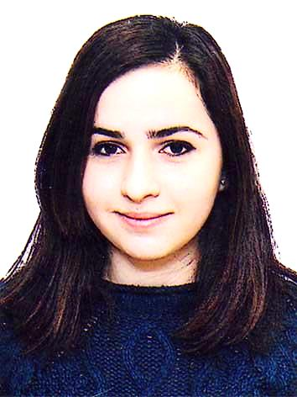
Gülmammadova Gunel

Personal information:
Date of birth: | 15.01.1993
Place of birth: | Baku
Address: | E.Topchubashov street h-12,m-86
Nationality: | Azerbaijani
Sex: | Female
Marital Status: | Single
Email: | gunel_gulmamedova@yahoo.com
Phone:  Mobile: | +994124409542  +994552464683

Education:
High school: | school#36 “Novruzov Brothers”
University: | Azerbaijan State Economic University (2010-2014)
Degree: | Bachelor
Qualification obtained: | Finance (In Azerbaijan) 2010-2011
 | Finance (Special Talented Group) (İn English) 2011-2014

Work experience:
Company: | FİNCA Azerbaijan
Department: | Marketing and Credit
Position: | Assistant intern
Term: | February- May 2013
Company: | Azerbaijan International Bank
Department: | Monitoring and Control
Position: | Summer internship program
Term: | July- August 2013
Company: | Bank of Baku
Department: | Operating and services, Finance
Position: | Summer internship program
Term: | May-July 2014

Academic achievements:
- 2010- was awarded Honorary Diploma from the high school
- 2010- University entrance examinations (TQDK 650 out of 700)
- 2012- Forex diploma (with the sponsorship of AR Finance Ministry and Garant Insurance)
- 2012- Honor Debate Certificate by IDEA Campaign
- 2013- “Youth Business Leadership Certificate by Junior Achievement (with the sponsorship of BP, USAİD and Am Cham)
• 2014- International English Languages Testing System (IELTS 6.5 out of 9)

Language skills:
Azerbaijan (Mother tongue) | Turkish (Good)
English (Fluent) | French (Elementary)

Computer skills: | MS Office ( Word, Excel, PowerPoint
 | Presentation), Photoshop CS5, İnternet Explorer

Other interests: | Cinematography, Dance (Latın)
 | Painting, Reading various articles.

