Curriculum Vitae

- Private Information 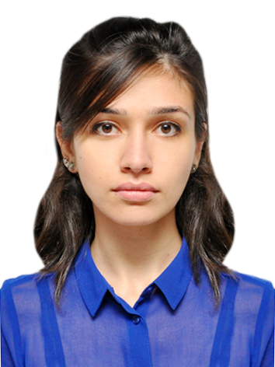

Name, surname, father’s name | Asmer Kazimova Arif
Date of birth | Baku, 02 April 1991
Nationality | Azerbaijani
Gender | female
Family status | single
Address | Baku, H.Aslanov 0025
Telephone no: | +994 (012) 478-85-29  +994 (051) 874-14-13
E-mail: | asmer.kazimova@gmail.com

II. Education
 | School / University | Faculty | Period
First school | The 84th secondary school |  | 1997-2008
High school | Azerbaijan State Economic University | General economics  Accounting and Audit | 2008-2012

III. Work Experience
Company name : “Smart Audit” LLC
Job title : Accountant
Period : 11.06.2012-on going

The main duties and responsibilities are as follows:
- Preparing of tax declorations (VAT, Withholding tax, Simplified tax, Road tax, Profit tax, Property Tax) ;
- Make the report on Debitors & Creditors;
- Tax calculations;
- Provide weekly or monthly outstanding and paid invoices reports as required by Clients;
- Making accounting journals for invoices, tax invoices, salaries, bank statements & etc. in 1C;
- Preparing of invoices & bank payment orders (also by Internet banking).

IV. Additional Qualifications (trainings & knowledge)
Trainig name | Organizer
“AIESEC Career Workshop” | AIESEC Azerbaijan
“CV & Interview” | BLBS
Financial Accounting (ACCA Paper F3)
Management Accounting (ACCA Paper F2)

V. Language Skills
 | reading |  |  | writing |  |  | speaking
 | low | good | excellent | low | good | excellent | low | good | excellent
Azerbaijani |  |  | + |  |  | + |  |  | +
English |  |  | + |  |  | + |  |  | +
Turkish |  |  | + |  | + |  |  | +
Russian |  |  | + |  | + |  |  | +

VI. Computer skills
programs | very good | good | low
Program 1C | +
Windows System | +
Microsoft office Word | +
Microsoft office Excel | +
Outlook | +

VII. Other skills and abilities
Hobby and interests | Swimming, psychology, intellectual games, National Geographic (TV & website), karaoke

