First Name: Ilgar 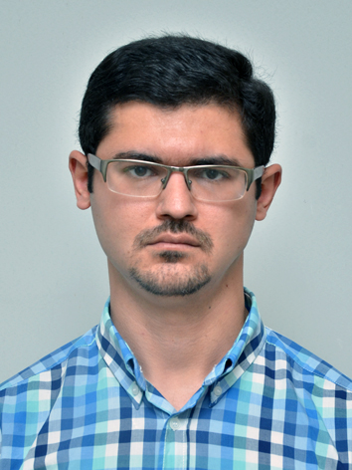

Last Name: Mursaguluyev

Patronymic: Shakir og.

Date of Birth: 23.11.1984

Marital Status: Single

E-mail: ilgarmsh@gmail.com

Address: Gara-Garayev str. 80, apt. 23, Baku, Azerbaijan

Phone Number: (+99412) 323-8772, (+99450) 427-1697

Education:
- Azerbaijan State Economic University
Faculty: Finance and Credit
From: 2001
To: 2005
Degree: Bachelor
- Azerbaijan State Economic University
Faculty: Finance and Credit
From: 2005
To: 2007
Degree: Master’s
- “Khazar” University
Faculty: Financial Accounting
From: February 2007
To: June 2007
Degree: Certificate
- Chichester High School, USA
Faculty: High School Education
From: 2001
To: 2002
Degree: Diploma

Work Experience:

- Relief International
Position: Global Roving Finance Officer
From: October 2010
To: June 2014
Responsibilities: Reviews monthly financial reports from RI oversee offices. Checks coding of field monthly transactions and ensures timely consolidation of these transactions into RI Consolidated Books in Sun system or Consolidated UK QB. Check Cash and Bank accounts reconciliation prepared by the field offices. Prepare and check up the budgets, analyze it and prepare the allocation for the funds. Assist the field offices due to auditing. Enrolled in US and UK audit preparation mission in South Sudan, successfully substituted Finance Manager for a period of time in South Sudan and Kenya

- Hydrolink Caspian Ltd.
Position: Assistant of the Financial Controller – Caspian Region
From: 2009
To: 2010
Responsibilities: Preparing the budget of the company, preparing the Balance sheet and the income statement of the company, Stock checking, preparing the cash flow of the company, analyzing and optimizing money transfers to the suppliers, analyzing the payments for the sold goods, equipment and spare parts, cooperation with the State Customs

- AZEL “Azerbaijan Electronics” CJSC
Position: Deputy Finance Manager
From: 2008
To: 2009
Responsibilities: Preparation of the budget for the company, preparation of the Balance sheet and the income statements of the company, preparation all the necessary reports for the International Financial Corporation, preparation of all the necessary documents for banks and all other financial organizations, analyzing the financial stability of the company, preparation of all the necessary documents for the National Deposit Center for registration and further reviewing of the stocks of the company.

- DNS Computer’s
Position: Assistant of Head of Financial Department
From: 2007
To: 2008
Responsibilities: Accounting clearance between the suppliers and the company, preparation of balance sheet and income statements of the company’s financial activity.

- Caspian International Broking
Position: Insurance Broker
From: 2005
To: 2006
Responsibilities: Looking for new customers, analyze the risk; prepare all the necessary documents for issuing the insurance policy.

Languages:

- Russian:
Reading: Excellent
Writing: Excellent
Speaking: Excellent
Understanding: Excellent
- English:
Reading: Excellent
Writing: Excellent
Speaking: Excellent
Understanding: Excellent
- Azerbaijani:
Reading: Excellent
Writing: Excellent
Speaking: Excellent
Understanding: Excellent
- Turkish:
Reading: Intermediate
Writing: Basic
Speaking: Intermediate
Understanding: Intermediate

Participation in Special Activities: Business Case Competition held by MBA and USAID, Ecotourism Presentation held by the University of Tourism – The economical impact of ecotourism on the economics of Azerbaijan Republic, Ecotourism Presentation held by the University of Tourism – The economical impact of alternative types of tourism on the economics of Azerbaijan Republic.

Computer Skills: Windows XP, Word, Excel, NETSIS, QuickBooks 2002, QuickBooks Enterprise Solutions Non-Profit Organization, SUN systems.

Personal Abilities: Strong interpersonal skills very well organized and detailed oriented. Have an ability to handle multiple tasks and work on busy schedule. Self motivated. Have an ability to work independently and with little to no supervision. Have an ability to plan and effectively manage complex, long-term projects. Have an ability to work as a team player on multiple projects. Have an ability to prioritize and organize work. Have strong analytical and research skills.

