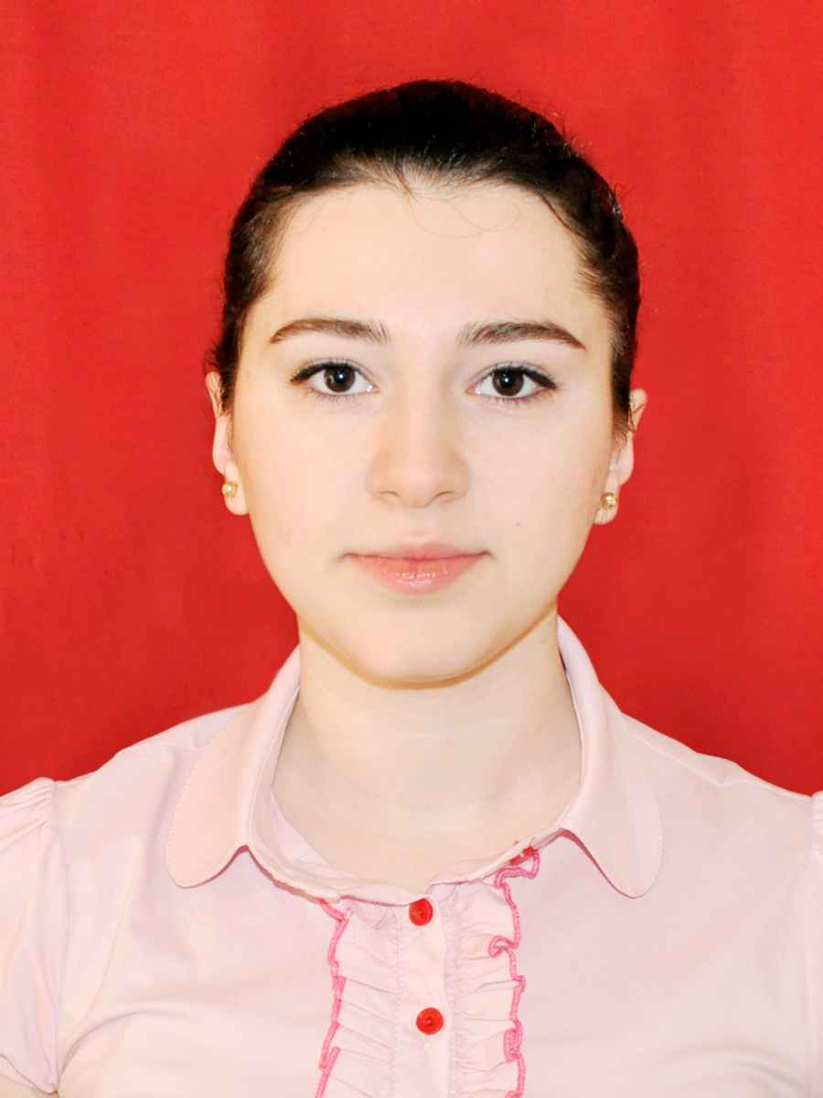 Address: Azerbaijan. Baku.
30 Abilov Street, door 1a.
Tel: 994 12 379 34 71
GSM: 994 55 713 69 09
e-mail: mustafayeva.narmin@gmail.com

Narmin N. Mustafayeva /1991/

Education:
2014- ____ Azerbaijan State Economic University. Financial control and
Auditing. Master degree.
  - Azerbaijan State Economic University. Accounting and
Auditing. Bachelor degree.

Trainings/cources and events:
ACCA F1 Accounting in Business (exemption)
ACCA F2 Management Accounting (exemption)
ACCA F3 Financial Accounting (72% - Pass) / 2015
ACCA F4 Corporate and Business Law (exemption)

The National Certificate In Financial Accounting (International Fundamentals)
(GRBS 2013)

“IV Youth Career School” (DVC 2012) ;
“Debate training cource”
“Body language training”
“Oratory Masterclass”
“Career planning”
“How to start a business”

2012 “X ASEU Debate forum” Committee Chair of Judges.
2012 “Azerbaijan Youth Debate Forum” Champion and II best speaker.
2012 “III Azerbaijan ASEU Open Debate Tournament” Champion and best X speaker.
2011 “Baku Open Debate Tournament – 2011 Summer forum” Finalist and II best speaker.
2011 “VIII ASEU Debate forum” VIII best speaker.

Computer skills:
Windows, MS Office (MS Word, MS Excel, MS PowerPoint, Outlook Express)

Language skills:
Azeri (native) , English (IELTS 6.5) , Russian (excellent) ,Turkish (excellent)

Personal skills:
Able to work with supervision in a busy and stressful environment, independent learning, ability of working with team, self motivation.

Hobbies:
Playing the guitar and piano, watching movies.

