PERSONAL INFORMATION | Nazarov Mushvig
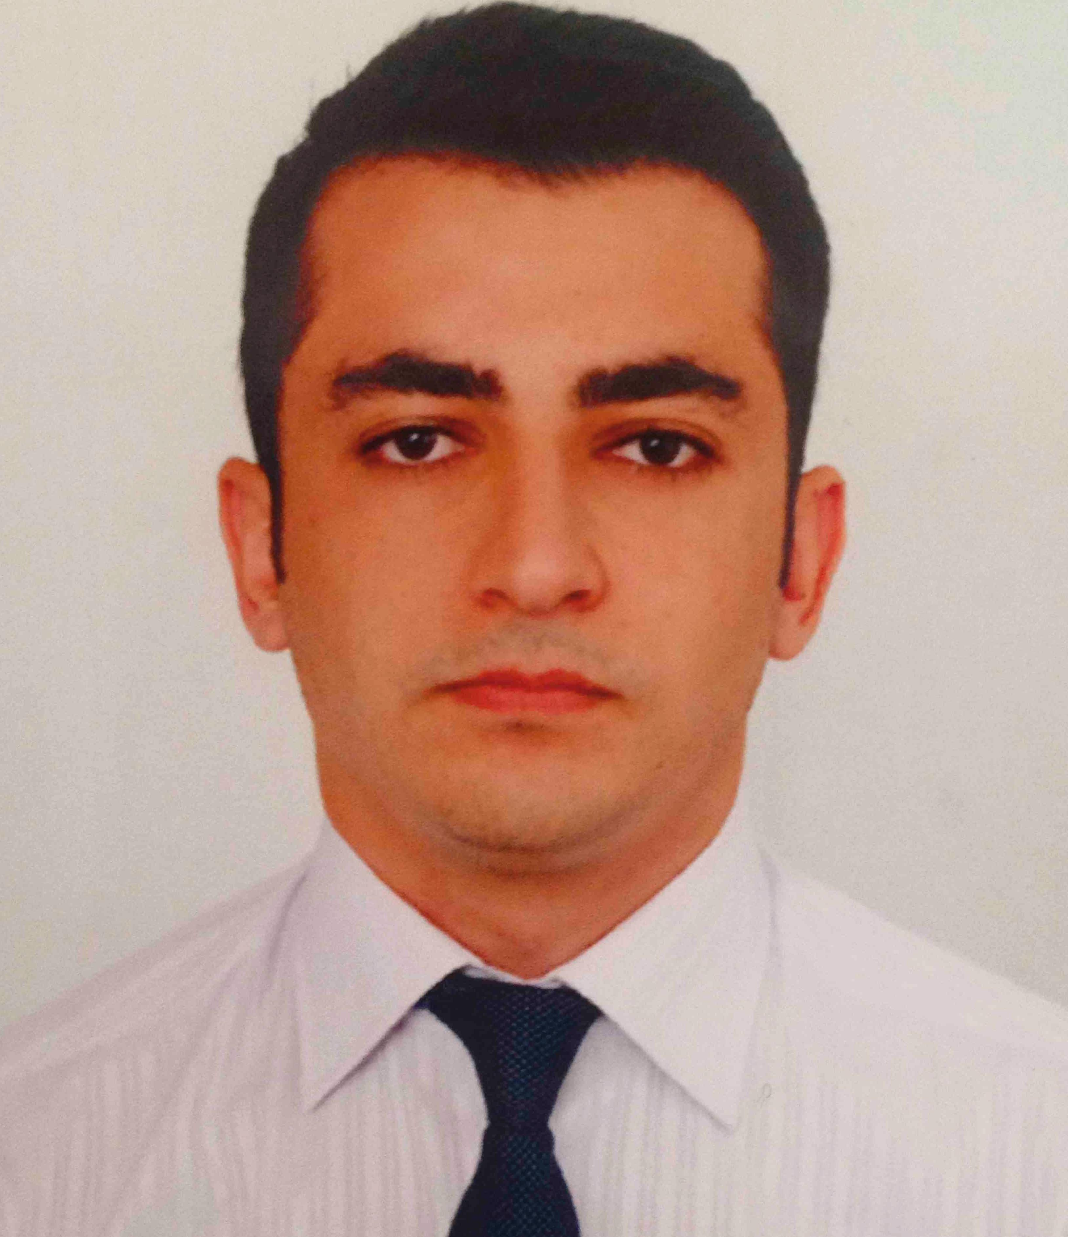 |   Hasan Aliyev str, Baku (Azerbaijan)

+994559190444

mushvign@gmail.com

http://www.linkedin.com/profile/view?id=162103427&trk=tab_pro

Skype mushvig17
 | Sex Male | Date of birth 17 April 1991 | Nationality Azerbaijani

WORK EXPERIENCE

13 August 2012 – 14 September 2012 | Intern
13 August 2012 – 14 September 2012 | Bank Respublika  http://bankrespublika.az
13 August 2012 – 14 September 2012 | Collecting daily transfers and making report using software with regards to cash collected;  Handling the credit account of different clients;  Data entry of daily cash transactions

17/06/2011 – 30/08/2011 | Finance Assistant
17/06/2011 – 30/08/2011 | Tuninguae  http://www.tuninguae.com/
17/06/2011 – 30/08/2011 | Surveying the record, statements and preparing report;  Estimate value of a variable at some future point and analyze decision making and planning in the future;  Prepare research report on new technologies and update company financial statements

EDUCATION AND TRAINING

27 September 2010 – 29 January 2013 | Bachelor of Banking and Finance
27 September 2010 – 29 January 2013 | Eastern Mediterranean University,
27 September 2010 – 29 January 2013 | AIESEC Eastern Mediterranean Member 2010-2011 Term;  Stock and Exchange Club Member 2010-2013 Term;

10 April 2010 – 17 April 2010 | Certificate
10 April 2010 – 17 April 2010 | Educon Academy and Consultancy agency,
10 April 2010 – 17 April 2010 | International Trade

10 Mar 11 – 10 Mar 11 | Certificate
10 Mar 11 – 10 Mar 11 | Academy education and consulting,
10 Mar 11 – 10 Mar 11 | Leadership and Management

18 March 2011 | Certificate
18 March 2011 | Eastern Mediterranean International office,
18 March 2011 | Personal Business skills

11 April 2011 | Certificate
11 April 2011 | IEEE and EMU,
11 April 2011 | Entrepreneurship Days:  Vodafone, Microsoft, Cisco lectures

13 April 2011 – 15 April 2011 | Conference
13 April 2011 – 15 April 2011 | Department of Banking and Finance at Eastern Mediterranean University,
13 April 2011 – 15 April 2011 | The First International Conference on Banking and Finance Perspectives (ICBFP`2011) provides a platform for academicians, practitioners, and researchers to present research and stimulate discussions on new trends in banking and finance.

PERSONAL SKILLS

Mother tongue(s) | Azerbaijani
Other language(s) | UNDERSTANDING |  | SPEAKING |  | WRITING
Other language(s) | Listening | Reading | Spoken interaction | Spoken production
English | C1 | C2 | C1 | C2 | C2
Russian | C1 | C2 | C1 | C1 | C1
Turkish | C2 | C2 | C2 | C2 | C2
Levels: A1/A2: Basic user - B1/B2: Independent user - C1/C2: Proficient user
Common European Framework of Reference for Languages

Communication skills | Team spirit;  - Good ability to adapt to multicultural environments, gained through my work experience abroad;  - Good communication skills gained through my experience as Finance manager.

Organisational / managerial skills | Leadership and team skills,  Communication and interpersonal skills,  Organizational and management skills,  Research skills

Job-related skills | Good command of quality control processes

Computer skills | Good command of Microsoft Office™ tools (Word™, Excel™ and PowerPoint™);  Working on Mac  Web building skills

Other skills | Tennis, Football, Horse-riding, Volley-ball and Traveling, Positions of responsibility in voluntary organizations;

Driving licence | BC

