ORKHAN SEYIDZADE
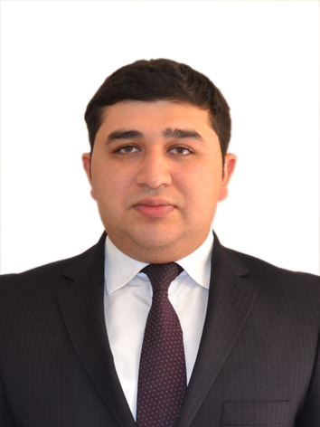

Mobile : +994 50 5810099
E-mail :orxanseyidzade2990@gmail.com
EDUCATION
Qafqaz University | Baku , Azerbaijan
Economics and Management ( Finance Credit ) | September 2007 – July 2012
Graduated with Diplom ( GPA 73% )
Core Courses: Finance , Micro and Macro Economics , Accounting Corporate Finance , Marketing, Economics,

PROFESSIONAL EXPERIENCE

MINISTRY OF EDUCATION
REPUBLIC OF AZERBAIJAN
Department of Finance Baku, Azerbaijan
Accountant February 2017- Present

MINISTRY OF LABOUR AND SOCIAL PROTECTION
OF POPULATION OF THE REPUBLIC OF AZERBAIJAN
State Employment Service Baku, Azerbaijan
Leading Specialist November- December 2016

STATE SOCIAL PROTECTION FUND
NERIMANOV DİSTRİC BRANCH
Head of personal account sector Baku, Azerbaijan
June 2015-July 2016 (reduction)

STATE SOCIAL PROTECTION FUND
Department of Forecasting
Leading Specialist
Baku , Azerbaijan
November 2014 – June 2015
Doing research about pension systems Gathering statistic information

Application of Twinning project of EU in Azerbaijan

Application of World Bank’s PROST model in Azerbaijan To analyze and plan budget draft of SPPF for next year

Access Bank ASC
Department of Business Credits Baku , Azerbaijan
Training Loan Officer
November 2013 – January 2014

Visiting costumers, analyzing costumers’ business and business stability To calculate costumers’ incomes , expenses and other financial ratios

To determine the amount of credit to be given

SKILLS AND QUALIFICATIONS

Social skills and abilities: Ability to work with the team
Ease of adaptation to different social situations

Organizational skills and abilities: Leadership, Management and documentation

Technical Skills • Microsoft Word
• Microsoft Excel
• Microsoft Power Point
• Microsoft Outlook
• Photoshop (Basic)
• CorelDraw (Basic)

Languages • Azerbaijani (Native)
• English (Fluent)
• Russian (Average)
• Turkish (Fluent)

MISCELLANEOUS
Exams |  | IELTS: Listening: 6.5, Reading: 5.5, Writing 5.0, Speaking 6.0
Hobbies |  | - Books, Journal, Reading, Psychology, Sports, Music, The internet and intellectual competitions, Football, Tennis
Nationality |  | Azerbaijani
Date of birth |  | 06/08/1990
Gender |  | Male

