Personal information |  |  | 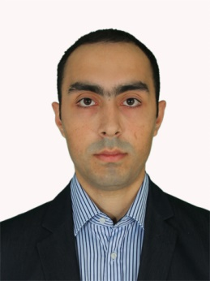
Last name | Abbasov | Marital status | Single
First name | Rashad | Speciality | Risk Management specialist
Father’s name | Qurban | Adress | Baku, 6th Microdistrict, 4 İ.Cumshudov str, apt 2
Date of birth | 20.03.1991 | Phone | (012) 569 10 28  (055) 242 22 27
Place of birth | Baku | e-mail R.Abbasov642@gmail.com

Education

University | Period | Faculty | Degree | №
Azerbaijan State Economic University | 2008-2012 | Finance Credit | Bachelour | 250381
Azerbaijan State Economic University | 2013-2015 | MBA-Finance  (English sector) | Master- last term

Experience

Employer | Position | Period
Bank Respublika OJSC | Risk Management Department  Specialist | 1 October 2014 -till now
Job duties: anti-money laundering, insurance (all matters), preparation and monitoring of bank’s daily liquidity ratios, monitoring of deposit portfolio, quarterly reports for Supervisory Board, controling of all users and roles of programs within bank, operation risks.

Language skills

 | Reading | Writing | Speaking | Understanding
Azerbaijan | Perfect | Perfect | Perfect | Perfect
English | IELTS - 7 | IELTS – 6.5 | IELTS – 5.5 | IELTS – 6.5
Russian | Normal | Normal | Normal | Normal

Computer knowledge and skills

Computer programs | Perfect | Good | Sufficient | Non-sufficient
Microsoft Office Programs | +
Internet | +
Some bank programs  (confidential) | +

Military Status

Military duty | №
Completed (1 July 2012 - 1 July 2013) | SX№ 0020171

Qualifications and Trainings

IELTS | Listening | Writing | Speaking | Reading | OVERALL
12 April 2014 | 6.5 | 6.5 | 5.5 | 7.0 | 6.5

General Banking Sertification Program
Training Center | Topics | Period | Result
Azerbaijan Bank Training Center | 1. National legisligation about Banking  2. Bank services and products  3. Principles of Accounting and Credit  4. Marketing and Customer service  5. Bank risks  6. Business ethics and Logic | 13 October 2014 - 29 April 2015 | Success  Overall - 91%  1st place  (Serial № 23030)

ACCA F3 – passed (16.07.2015)

