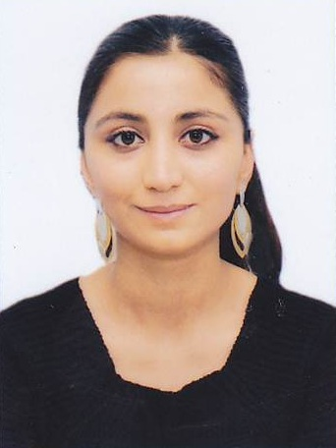 | Turkan Nabili Yunis |  |  | Phone:  (cell): +99455 993 96 67  (cell):+994 51 477 13 78  E-mail:  turkan_nabizade@hotmail.com  Linkedin: TurkanNabili
Personal Information
Gender: Female
Nationality: Azerbaijani
Age:23
Birth Date: 01.03.1991
Marital status: Single
Languages: Azerbaijani (native), English (fluent), Turkish (fluent),Russian(good),French(basic)

Education
International University in Geneva  November 2012- December 2013  Geneva, Switzerland  URL: http://www.iun.ch  Qafqaz University  September 2008 - July 2012  Baku, Azerbaijan  URL:http://www.qu.edu.az  E-mail:info@qu.edu.az |  | Master degree  Master of Business Administration  Bachelor Degree (Honors Degree)  Faculty: Economics and Administrative Sciences  Specialty: Finance and Credit
Technical Summary
- MS-Office: Word, Excel, Power Point, Access
- E-views (econometric): Good user of E- views
- Logo (Program for Accounting)
- 1C,8.0th version (Program for Accounting)
-F3 program(financial accounting program)
-SAP program
Work experience

Association of Football Federations of Azerbaijan Financial expert
(January 07 2014-----present)

Internship
July 05-August5 ,2010  Bank Asya  Address: KüçüksuCad.AkçakocaSokak  N:6 Ümraniye 34768 İSTANBUL  Tel:0216 633 50 00  Faks:0216 633 50 50  July 05-August 05,2011  AzerTurk Bank  Address:İslamSafarli str.5  Tel.: +994 (12) 497-43-16/17/18/19  Faks: +994 (12) 598-37-02 |  |  | Department: Accounting  Department: Credit, Customer Services
Honors and Rewards

2008 - 2012 |  |  | 1. Certificate for the best Educational Project of the SIFE 2008 Contest (As a member of team)  2. 3rd place in National Championship on Student in free entrepreneurship (SIFE) contest. Our SIFE team project; named “AZmarketinq support to business" was nominated the “Best Project on Business” among other business projects of different universities in 2008 SIFE contest.  3. Certificate for the best Online Project of the SIFE 2009 Contest (As a member of team)
Training and seminars
2008-2012 |  |  | 1. Participant of SIFE (“Students in Free Enterprise”) -international programme amongst university students in 2009  2.Awarded with the Appreciation certificate by Business intelligence LTD and Azerbaijan Quality Association on the conference ‘’From creative ideas to Effective management”’, world known trainer and Guru Dr. Gregory H. Watson.  3. One of the participants of the certificate program named “Global Business Strategies” organized by Qafqaz University (May, 2011)  4.One of the participants of the certificate program named “Global Logistics and Supply Chain”  5.Certificate for the “Banking principles and role of the Central Bank in banking system”-By Central Bank of Azerbaijan
Community Services In University |  |  | A member of SIFE (Students In Free Enterprise) at Qafqaz University from 2008 to 2010. SIFE is an International Student Program which gives a chance to students to prepare creative and innovational projects on Commercial, Educational and Social spheres.
Personal Characteristics |  |  | Creative in project storming, communicative, striving to best, open to experience, extroverted, Flexible and Sociable,
Interests |  |  | Volleyball, reading and travelling
Interested Majors |  |  | Key majors: Finance, Accounting,Risk Management, Corporate Financial Management  Minor majors: Operations Management, Tourism management, International Trade
References |  |  | AzizovMayis  Assoc.PROF.at the Azerbaijan Qafqaz University (www.qu.edu.az)  Cell(Aze): +994 55 6210445  E-mail: mezizov@qu.edu.az  PhD. ABUTALIBOV Rasim  General Director of Azmarketinq LLC (www.azmarketinq.com)  Cell (Aze): +994 55 6449247  E-mail: azeraz2002@yahoo.com

