Ulvi Badirkhanov
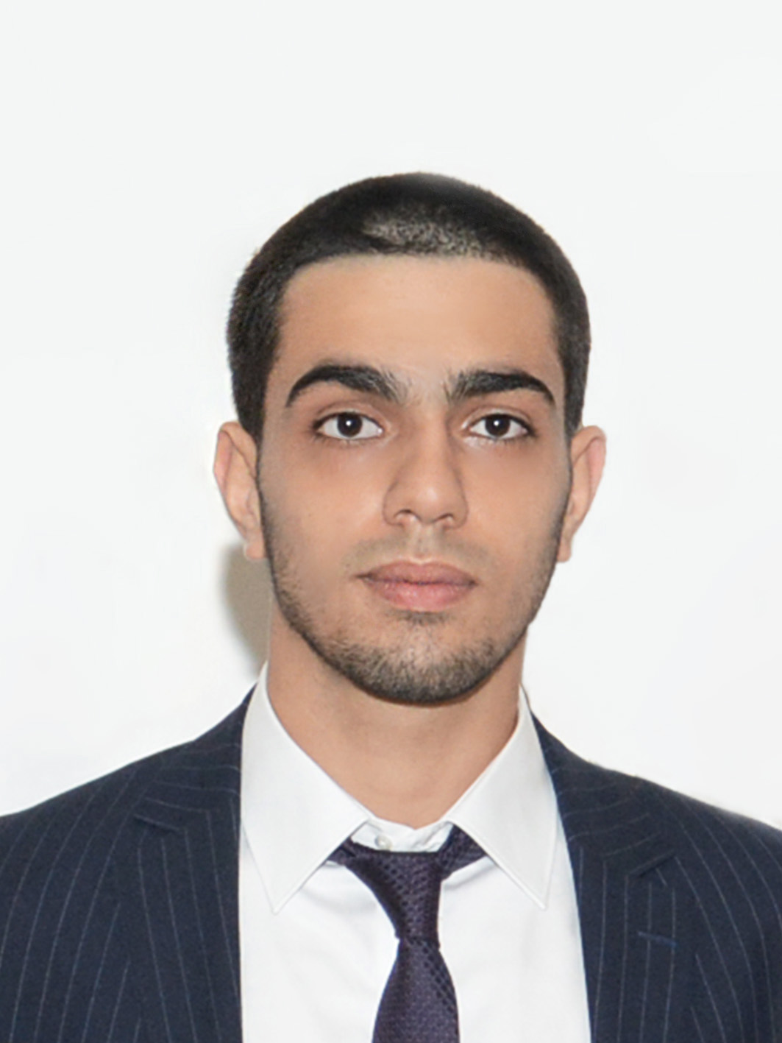
Alesker Alekberov str, build 12, Apt 12, Baku AZ 1073, Azerbaijan
(50)750 26 06, (12)539 33 85, ubadirkhanov@mail.ru

Work Experience

Assistant of Chief Accountant 01/03/2014-present
“Shafa” medical center, Baku, Azerbaijan
Handling the tasks of updating and ensuring accurate registration of all daily transactions. Maintaining accounting records by filing documents, reconciliation of bank statements by comparing with general ledger, verifying and top up bank deposits and bank payments, reconcile with bank records. Maintaining accounting databases by entering data into the system, reconciliation of all accounting documents such an invoices, billings, employee reimbursements, cash receipts, vendor statements, journal vouchers and etc.

Internship in Treasure Department
Treasure Dept #12, Baku, Azerbaijan 06/2013-07/2013
Kept cashbooks up to date, balanced daily cash flow, matched the sequence of entries in the cashbook with the sequence of receipts and payments.

Education

Azerbaijan State Economic University
Bachelor’s degree, faculty of Finance 09/2010-05/2014

Baku European Lyceum
GPA 4.50 (out of 5.0), Honor Student 09/1999- 05/2010

Trainings and Courses
Excel- Galaxy Education Center
English (advanced level finished) – ILC
French –Lingua Franca
Association of Certified Chartered Accountant (F3-Financial accounting) – GRBS preparation courses

Computer and Language Skills
Working experience with MS Office (Word, Excel, PowerPoint), Photoshop, Internet explorer.

Languages
Fluent in Azeri (native), English, Russian, Turkish, with dictionary in French

