Curriculum Vitae
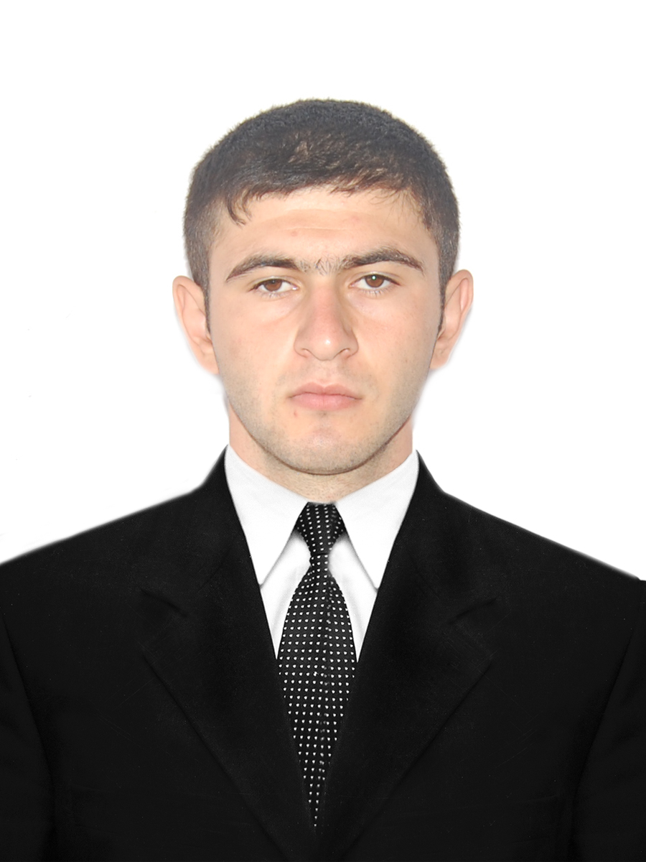

First name / Surname: Lachin Kamilov

Birth date and place 24.05.1992. Azerbaijan, Shabran

Gender: male
Nationality: Azerbaijani
Address: Xirdalan city. A.Shafiyev st.
Mobile: (050) 581-50-16
E-male: kamilovlachin@gmail.com

Education:

School | Major | Entrance score | Dates | Level
Azerbaijan State University of Economics | Finance | 640 | 2009-2013 | Bachelor of Finance
Azerbaijan State University of Economics | Accounting and audit | 94 | 2013-2015 | MS

Computer skills:

Programs | Low | Medium | High
Microsoft Office |  |  | ☑
BTP, B1, B3 |  |  | ☑
Uyumsoft ERP(HR Module) |  |  | ☑
1C ERP (8.2, 7.7) |  |  | ☑
Smart bank | ☑

Personal qualities:

  - Communication skill.
  - Team player skills
  - Attention to detail
  - Enthusiasm and personal drive
  - Willing to learn
  - Self-motivated
  - Proactive and systematic

Trainings and forms

Organizer and/or trainer | Name of Training | Topic
Junior Achievement Azerbaijan | Business Ethics | Global ethic rules
Junior Achievement Azerbaijan | Success skills | Practicing of success skills
Djabrail Valiyev | Marketing analysis | PESTLE (STEPLE)  BCG and ABC
Parabank OJSC | Banking | *Management of Bank actives  *Management of Personal
Samir Balayev  Unibank | Legal Control In Banking | Bank legislation
Pəarviz Guliyev  Expert of ABTC | Internal Control Systems and internal audit | Principles of Internal control
ALLIANZ CONSULT | Management | Motivation, Change management and strategic managing
Irada Mikayilova  (VF Azercredit, trainer) | HSE | ISO based HSE
Khayal Mammadxanlı | Insurance | Base of Insurance law
Nigar Sadigova  Junior Specialist in Bank BTB | ACCA F3 | Financial Accounting
Mr. Gonzalo Garland  PhD Candidate in Economics, University of Pennsylvania | “Emerging Markets and Diversification of Economy” | Diversification of Economy
Farid Sattarov  Director of Qarant invest brokerage company | Season of Financial trainings | Financial Markets and Financial Instruments
İn-forex brokerage company | Forex | Forex and analyse
MSA | General Office Hazards. | General Office Hazards.

Languages:

Languages: | Azerbaijani | English | Russian
Levels | Advanced | Upper Intermediate | Elementary
Work Experience:

Organization | Dates | Position and job description
Nexia EA LLC  Audit and consulting | 12.03.2014 | Tax Consultant/ Accountat  - Dealing with ERP (1C 8.2)  - Payroll processing (Sick leave, social leave and others)  - Tax auditing  - Statutory accounting of day-to-day transactions.  - Managing good communications with clients.  - Preparing Trial Balance.  - Preparing Managerial Accounting Reports  - Conducting Cash Book.  - Preparing reports (Tax, SSPF and others).
Puls-R LLC | 12.06.13- 31.01.2014 | Consultant assistant  - Preparing HR manuals  - Conducting Performance Appraisal  - Assessment of training needs  - Preparing Project reports  - Basic accounting works (Preparing payment orders, different report to the state authorities)  - Recruiting interns.  - Selection of trainers.  - Conducting”Mystery Shopper” surveys and preparing reports.
Puls-R LLC. Business and HR Consulting company | 18.02.2013- | Intern on behalf of Youth Business Leadership Project supported by BP, AMCHAM and Junior Achievement Azerbaijan  - Assessment of employees of customer companies  - Preparing motivation proposals (programs) for customer companies  - Translating documents  - Preparing job instructions for employs of customer companies
World Vision fond AzerCredit Non-bank credit organization | 15.10.2012- 25.12.2012 | Volunteer in HR department  - Assist with conduct staff satisfaction survey and analyzing of results  - Technical support to staff testing for Grading system and recruitment  - Assist in documentation of sick leave and sick pay  - Data entrance (Uyumsoft programme)  - Technical support in organizing of internal trainings  - Technical support to “Staff retreat” events
Agrarcredit  non-bank  credit  organization | 06.07.2012-04.08.2012 | Intern (accounting and credit departments)  - Assist with preparation of Clients’ Business plans  - Participating in Monitoring of credits  - Data entrance (Smart Bank programme)

Reference:
- Asif Nasibov , Director, Puls-R LLC. Contact: 0503154469.

