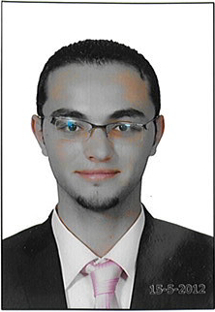
Ahmed Tawfeeq
ahmed_croko@yahoo.com
0546758686
Personal information:

- Date of Birth : 05/06/1990
- Nationality : Egyptian and Palastinian.
- Martial status : Single.
- Iqama : Transfebal.
Career Objective:
  - To work as accountant in a reputable company, which improve my skills and satisfy my ambitious

Education:

  - B.sc. in accounting, Faculty of Business Administration and international Marketing Sinai University 2012.
  - Grade: Excellent
  - GPA: 3.71/4
Experiences:
IN Egypt:
One Year in El Salam Contracting Company
IN KSA:
From 1 May 2014 till now in Zayad Al Habib for contracting (Part Time)
10 months in MMS Arabia {Marketing Services}
Qualifications:

- Ability to work under pressure.
- Effective communication.
- Good analytic and problem solving skills
- Team work oriented
- Positive attitude for learning & continuous development.
- Time management.

Languages:

- Arabic: Mother Language.
- English: Written and Spoken.

Computer Skills:

- Windows OS Handling and Troubleshooting
- Microsoft Office
- Excellent Internet Research Skills

Documents Available Upon Requested

