Mustafayeva Aysan 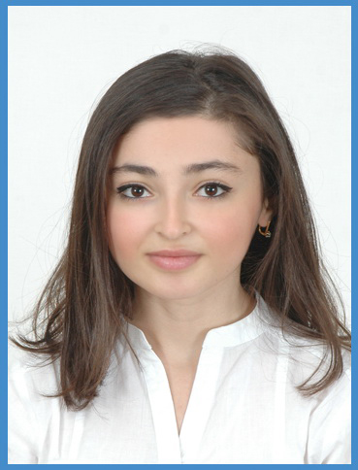
Address: 96A.,Academician Hasan Aliyev St.,
apartment 19.,Baku ,Azerbaijan

E-mail: : aysanka@live.com

Telephone: (+994 12) 502-26-56
(+994 70) 308-45-65

Personal Information:
Date of birth: June 21, 1990
Marital status: single
Nationality: Azerbaijanian

Objectives:
- To create my own career, improve knowledge and move ahead;
- To use my special knowledge and professional experience in a corresponding sphere to full potential.

Summary of qualifications:

- Ability to quickly acquire new knowledge and skills and apply it in daily work activities.
✓ Ability to operationalize strategic planning into day-to-day operations.                    
✓ Ability to eliminate conflicts emerging during joint activities and establish firm peace.

Work Experience:
Worked in insurance agency “Qarant Sığorta ASC” during my university
1 month of practise in “European Tobacco Baku”

Brand-manager “SHAKH” company

6 month of practice in Bank Respublika

Manager – Sino Tour LLC

Education:
Lyceum № 43, Baku September 1996 - May 2007
Azerbaijan State Economic University
The faculty of commerce (Management of economic resources) – Logistics (2007-2011)

KET – 87% (passed with merit )
IELTS – score 6,5

Professional Skills:
Software: Windows XP, Microsoft Word, Excel, Power Point, Internet Explorer, Internet and
e-mail applications, Outlook Express.

Languages:

Russian, Azeri (native), English and Turkish.

Personal Skills:
Responsible and hard-working person, good decision making, communicational and interpersonal skills.

Other skills occupations:

Computer skills for user, music, dancing, psychology, sports ( aerobics, badminton ), tourism,
drawing, knitting, the fan of documentary films & policy, to get new dialogue with competent &
educated people.

Motto:

If you cannot change the situation, change your attitude towards it and the situation definitely
will change by itself.

NOTE: I graduated from the university and school russian language.

