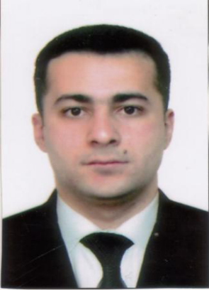
Nazim Qasimov Akif
Date of birth : 25/11/1983 Place of birth : Baku city, Azerbaijan mob : (+ 99470)8060280 e-mail: nazimgasimov83@mail.ru Nationality: Azerbaijan.
Education: Secondary school №20 (25may2000)
Azerbaijan State University of Economics ( 25 jully2004)
Specialty: Economics of trade and marketing.

Experience: 4) Rapid Solution LLC, (13.01.2014-13.02.2014)
Position: Project Coordinator.
Activities and responsibilities:
Time sheet keeping in ERP.
• Register and Control Annual Leaves (Sick, Educational & etc.)
• Checking time sheets of engineering team, generate job sheets and sending them for client’s approval,
• Approved time-sheets / job sheets evaluating and sending for invoicing.
• Use project scheduling and control tools to monitor projects plans, work hours, budgets and expenditures
• Communicate ideas for improving company processes with a positive and constructive attitude, and for developing this attitude in others
• Keep the Project Manager (PM) and others informed about project status and issues that may impact client relations
• Delivered presentation to company employees on ERP improvements, to align them with changes.
• Ensure clients’ needs are met in a timely and cost effective manner.
3) RIFENG. (2008-2013)
Supply Chain or Operation
Activities and responsibilities:
- Making estimates of required deliverables for the project
- Monitoring contractors in accordance with all safety standards.
- Preparation of warehouse reports.
- Procurement and purchasing of all business units and solving the problems without any upsetting process.
- Planning of systems for water supply

2) Intermedia (2005-2006)
Service Company that is well-known in sales and maintenance of safety equipment.
Sales manager
Activities and responsibilities:
- To attract the new clients and to manage providing
of the services according to all HSE requierements.
- Counting goods
From July 2004 till July 2005 passed the military service
1) ABC (Audio video centre) (2001-2004)
Position Operator cutter
Activities and responsibilities : * Record and taping of audio and video DVD disks and plate holders as well as its assembling.
Languages: Azerbaijan –native
Russian-native
English-advanced

Computer skills: Ms Office 2013.Outlook.ERP system, AutoCAD.

COVER LETTER

Why I’m necessary for your company

First of all, I am ready to evolve and assist in the development of your company, which has so much potential, interest in the success and development of the company, that’s why I think that you will be interested in original, ambitious and easily trained people.
Also, I have an experience of working with people, including foreigners. Then I have good communication skills, and quiet good knowledge of English language.
I’m looking forward to help you in realization of your plans and ideas, advancement of new ideas and application of skills in practicing and getting new ones.
I wish to become a part of a strong team that will achieve good results with a presentable work of its members!

