PERSONAL INFORMATION: Sharifova
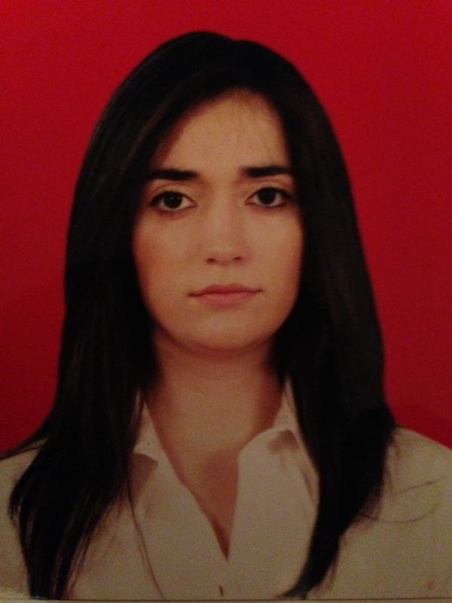
Aysel
Inayet

Nasimi district,M.Qasimov
street 14 ,home 45

012 4404665
+994 50 613 8388

asharifova@yahoo.com

Sex: Women
Date of birth: 16.05.1988
Nationality: Azerbaijanian

Applied for Lawyer position

WORK EXPERIENCE
From 16.05.2015 till Lawyer at CSS LLC
now

From 12.01.2015 till Trainee at Baku Insuarance OJSC
30.04.2015

EDUATION AND TRAINING
2014/2016 Baku State University,Master Degree,
Commercial Law
2006/2011 Baku State University,Bachelor Degree of
Law Faculty
15.10.2009/ «Labor Legislation,Practical Affairs of
15.11.2009 Labor Right» in Arbitration Right
Bureau
2009 «CEDAW Convention on Women
Rights» at ABACEELI by USAID
2010 «Women's Rights in Islamic Law»
seminar at ABACEELI by USAID
2012 «Financial Law» seminar at ABACEELI
by USAID
2015 Baku SLS on Contract Law

COMPUTER SKILLS
Word,Excell,PowerPoint,Access

LANGUAGE

Mother tongue Azerbaijani

Other Language(s) English upper-intermediate
Russian advance

