Curriculum Vitae

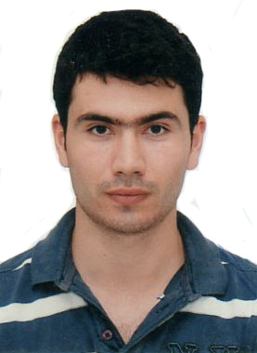

Name: Javid Mansimov
Birth Place and Date Azerbaijan, Salyan city, 02.05.1990
Current Address: Azerbaijan, Baku city, Z. Khalilov 40-a Street, house 37
Post index: Az1000
Marital status: Single
Military Service: Served in Military Base № n (2012July-2013July)
Cell: (+994 50) 513 26 66 : (+994 51) 517 34 07
E-mail: mensim_cavid@list.ru

Work Experience:

1. 2013 Oct -2013 Jan. English tutor in « SF Groups (IB club and LIB education center) »

Duties:
- Teaching General and Academic English - Using different and interesting methods for learning (by games, music, etc) - Making English speaking country atmosphere - Moderating conversation clubs

2. 2014 Jan-Feb. Expert on Problemmatic Loans in « UNIBANK head office »

Duties:
- Using of special bank sofware UDC (unibank debt collector)
- Making mobile calls to costumers for their loan debts
- Answering all costumer questions about their loans
- Warning costumers for their monthly loans by mobile calls
- Making special notes for each costumers

Education:

High education: Sept2008-July2012, Academy of Public Administration under President of the Republic of Azerbaijan
Department: «Public Administration»
Major: «Bachelor's of Public Administration»
Thesis work: «State and municipal administration»
GPA of Diploma: Diploma with Distinction (88.42 out of 100)

Secondary education: Sept1997-July2003 Hajiqabul city, secondary school and Sept 2003-July2008 Shirvan city, Private high Turkish school
GPA of Attestation: Attestation with Distinction (4.95 out of 5)

Languages.
Azeri (native)
English (excellent ( IELTS 7.0 score))
Turkish (excellent (secondary school education language in some subjects))

Computer skills
-Microsoft Office programs:
- Word
- Excel
- PowerPoint
- Access
- Outlook
- Internet

Additional Information:
- Got 631 point out of 700 from SSAC (the state student admission commission)
- Having BC category driving license
- Unit commander in military service
- Get on well with group team members
- Able to work under pressure
- Feel special responsibility and discipline during work time

Thanks for paying attention to my CV, considering that it will be, by far, pleasure for me to associate with you.

