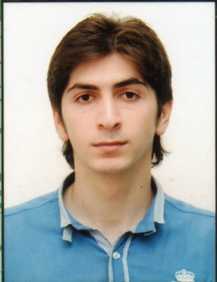
PERSONAL INFORMATION
Name |  | Ervin
Surname |  | Ahmadkhanov
Patronymic |  | Şahin
Date of Birth |  | 24 May 1991
Birth place |  | Azerbaijan, Quba
Marital Status |  | Single
Military service |  | Accomplished / 2012 - 2013
ADRESS / TEL
Adress |  | Azerbaijan, Baku, town Khirdalan
Tel |  | 050 429 78 39
EDUCATION
University |  | Azerbaijan State Oil Academy / 2008-2012
Qualification |  | Economy and management of production and service fields
Degree |  | Bachelor's / GPA 4.9 out of 5.0
COMPUTER SKILLS
Microsoft Office
LANGUAUGES
 | Writing |  | Reading | Speaking
Azerbaijani | 5 |  | 5 | 5
English | 5 |  | 5 | 5
Russian | 4 |  | 4 | 4
Turkish | 5 |  | 5 | 5

