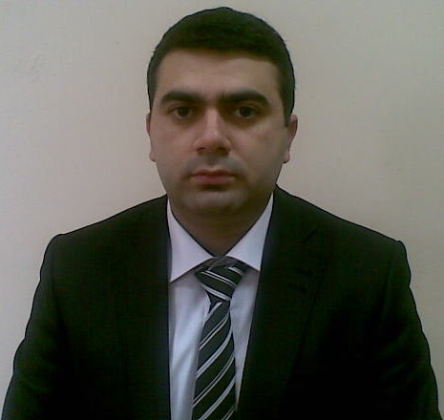
Curriculum Vitae

Personal information________________________________

Name Amiraslan Aliyev Faiq oglu
Date of Birth 12/06/1988 (dd/mm/year)
Nationality Azerbaijanian
Marital Status Married
Current Address 98b Academic Hasan Aliyev str. Narimanov district, Baku, Azerbaijan AZ1110
Phones (012)4653390
(077)4020014, (cell phone)
E-mail amiraslan.a@hotmail.com

Education:
University Azerbaijan State Economic University
Major MBA (Master of Business Administration) specialization in Finance 2010-2013

University Azerbaijan State Economic University 2005-2009
Major Business Administration (bachelor)

Language Skills Azeri (excellent)
English (intermediate for speaking, listening and writing upper intermediate)
Russian (good)
Turkish (excellent)

Computer Skills Microsoft Office, 1C, Logo Gold, Netsis - Advanced
Internet Explorer -Advanced

Additional ability ACCA (F1-exemption, F2, F3-passed). I have also practical knowledge in internal audit, national accounting and program 1C.

Military service

Location The village Yukhari Oksuzlu of the Tovuz district
Military position Staff of cannon, clerk

Work experience

Company İntermarket MMC-ПАТЭРСОН (2008-2009)
Job position Seller-cashier

Company NURGUN Holding (2010-2011)
Job position accountant

Company DNS Computers (2011-2012)
Job position accountant

Company VF Azercredit LLC (2012)
Job position internal auditor

Practice

Practice SHOLLAR BOTTLING COMPANY Ltd

Achievements 1st International Student Conference, Azerbaijan State Economic University, Azerbaijan, Baku 10-12th December
2nd International Student Conference, Azerbaijan State Economic University, Azerbaijan, Baku 13-15th December 2006 “Economic Growth-2006”
Jalal-I course-Company account

Personal interest Interests include playing chess, reading, watching films English language.

All additional information and references will be kindly provided upon request

