EMPLOYMENT APPLICATION FORM (EAF)

#1. Applied Position Title/Müraciət ediniyiniz vəzifənin adı:
Lawyer
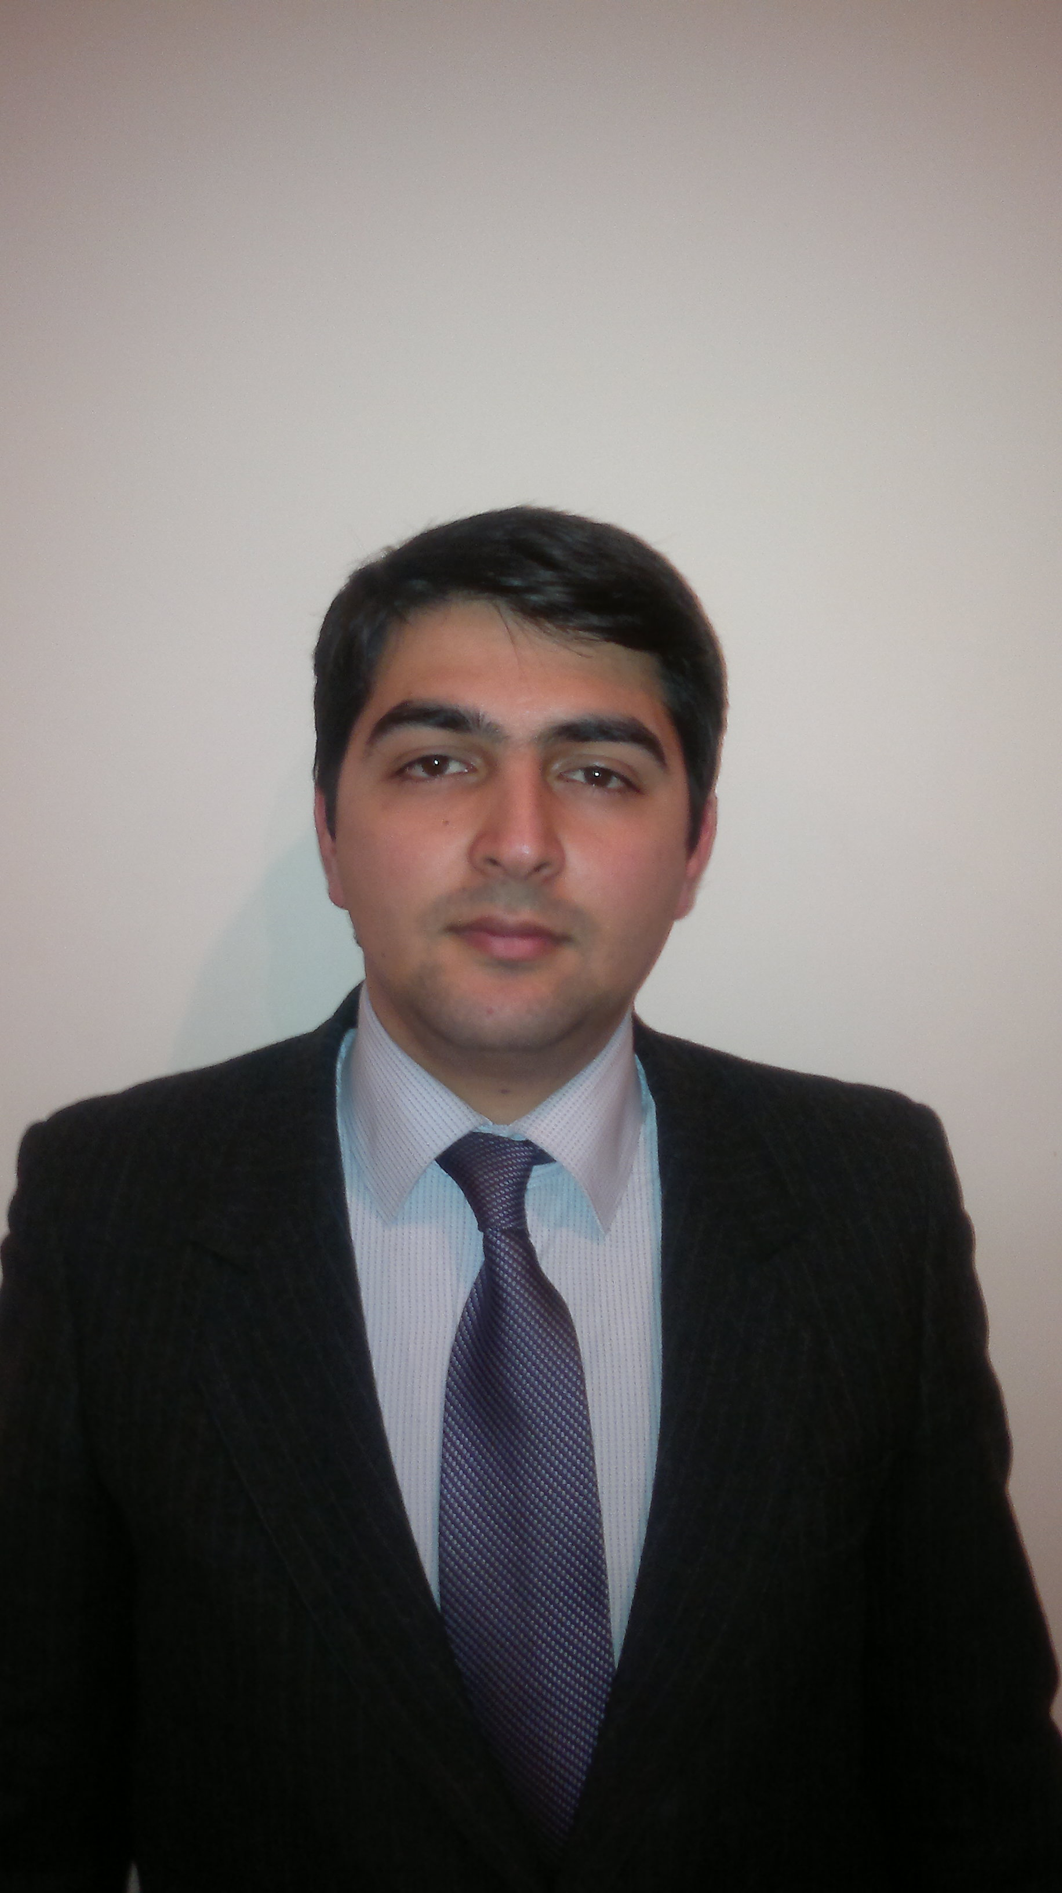Please insert your photo

Xahiş edirik şəklinizi buraya əlavə edin

#2. Personal Information/Şəxsi Məlumat:
Name Surname/Ad Soyad: | Zaur Samadov
Birth Date/Doğum Tarixi: | 28.01.1989
Citizenship/Vətəndaşlıq: | Azerbaijani
Home Address/Yaşayış Ünvanı: | Baku, Nasimi region, Dagistan str.36, fl.37
Phone/Əlaqə telefonu: | +994517927322,+994702410701
Marital Status/Ailə Vəziyyət: | Single
E-mail/Elektron poçt: | zaursamedov@hotmail.com

#3. Education and Training/Təhsil və Təlim
# | University; Institution; Training Company/Təhsil Müəssisəsinin və ya Təlim Şikətinin adı | Education & Degree/İxtisas və Dərəcə | From – To/Başlayıb - Bitib
3.1 | Baku State University | Law, bachelor | 2006-2010
3.2 | Baku State University | Law, master | 2011-2013
3.3 | ABA CEELI | Trainings | 2010-2012
3.4 | University Youth Organization | Deputy of the head of organization | 2008-2009
3.5 | “Ireli” Organization |  | 2009

#4. Work Experience/İş Təcrübəsi
# | Organization/Müəssisənin adı | Contact Information/Əlaqə Məlumatı | To – From/Başlayıb - Bitib | Department & Position/Şöbə və Vəzifə
4.1 | Alanya Oazis Beach |  | 2008 | Law and HR Department, Chief expert in Law and HR
Duties/Vəzifələr:
- Relationship between the clients
- Making Contract
- Relationship between the workers

4.2 | Nasimi Court |  | 2009-2010 | The helper of judge
Duties/Vəzifələr:
- Making all court documents (resolutions and etc.)
4.3 | “ANS” Independent Broadcasting and Media Company |  | 2011-2014 | The Head of the Legal Department
Duties/Vəzifələr:
- making contracts with native and foreign individuals and legal entities
- participating in the court (Regional, Appeal)
- making work contracts
- organization of trainings
- working with government
- giving juridical advices
- making company documents
- working with debitors

4.4 | “ANS-CHM” Broadcasting and Media Company |  | 2011-2014 | The Head of the Legal Department
Duties/Vəzifələr:
- making contracts with native and foreign individuals and legal entities
- participating in the court (Regional)
- working with debitors
- writing law documents

4.5 | ANS Press Publishing House |  | 2012-2014 | The Head of the Legal Department
Duties/Vəzifələr:
- making contracts with native and foreign individuals and legal entities
- participating in the court (Regional)
- working with debitors
- working with government
- writing law document
- giving law advices
4.6 | ANS Kommers Company |  | 2011-2014 | The Head of the Legal Department
Duties/Vəzifələr:
- making contracts with native and foreign individuals and legal entities
- participating in the court (Regional, Appeal, High Court, Constitutional Court)
- working with debitors
- working with advertising legislation
- working with government
- writing law document
- giving law advices
- participating in the parliament (changing the law document)
4.7 | De Jure Law Company |  | 2012 | Lawyer
Duties/Vəzifələr:
- making contracts with native and foreign individuals and legal entities
- participating in the court (Regional, Appeal)
- working with government
- writing law document
- giving law advices
4.8 | “ANS” Group of Companies |  | 2014-2014 | The Head of the Legal Department
Duties/Vəzifələr:
- making contracts with native and foreign individuals and legal entities
- participating in the court (Regional, Appeal, High Court, Constitutional Court)
- making work contracts
- organization of trainings
- working with government
- giving juridical advices
- making company documents
- working with debitors
- participating in the parliament (changing the law document)

Please attach available written references into your EAF/Xasiyyətnamə məktubu mövcuddursa İMF-na əlavə edin.

#5. Skills Profile/Bacarıqlar
Language Proficiency  (Please attach confirming certificate if available)/  Dil (sertifikatınız varsa əlavə edin) |  | Computer Literacy  (Please list computer skills)/  Kompüter Bacarığı  (Bildiyiniz proqramları sadalayın)
English-VerballDanışıq: | Excellent (LSI in Cambridge, England, certificate on business English) | - Office  - Adobe Reader  - Photoshop  - Internet
English-Written/Yazılış: | Excellent (LSI in Cambridge, England, certificate on business English) | - Office  - Adobe Reader  - Photoshop  - Internet
German- VerballDanışıq: | Good (Certificate Stufe A, B, C)
German-Written/Yazılış: | Good (Certificate Stufe A, B, C)
Russian-VerballDanışıq: | Excellent
Russian-Written/Yazılış: | Excellent
Experience in reaching the problems
Excellent writing Skills
Excellent communication Skills
Excellent Presentation Skills
Mathematical thinking
Experience in organization of trainings/workshops(volunteer work as trainer assistant in AzETA and British Council)
Computer Skills
Leadership
Good management Skills

#6. Hobby
Graduated from the music school
Black belt in karate, swimming and tennis

.

