CURRICULUM VITAE

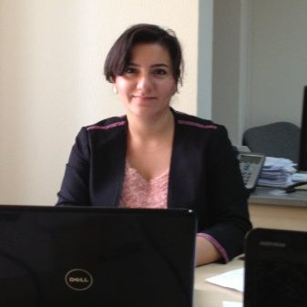
NAME: Gulshan Imanova Oruj

DATE OF BIRTH: 27th October 1982

PLACE OF BIRTH: Moscow, Russian Federation

NATIONALITY: Azeri

GENDER: Female

ADDRESS: 29/ A. Hagverdiyev 2

TELEPHONE: Mobile: (994 50) 503 00 98
Home: (994 12) 538 53 85
E- MAIL: gulshan.orujova@gmail.com,

EDUCATION:
- School №: 20 named after Arif Huseynzade
- Azerbaijan State Economic University
- Association of Chartered Certified Accountants
QUALIFICATIONS:
Economics / Finance and credit (Bachelor's Degree) / 1999-2004
Economics / Finance and credit (Master’s Degree) / 2004-2007 (Honours)
Association of Chartered Certified Accountants / 2011

KNOWLEDGE:
Knowledge of following ACCA qualifications papers:

Paper F1 – Accountant in Business
Paper F2 – Management Accounting;
Paper F3 – Financial Accounting.
Paper F4 - Corporate and Business Law
Paper F7 - Financial Reporting – on progress

Knowledge of standards:
- General Accepted Accounting Standards (GAAP);
- International Financial Reporting Standards (IFRS);
LANGUAGES:
 | Reading | Writing | Speaking
Azeri | Fluent | Fluent | Fluent
English | Fluent | Fluent | Fluent
Russian | Fluent | Fluent | Fluent

HONORARY EDICT: For a taken an active participation in the 75 years of Azerbaijan State Economic University and Collaboration Alliance (27 February 2006)

EMPLOYMENT HISTORY:

June 1, 2001 – July 1, 2007 Azerbaijan State Economic University – Operator of “Distant

and Additional Education Center”, “General secretariat”

July 1, 2007 – April 1, 2009 Ministry of Communications and Information Technologies for State

Management of Radiofrequencies - Engineer of “General secretariat”

April 1, 2009 – December 28, 2012 Institute of Information Technology “Science department” - Scientific officer

December 28, 2012 – Present Euro Audit LLC- Member Firm of Nexia International – Consultant& Tutor,

CAPSAP project
Responsibilities:
- Tuition National Financial Accounting, F3 Financial Accounting, IPSAS;
- Management the realization of the departmental tasks assigned by the general management;
- Reports to general management on departmental plans and performance;
- Management, guidance and control of department staff, direction of their daily activities;
- Control and management of procurement and supply chain system;
- Planning and management the department’s activities and resources to achieve stated and agreed targets and objectives for financial and trading performance, quality, culture and legislative adherence;
- Identifying relevant quality-related training needs and delivering training;
- Setting up and maintaining controls and documentation procedures;
- Assessing the product specifications of the company and its suppliers, and comparing with customer requirements;
- Planning of work to be accomplished & preparing schedules for completion of work;

PUBLICATION:

2006 - “Ways of increase of an overall performance of the financial control authorities” (Role of the Financial Control for acceleration social and economic development. International Scientific Conference, p.p.120-123)

2007 - “Improvement of the Financial Control System” («The Azerbaijan Model of National Economic Development» International Scientific Conference, p.p.131-132).

2007 - “Features of formation of a securities market in Azerbaijan” (Triumph of the economic strategy Heydar Aliyev. Republican Scientific Conference) – at the print.

