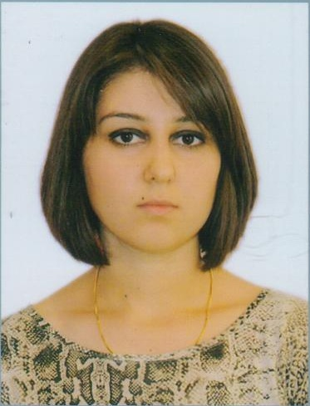 | Ashurova Jamila  Address: Yasamal district, M.Nachkchivani str 15  Country: Azerbaijan  City: Baku  Index: 1065  E-mail:  cashurova@gmail.com |  | Phone(s):  (+99450) 233 13 77 | cell
Personal Information
Gender: Female
Age: 26
Birth Date: 16.12.1987
Marital status: single
Languages: Azeri (native), English, Russian, German(beginner)

Education
September 2005 - June 2009  Azerbaijan State Economic University |  | Bachelor Degree  Faculty: Commerce  Specializing: Economics and management
September 2013 – June 2015  Qafqaz University |  | MBA Degree  Faculty: Management Information Technology
Work Experience
August 2009 – July 2013  Sanur Holding LLC |  | Accountant  - Daily reports  - Tax reports (VAT, Road,Income, Property, Tax withheld at the source of payment in relation with employment, Simplified tax)  - State Social Fund reports (B1 quarterly and annual, B3) online and on paper  - Statistical reposts (quarterly and annual) online and on paper  - Payroll calculation  - Bank payments  - Reconsolidation with banks  - Bookkeeping  - Azpetrol – fuel loading on cards  - Reconsolidation with Tax Department  - Payments over deposit  - Reconciliation reports  - Controlling contracts  - Filling permits for cars and speedometer checking  - Writing orders  - Filling record of service  - Personnel officer work  - One-stop shop documentations
July 2013 – till now  Baku Shipyard LLC |  | Accountant assistant  - Daily reports  - State Social Fund reports (B1 quarterly and annual, B3) online and on paper  - Checking payroll calculation  - Fixed Assets  - Invoices  - Bookkeeping  - Purchase Order Matching  - And others.
Non Formal Education
August 2008 - October 2008  May 2011 – July 2011  March 2013 – suspended |  | Accounting course  Organized by Tutor  Main topic: General Accounting  English language course  Organized by Language Service Direct  Main topic: General English (upper-intermediate)  DipİFR - ACCA  Organized by Headstart İnternational  Main topic: Diploma in Financial Reporting Standards
Technical Summary
- Advanced user in Microsoft Office
- Azmuhasib
- Beginner in 1C vs7.7, vs8.2
- Menu Borland Delphi 5
- Beginner in MS Project
- SunSystems, Vision, Mocosh

