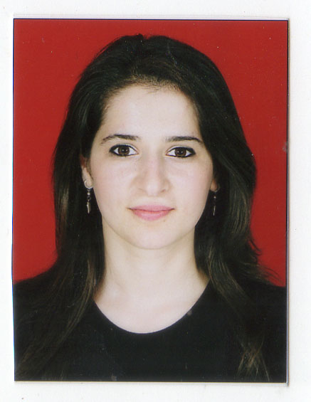 | Konul Guliyeva Aliyar 26 district, OLIMP MTK,  build.7, apart. 22  Khirdalan city, AZ 0100, Azerbaijan  Mob: (+994 55) 456 07 01  Email: qkonul@yahoo.com  Birthday: 04.08.1990/Sumgayit

education | 01/2012-05/2015 Azerbaijan State Economic University Baku, Azerbaijan.  Master Degree  Major: MBA- finance  09/2008-07/2012 Azerbaijan State Economic University Baku, Azerbaijan.  Bachelor’s Degree  Major: General Economics / Assessment Specialist  09/1997-07/2008 Tefekkur lyceum
work experience | 07-09/2010 Bank Republic JSC Baku, Azerbaijan.  Working as a (undergoing practical training)/Responsibilities include:  - Making money transfers  - Non-cash bank transfers  - Department of branches of work  16/09/2011-present "Azerenerji" JSC/Investments Department/Debt Capital Markets Division / leading economist  Responsibilities include:  - Preparing Presentations  - Preparing Financial Analysis  - Rating related requests/semi-annual reviews, etc.  - Administrative issues of DCM  - Managing request letters  - Prepare & Control Folders/Loan agreements, correspondence, policy & procedures, orders  - Translating Legal documents/agreements  Work ability:  - Preparing Covenants Document  - Preparing and analysing of Loan Book  Contributed in the implementation and follow-up of ERP project within the Company
Additional certifications | ACCA Students| Passed F1 & F3 level  January- July, 2012- Head Start International Course  ACCA- F1 (3 months)  ACCA- F3 (4 months)  June 4-7, 2013 – “ Youth Leadership and Advocacy Workshop” organized by CIPE and EDF SBIIYF  14-25 Noyabr,2011- "USAİD in collaboration with Cambridge Resources International"  “Program on Investment Appraisal & Risk Analysis”  Module I: Financial & Risk Analysis  Module II: Economic & Stakeholders Analysis  04/05/2008-04/06/2008 “ International Turkish Olympics “ / in Turkey/ Istanbul  Gold medal  23/01/2008 “ International Turkish Olympics “/ in Azerbaijan / Baku,  Silver medal  07/05/2010-09/05/2010 AR President of the Council of State Support to Non-Governmental Organizations, Support Fund for Young Talents  The project cycle management, project design and writing of the project training  19/12/2009-24/12/2009 Young European Federalist representative of Azerbaijan  Conflict resolution and effective communication training  05/04/2009-05/06/2009 The Fund of Aid for Youth  English course/Certificat A127  19-24/12/2009- Young European Federalists- Azerbaijan  “Conflict resolution and effective communication” training  03/09/2009 and 03/12/2010 Ministry of Culture and Tourism of the Republic of Azerbaijan, Secondary Diploma  01/02/2011- 30/05/2012- grant-aided student of H.Z.Tagiyev Foundation  04/07/2011-04/09/2011-“İRƏLİ” Public Union Media Academy Project  Honors Diploma
SKILLS | Computer: Windows 2000, XP, MS Word, MS Excel, MS Outlook, Power Point, MS Project (basic)
LAnguages  marital Status  STRENGTHS | Azeri (native), English (fluent), Turkish (fluent), Russian (normal)  Married, have a child.  Great ability to quickly comprehend. Very energetic, organized, responsible. Have Team work ability. Business, Presentation activity, initiative and good communication skills, can solve problems.

