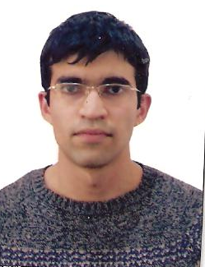

Rufat Rauf Isayev
Alikhanov street 89/52, Baku, Azerbaijan, AZ1114

Phone:+994 12 569 60 69
Mobile:+994 77 723 53 54

e-mail: isayevrr@gmail.com
isayev.r.r.21@mail.ru

Personal Statement
Education
1995-2006 Secondary School N#27
2006-2010 Azerbaijan State Economic University,
Business Administration Faculty(BA)
2010-2012 Azerbaijan State Economic University,
International Business Faculty (MBA).

Modules included:
-  Human resources
-  Accounting
-  Marketing
-  Microeconomics
-  Macroeconomics
-  Finance
-  Business Mathematics
-  Strategic management

Work Experience
June 2010-January 2013 Accountant assistant in small sized firm
January 2013- till now Head of tax department of M.A.Rasulzade
municipality

Skills
- Language-Excellent Russian. Good command of English.
- TOEFL IBT Certification (score of 92)
- ACCA F3 72%
- Computer. Microsoft Office programs.

Additional information: In 2013 I participated in Training Course “Shift
Perspective” which was held in Austria.

