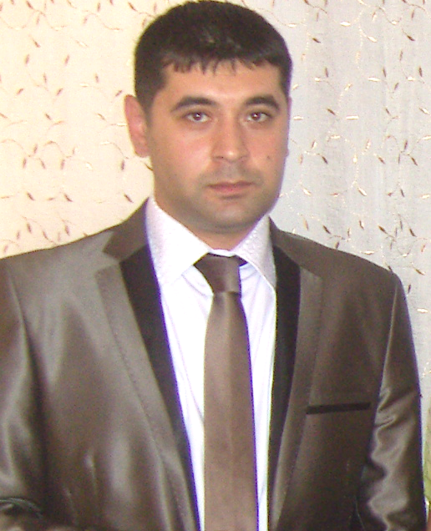
ELVİN KARİMOV- ACCA F3
Birth date: 06/ 05/ 1983
Married, have passed military obligation
Adress: Baku, New Yasamal, A.Ahmadov str;
“ETALON” residential complex
Cell ( 99455) 637 34 10
Home ( 99412) 372 13 82
e-mail: elvin.karimov@yahoo.com ; elv-in-baku@mail.ru

Career Objective
- A full-time position in Finance and Administration where I can demonstrate my technical and business skills and contribute to the company.
- To work in an achievement-driven environment for the mutual development of the organization and myself.

Employment History
- BUNYAD SARDAROV MACHINE BUILDING OJS COMPANY

Period: June’13 - ONGOING
Position held: Accountant of procurement department & overseas procurement
manager
Description of duties: Financial accounting of procurement department,preparing
Accounting transactions (Dt & Cr), Cash flow, P&L sheets
Implementing of foreign purchasing

- DEPARTMENT AGAINST TURNOVER OF COUNTERFEIT CURRENCY, FORGED DOCUMENTS, GOODS & PRODUCTS.
Period: December’11- June’13
Position held: Financial investigator (Documentary Works)
Description of duties: investigation of financial falsification crimes, calculations
during circulation of fake currencies and so on.

- ARAN HUMANITARIAN REGIONAL DEVELOPMENT ORGANIZATION
Period: April’10- December’11
Position held: Financial Manager, Member of the management board

Description of duties: Discussing and maintaining donor agreements and staff
contracts; Monthly TOP-UPs &CASH FLOWs to donors; Budget monitoring of 7-9
projects; completed financial reporting to donors and governmental departments
(quarterly, semi-annual, annual and according to demand) Keep the Executive director
informed on level of expenditures; and etc.

- ACCESS BANK
Period: September’08- September’09
Position held: Financial Analysis, Loan Officer

Description of duties: Determine whether or not people or businesses qualify for loans, monitoring customer information, determine new customer needs and opportunities, credit analysis, verification, monitoring of timely repayment, helping the borrower by making decisions, communicating with customers and other organizations outside bank (DIRECT MARKETING)

- IDEAL CONSTRUCTION, PETROL INDUSRTY, INTERNAL & EXTERNAL BUSINESS RELATIONS LTD. (ISTANBUL, TURKEY)
Period: February’08- May’08
Position held: Financial Manager, Deputy Executive Director

Description of duties: As executive director usually was out of Istanbul formally I had to do his obligations. As a company we used to import the most advanced elevators in standards of the time and from this cause I was implementing the finance analysis of this type of market .Overall financial management as a financial manager was my obligation

- “VAGIF & SONS” LTD. ( VILNIUS, LITHUANIA )

Period: May’07- Present
Position held: Shareholder, Executive Director

Description of duties: There is a great demand for dry fruits at Baltic States. I was importing dry fruits from Iran, Ukraine, Belorussia and Azerbaijan to Lithuania. I was personally controlling import, export and financial issues. In addition, I was implementing production of semi finished products-PC computer parts imported from Germany, completed and sold to permanent customers (stores)

- AZERBAIJAN INTERNATIONAL MINING COMPANY (BRANCH OFFICE IN NAKHCHIVAN AUTHONOMIC REPUBLIC)
Period: August’06- April’07
Position held: Financial Manager, Deputy Executive Director

Description of duties: As AIMC was established abroad Azerbaijan shareholders and members of board of directors usually were at England, Canada and USA. Therefore some of Executive Director's authorities notarially were given me by power of attorney. It was intended for cooperating officially with governmental agencies of the Nakhchivan Autonomous Republic, for managing bank account, bank transactions and reports to Tax authorities, Social Protection Fund, Department of Statistics and etc. As a financial manager my main duties were calculation of costs arising during the operational-mining activity and preparing future monthly and quarterly budget in advance.

- AZERBAIJAN INTERNATIONAL MINING COMPANY BAKU REPRESENTATIVE OFFICE
Period: May’06- August’06
Position held: Accountant

Description of duties: Perform all activities related to financial accounting according to PSA agreement, such as invoicing, tracking of supplier payments, cash flow analysis, petty cash calculations ,salary calculations,ammortization,depreciation and etc.

Education
1990-2000 Secondary school
2000-2004 Azerbaijan State Economic University
Faculty: Finance and credit - Bachelor's degree

Summary of Skills:
English, Russian, Turkish, Azeri- FLUENT | 1C Accounting Programme 8.2 and 7.7
ACCA F3 Financial Accounting | Financial Functions and Formulas in Excel
International Financial reporting standards (IFRS) | “LFS” bank program, MS Office
Professional Experience
- Time Management, personal organization and Planning Skills
- Financial Management Skills
- Proficiency in arithmetic and budget preparation.
- Proficiency in understanding complex financial and legal documents.
- Good negotiation and presentation skills.
- Apply finance policies and procedures to communicate effectively with other departments.
- References Available upon request

