PERSONAL INFORMATION | Emin Khalilov
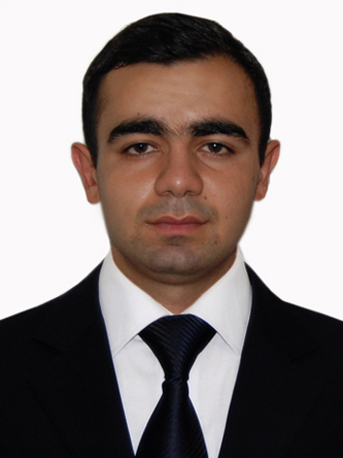 |   20 yanuary,34/7, Baku (Azerbaijan)

012 341 86 04  +994 51 571 46 03 +994 55 813 27 37

xelilov.emin1@gmail.com
 | Sex Male | Date of birth 02/01/1992

WORK EXPERIENCE

05/07/2010–05/08/2010 | Internship
05/07/2010–05/08/2010 | Azerbaijan Republic Sebail District Court  U.Hadjibeyov str.30 Baku (Azerbaijan)
05/07/2010–05/08/2010 | Studied of the executive branch, the structure of executive authority, conduct of business, documentation.Worked with receiving appeals of citizens .Took part in public works.
05/07/2010–05/08/2010 | Business or sector Public administration and defence; compulsory social security

05/07/2011–05/08/2011 | Internship
05/07/2011–05/08/2011 | Azerbaijan Republic Khatai District Cour  Nobel ave.23 Baku (Azerbaijan)
05/07/2011–05/08/2011 | Studied of the executive branch, the structure of executive authority, conduct of business, documentation.Worked with receiving appeals of citizens .Took part in public works.

EDUCATION AND TRAINING

15/09/2013–Present | Master
15/09/2013–Present | Azerbaijan State Economic University, Baku (Azerbaijan)
15/09/2013–Present | Administration and regulation of business

15/09/2009–01/06/2013 | Bachelor
15/09/2009–01/06/2013 | The Academy of Public Administration under the President of the Republic of Azerbaijan, Baku (Azerbaijan)
15/09/2009–01/06/2013 | Public Administration ,Management

18/08/2011–18/11/2011
18/08/2011–18/11/2011 | UNITY Language Learning Test Preparation and Translation Center (Language Learning Test Preparation and Translation Center, Baku (Azerbaijan)
18/08/2011–18/11/2011 | Academic English(IELTS)

27/10/2011–11/12/2011 | Certificate
27/10/2011–11/12/2011 | US Educated Azerbaijani Alumni Association, Baku (Azerbaijan)
27/10/2011–11/12/2011 | Azerbaijan Business Case Competition 2011

05/10/2011–16/11/2011 | Certificate
05/10/2011–16/11/2011 | Qarant Invest (Financial Institution), Baku (Azerbaijan)
05/10/2011–16/11/2011 | Financial Trainings

PERSONAL SKILLS

Mother tongue(s) | Azerbaijani
Other language(s) | UNDERSTANDING |  | SPEAKING |  | WRITING
Other language(s) | Listening | Reading | Spoken interaction | Spoken production
English | C1 | C1 | C1 | B2 | B2
Russian | C2 | C2 | C2 | C2 | C2
Levels: A1/A2: Basic user - B1/B2: Independent user - C1/C2: Proficient user
Common European Framework of Reference for Languages

Communication skills | Good communication,team spirit,ability to adapt in every environment.Critical,self-critical demanding,managerial approach.Commitment,perseverance,discipline,initiative.Good manners,social competence,the ability to convince.

Organisational / managerial skills | Punctual,Organized,Creative.  Good presentation skills

Job-related skills | Studying the ACCA F3(Financial Accounting) paper at the moment.

Computer skills | - Good command of Microsoft Office™ tools (Word™, Excel™ and Power Point™)

ADDITIONAL INFORMATION

Studying the ACCA F3 paper at the moment
From 01.07.2013 to 01.07.2014 was in military service.

