 |  | 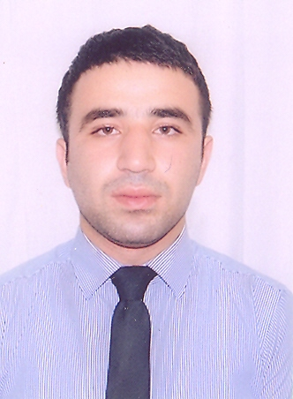
Europass
Curriculum Vitae
Personal information
Surname(s) / First name(s) |  | Bayramov Elshan
Address |  | M. Hadi 97, App.70  1129 Baku (Azer)
Telephone(s) |  | +994123799210 |  |  |  |  | Mobile |  |  | +994506862992
E-mail(s) |  | bayramov87@mail.ru
Nationality |  | Azerbaijani
Date of birth |  | 15 April 1987
Gender |  | Male
Work experience
Dates |  | 01 June 2007 - 01 September 2007
Occupation or position held |  | Intern
Name and address of employer |  | "Kapital" Bank  Fuzuli 71, 1014 Baku (Azerbaijan)
Dates |  | 01/11/2010 →01/06/2012
Occupation or position held |  | Credit Officer
Main activities and responsibilities |  | Our mission is to provide financial services to Azerbaijan’s lowest-income entrepreneurs so they can create jobs, build assets and improve their standard of living. We deliver these services through a global network of locally managed, self-supporting institutions.
Name and address of employer  Dates  Occupation or position held  Main activities and responsibilities  Name and address of employer |  | Finca-Azerbaijan  Jafar Jabbarli 44, 1065 Baku (Azerbaijan)  01/06/2012→Present  Customer Relationship manager  Effectiveness and productivity in order to achieve strategic goals. Opening bank accounts  and realizing necessary bank operations regarding accounts. Good problem solution skills and  take action to minimize factors that create problems.  “YapıKredi Bank” Azerbaijan CJSC  Nizami str 69,ISR plaza 1st floor, Baku, Azerbaijan
Education and trainings
Dates |  | 01 September 2004 - 01 May 2008
Title of qualification awarded |  | Bachelor of Finance and Credit
Name and type of organisation providing education and training  Dates  Title of qualification awarded  Name and type of organisation providing education and training  Dates  Title of qualification awarded  Name and type of organisation providing education and training  Additional information |  | Azerbaijan State Economic University  Istiglaliyyet 6, Baku (Azerbaijan)  09 June 2012 – 16 June 2012  "Service excellent"  “YapıKredi Bank” Azerbaijan CJSC  09 November 2012  “Fight against legalization of criminally obtained funds or other property”  “YapıKredi Bank” Azerbaijan CJSC  IELTS score 6.0  F 3 ( Financial accounting )
June
Personal skills and competences
Mother tongue(s) |  | Azerbaijani
Other language(s)
Self-assessment |  |  | Understanding |  |  |  |  | Speaking |  |  |  |  | W r i t i n g
European level (*) |  |  | Listening |  | Reading |  |  | Spoken interaction |  |  | Spoken production
English |  |  | C1 | Proficient user | C2 | Proficient user |  | C2 | Proficient user |  | C1 | Proficient user | C1 | Proficient user
Russian |  |  | C1 | Proficient user | C1 | Proficient user |  | C1 | Proficient user |  | C1 | Proficient user | C1 | Proficient user
Turkish |  |  | C1 | Proficient user | C2 | Proficient user |  | C1 | Proficient user |  | C1 | Proficient user | C2 | Proficient user
 |  | (*) Common European Framework of Reference (CEF) level
Computer skills and competences |  | Operation System: Windows XP  MS Office: Word, Excel, PowerPoint and etc;  Outlook Express, Internet Explorer and etc.
Driving licence(s) |  | C, B

