PERSONAL INFORMATION | Elshan Bayramov
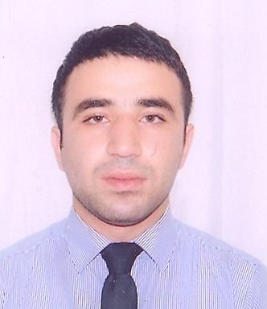 |   Baku , M.Hadi str 97 , app 70 AZ-AZ1129 Baku (Azerbaijan)

994123799210  994506862992

bayramov87@mail.ru
 | Male | Date of birth 15/04/1987 | Nationality Azerbaijani

WORK EXPERIENCE

01/06/2007 | intern
01/06/2007 | Kapital bank, Baku (Azerbaijan)

01/11/2010–01/06/2012 | credit officer
01/11/2010–01/06/2012 | Finca - Azerbaijan  Jafar Jabbarli 44 AZ-AZ1065 Baku (Azerbaijan)
01/11/2010–01/06/2012 | Mission is to provide financial services to Azerbaijan’s lowest-income entrepreneurs so they can create jobs, build assets and improve their standard of living. We deliver these services through a global network of locally managed, self-supporting institutions.

01/06/2012–Present | Customer relationship manager
01/06/2012–Present | YapiKredi bank Azerbaijan CJSC  Baku , Nasimi dist ,628 str . J.Mammadguluzadeh 73 G AZ-AZ 1078 Baku (Azerbaijan)
01/06/2012–Present | Effectiveness and productivity in order to achieve strategic goals. Opening bank accounts and realizing necessary bank operations regarding accounts. Good problem solution skills and take action to minimize factors that create problems.
01/06/2012–Present | Business or sector Banking

EDUCATION AND TRAINING

01/09/2004–01/05/2008 | Bachelor of Finance and Credit
01/09/2004–01/05/2008 | Azerbaijan State Economic University  İstiglaliyyat str 6 (Azerbaijan)

09/06/2012–16/06/2012 | Service excellent
09/06/2012–16/06/2012 | YapiKredi bank Azerbaijan CJSC, Baku (Azerbaijan)

09/11/2012 | Fight against legalization of criminally obtained funds or other property
09/11/2012 | YapiKredi Bank Azerbaijan CJSC, Baku (Azerbaijan)

PERSONAL SKILLS

Mother tongue(s) | Azerbaijani
Other language(s) | UNDERSTANDING |  | SPEAKING |  | WRITING
Other language(s) | Listening | Reading | Spoken interaction | Spoken production
English | C2 | C1 | C1 | C1 | C1
 | İELTS certificate
Russian | C1 | C1 | C1 | C1 | C1
Turkish | C1 | C1 | C1 | C1 | C1
Levels: A1/A2: Basic user - B1/B2: Independent user - C1/C2: Proficient user
Common European Framework of Reference for Languages

Job-related skills | Financial accounting ( F 3 )

Computer skills | Operation System: Windows XP  MS Office: Word, Excel, PowerPoint and etc;  Outlook Express, Internet Explorer and etc.

Driving licence | B1, C1

