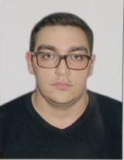

CIRRUCULUM VITAE

Name: Hasanzadeh Rauf Vahab oglu
Birth date: September 29, 1992
Marriage: Single
Nationality: Azerbaijani
Current address: Suleiman Taghizada street 25, Baku, Azerbaijan
Contact number: (+994 51) 973 29 92

E-mail: rauf.hasanzadeh@gmail.com

Education:
1999-2010 Baku European lyceum
2010-2014 Baku Azerbaijan State Economic University

Faculty: Accounting and audit
2014-2016 Baku Azerbaijan State Economic University
Faculty: Master of business administration (finance)

Personal skills:
Excellent communicating skills. Very scrupulous and dedicated. Always eager and happy to learn. Would like to obtain a position in a serious company with a good team and the ability to grow as a professional.

Languages:

Russian (native),Azeri(native),English(fluent),Dutch(basic),French(basic)

Work experiences:
03.05.2014-... Parabank-Credit department

Computer skills:
Microsoft Office

Hobbies and Interests:
Having a rest in fresh airand preparing BBQ, reading, football

