Curriculum Vitae |  | 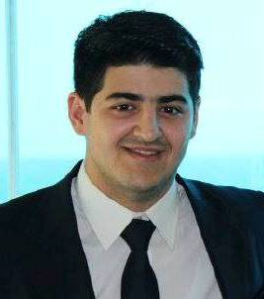
Personal Information
First name(s) / Surname(sm) |  | Rashad Jafarov
Address |  | M.Sanani street 24, Baku city, Azerbaijan
Telephone  Email |  | Mobile: 0556006589  jafarov.rasad@gmail.com
Nationality |  | Azerbaijani
Date of birth |  | 27/06/1993
Gender |  | Male
Work experience |  | Azerbaijan Student Youth Organizations' Union
Occupation or position held  University Entrance Score |  | Chairman of Debate in“Tudifak”  583
Education and training
- Dates |  | 2010-2014
Title of qualification awarded |  | Bachelor
Principal subjects/occupational skills covered |  | Business Administration and Management  2014-2016 Master  Business Administration and Management
Name and type of organisation providing education and training |  | Azerbaijan State Economic University, Turkish faculty (education is held in Turkish language)
- Dates  Subject  Name and type of  organization providing  education and training |  | ACCA-F3-79 score(Financial Accounting)  ACCA-F1-exemption(Accountant in Business)  Held at Headstart International Training Center
3) Dates  Principal  subjects covered  Name and type of  organization proving  education and training  4) Dates  Principal  subjects covered  Name and type of  organization proving  education and training  5) Dates  Principal  subjects covered  Name and type of  organization proving  education and training  6) Dates  Principal  subjects covered  Name and type of  organization proving  education and training |  | June-August 2012  TOMER (Language and Cultural Seminars)  Akdeniz University, Turkey  September-December 2011  English language course  World Hope International Azerbaijan-English Language School  May 2011  Financial Crises  AAA- US-educated Azerbaijani Alumni Association  May, 2013  "Perspectives of Insurance Sector" Conference  Buta Insurance in cooperation with Tudifak
Language skills and competences
Mother tongue(s) |  | Azerbaijan
Other language(s) |  | English(Upper-intermediate), Turkish(pek iyi), Russian(средный)
Computer skills and other competences  Driving license  Additional Information |  | Microsoft Office( Word, Excel, Power Point), Tax Code of Azerbaijan Republic  Yes  I am a purposeful, diligent person with critical thinking and appropriate forecasting abilities and have good knowledge in technical subjects such as math. I am sure that I can make desirable contributions to your company with the help of my knowledge and experience.

