Shahin Taghizade 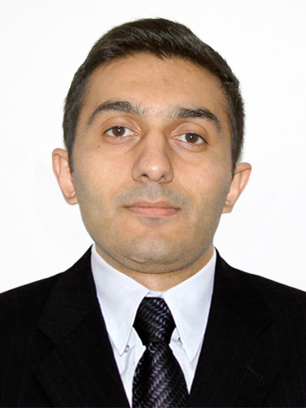
Resident of Azerbaijan Republic

LinkedIn Public Profile:  https://www.linkedin.com/pub/dir/Shahin/Taghizade | Mobile: (+99450) 291 96 46  (+99450) 455 77 59  Email: taghizade.sh@gmail.com
SUMMARY
A Highly motivated and result driven financial professional who is a self-starter and works well with minimum supervision. Ability on IFRS skills with financial statements and reporting, cash flow statement, investment analysis, discounted cash flow, Monte Carlo simulation, scenario analysis, cost of capital and etc. To be able to make decisions immediately and independently. Skilled at working with people with diverse backgrounds and work well under pressure as part of a team
EDUCATION
2004 – 2008  2009 – 2011  2012 – 2014 | Bachelor, Finance and Credit  Azerbaijan Cooperation University, Baku, Azerbaijan  MBA, Management  Azerbaijan State Economic University, Baku, Azerbaijan  MBA, Global Banking and Finance 3.0/4.0  EBCM, Business School of Munich 84/100
25th of September | Thesis: Capital Budgeting decisions at Allianz SE under positive NPV 84B

EMPLOYMENT DETAILS

November 2010 - September 2011 | State Oil Company of Azerbaijan Republic (SOCAR) Azerigas PU, Nasimi Gas Company  - Create & maintain fixed assets data with SAP ERP/ FI module  - Perform monthly analysis and prepare reconciliations.  - Create and present financial statements  - Posting of transactions to the General ledger and fixed assets module of SAP ERP  - CAPEX (Capital Expenditure)
July 2010 – October. 2010 | State Oil Company of Azerbaijan Republic (SOCAR)  Successful students full-time summer intern/Bibiheybat Oil & Gas PU  Accountant:  - Create & maintain material management and fixed assets data with SAP ERP  - Reconcile General Ledger Accountants  - Posting of transaction to General ledger and material management module of SAP ERP/ MM module
July 2009 - July 2010 | “Icherysheher” State of Historical-Architectural Reserve  Accounting and Treasury Department  Accountant:  - Monitor and clear account receivable and account payable balances  - Prepare and review Cash Flow  - Analyse and review budget  - Payroll & Tax/Tax accounting  - Reconciliation of general ledger accounts  - Prepare monthly and annually reports  - Assist with processing payroll and certified payroll process  - Assists with construction projects and preparing reporting

PROFESSIONAL TRAININGS ATTENDED
21 November 2012 | Investment Management, Munich; R. Setharaman, CEO of Doha Bank
25 June 2009 | Business skills and ability of to persuade people; Michael Bang, Baku
13 January 2008 | Budget work; EITI and Khazar University, Baku

LANGUAGE PROFICENCY

- English – fluent
- Turkish – fluent
- Russian – good
- German – basic

SOFTWARE PROFICENCY

- Exposure to SAP ERP
- Advanced user of Microsoft Excel
- Advanced user of Microsoft PowerPoint

INTEREST AND HOBBIES

- Reading
- Football
- Travelling
- Music

Personal
- Can work on own initiative
- Reliable and punctual
- Able to work well under pressure
- Attention to details
- A capacity for innovation
- Open minded and non-judgemental.

TRANSFERABLE SKILLS

- Motivate and train or tech others
- Assess and evaluate my own work and others
- Time-management
- Get results
- Think of others
- Problem Solving and etc.

REFERENCES

- Available on request

