**Hafiz Verdiyev**

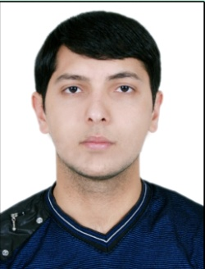

Date of birth: 03 November 1990

Address: Baku c., Sabunchu dis., Bakikhanov set., Agayev str.43

Phone: (+994) 55-651-38-36

E-mail: [hafizverdiyev90@gmail.com](mailto:hafizverdiyev90@gmail.com)

***Education***

2008 - 2012 Azerbaijan State Economic University (entrance mark 647)

International Economic Relations faculty

Bachelor degree

2015 - ACCA (the Association of Chartered Certified Accountants)

F1 (Accounting in business) – Exemption

F3 (Financial Accounting) – Passed (81%)

F2 (Managerial Accounting) – Passed (84%)

***Work Experience***

**February – September 2014 “V and B” Consulting LLC**

**Accountant**

Responsibilities:

1. Making ledger and journal entries
2. Bank reconciliation
3. Preparing payroll and implementing appropriate entries
4. Entering non-current assets adding duty, transportation, insurance expenditures
5. Performing and controlling procurement prepayments
6. Process sales, AR, AP transactions into the system
7. Compute payments to tax, social funds and preparing reports respectively for each authorities and etc.

**September 2014 – “Baku Electronics” LLC**

**Finance Specialist**

*Responsibilities:*

1. Recording advertisement, maintenance, insurance, store rent, service-installment, fuel expenses and controlling ledger accounts respectively
2. Establishing various types of expenditure provision and prepayment accounts and manage them
3. Preparing monthly franchise reports and reconciling franchise stores
4. Conducting customs, suppliers prepayments accounts
5. Participate in costing procedure (entering transportation, duty, insurance, service expenditures)
6. Preparing KPI report and making adjustments if necessary
7. Preparing internal expenditure analyze reports and etc.

***Languages***

English - Upper-intermediate

Russian - Intermediate

Turkish - Excellent

***Personel AND TeCHNICAl Skills***

Numerate, keen to learn, investigative

Strong Excel, Word, Outlook, Power Point skills

Knowledge of accounting software programs (1C, ERP)

***Hobbies***

Reading, football (playing, watching), traveling and etc.

***References***

References available on request