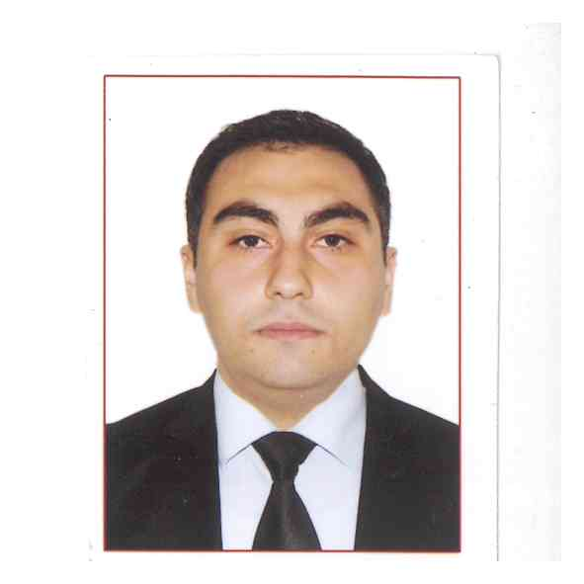**CURRİCULUM VİTAE**

**Kenan Piriyev**

**Bakı şəh. Binəqədi ray. S.S.Axundov küç F5**

**Azerbaijani**

**14.10.1988**

**Tel : +994 51 409 04 70**

[**Kenanpiriyev@hotmail.com**](mailto:Kenanpiriyev@hotmail.com)

**kpiriyev@gmail.com**

**EDUCATİON**

2006- 2010. Azerbaijan State Economic University (Azerbaijan)

BA Economics major

2010-2013. Hacettepe University (Turkey)

MSc Master of Business Administration major ( Finance )

Title of Project: Credit Risk measurement in Banking system.

**SKİLLS**

**Computer** : MS WİNDOWS APPLİCATİONS (Word / Excel / Power Point / Outlook), İnternet , Eviews , LINDO

**Language** : Azeri ( Mother tounge), Turkish ( Mother tounge) , English (conversational) , Russian (conversational )

**Course** : INTERACTIVE ENGLISH LANGUAGE SCHOOL ( ADVANCED ) 10/06/2013 - 13/09/2013 in THE UK ( BRIGHTON )

**Course:** “Financial Controlling in Banks” at Azerbaijan Bank Training Centre

**WORK EXPERİENCE**

07/2009 - 09/2009 “Azer – Türk Bank” INTERNSHIP

09/2011 - 07/2012 “Optimum Al Elektrik AS“ as a Sales Manager

10/2013 - 01/2014 “BTB Bank” as a Process Manager at Retail Product Development and Process Management Department

01/2014 - “ASB Bank” as a Internal Control

**COVER LETTER**

Kenan Piriyev

Bakı şəh. Binəqədi ray. S.S.Axundov küç . F5

+994514090470

Kenan.piriyev@hotmail.com

14/10/1988

Dear sir:

I contact you regarding in the open position. My educational background in Finance, along with my experience, makes me an excellent candidate for this position.

My resume shows that I have been consistently rewarded for hard work with promotions and increased responsibilities. These rewards are a direct result of my expertise in my commitment to personal and professional excellence, and my excellent written and oral communication skills.

If you have questions, or if you want to schedule an interview, please contact me at +994514090470. I look forward to meeting you to further discuss employment opportunities with yours Company.

Sincerely,

Kenan Piriyev