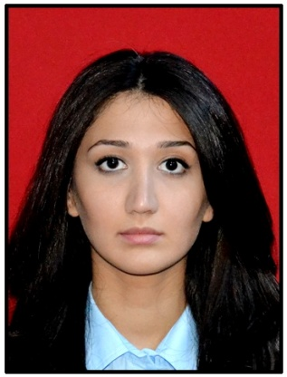

**Sadikhova Nazrin Djavanshir**

***Personal information***

**Date and place of birth:** Baku, Azerbaijan, 09.09.1992

**Nationality:** Azerbaijani

**Marital status:** Single

**Adress:** H.Zerdabi 77,43

**Telephone:** (012)4326541,(051)5876505

**E-mail:** nazrinsadikhova@gmail.com

***Education***

Azerbaijan State Economic University - “Accounting and audit” 2010-2014

***Work Experience***

* **Lifestyle Photography by Orkhan Aslanov** *-office manager (02.2014-now)*
* **Bakı Şampan Şərabları** *-intern in accounting department (04.2014-05.2014)*
* **Bank of Baku -***intern in Department of Management of sales channels (09.2013-02.2014)*
* **Bakı Elektrikşəbəkə**  *– intern in Accounting department (07.2013-08.2013)*
* **Kapital Bank** *– intern (06.2012-09.2012)*

***Personal skills***

**Languages:** Azerbaijani (advanced), Russian (advanced), English (upper intermediate)

**Computer skills**: Microsoft office (Word, Excel, Power Point)