Curriculum Vitae 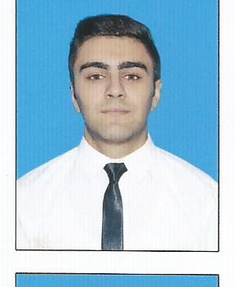

PERSONAL INFORMATION Ramin Cavadov

 Asad Ahmadov 4/222,Baku(Azerbaijan)

** (+994 55)608-31-68**

** ramincavadov.rc@gmail.com**

**WORK EXPERIENCE **

**07 July 2013–31 May 2013 Summer internship (Accountant)**

**Baku Electric Network**

**18 April 2014–25 May 2014 Summer internship (Auditor assistant)**

**Baku Chinar Manufactory**

**15 October 2013 Translator during Presidential elections**

**21 July - Present Intern in Azercredit LLC – Ledger Accountant in Head Office.**

**20** November 2013 **Collaboration with Tranzart team company (American non-financial company)**

EDUCATION 

2010 - 2014 Azerbaijan State Economic University/Accounting and Audit(Bachelor)

*University entrance point 590*

*2015-2017 Azerbaijan State Economic University/ Accounting and Audit (Master)*

*University entrance point 93*

1999 - 2010Ismayilli secondary schools #1

TRAININGS 

“I am a young Businessman” Economic School

*By Azerbaijan State Economic University, Student Youth Organization*

CERTIFICATES 

03.08.2014 – 12.08.2014 Certificate from IELTS

(Listening6.5 Reading 7 Writing 6 Speaking 6 Overall Band 6.5)

FFA/F3(Financial Accounting)

FFA/F8(Audit and Assurance- in process)

CFA level 1 Ekonomics, Quantitive methods (Time valuing of money)

ACHIVEMENTS 

May 2015 Result of test examination when applying to a master degree

according to The State Students Admission Commission –93

June 2010 Result of test examination when applying to a university according

to The State Students Admission Commission – 590 (84,3%)

PERSONAL SKILLS 

Mother tongue Azerbaijani

Other language(s) UNDERSTANDING SPEAKING WRITING

Listening Reading Spoken interaction Spoken production

English C1 C1 C1 C1 C1

International English Language Testing System-IELTS (Academic) Overall Band Score 6.5

Russian (fluent) C2 C1 C1 C1 C1

Levels: A1/A2: Basic user - B1/B2: Independent user - C1/C2: Proficient user [CommonEuropeanFrameworkofReferenceforLanguages](http://europass.cedefop.europa.eu/en/resources/european-language-levels-cefr)

COMPUTER SKILLS Microsoft Office (Word, Excel, Power Point) - Good

1C “Finance” good

Internet Explorer – Excellent

SunSystems-Good

# Personal Information:

# Social life: Member of IB youth Club.

# İ am a passionate, dedicated, bright, who strive for efficiency and effectiveness in operations with my pro-active approach and outgoing attitude. Able to demonstrate any ability to work in a demanding, fast-paced environment, possessing excellent time management and analytical skills coupled with initiative and a strong willingness to learn.

# Goal - being a member of Acca.