***SEVINJ NAGHIYEVA***

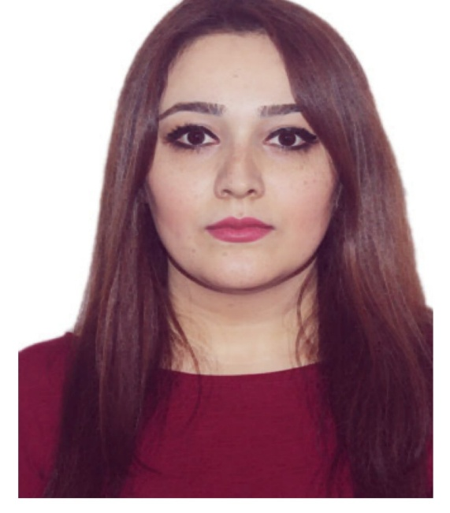

***E-mail: sevinj_naghiyeva@yahoo.com***

***Phone:(+99451) 885 75 75 (mob)***

***Date of birth: 30.03.1986***

***Citizenship: Azerbaijani***

***EDUCATION***

***2012-2014*** **KHAZAR UNIVERSITY**

The School of Economics and Management, MBA

***2009-2011*** **AZERBAIJAN STATE PEDAGOGICAL UNIVERSITY**

Biology, MA

***2003-2007 BAKU STATE UNIVERSITY***

Biology, BA

***WORK EXPERIENCE***

***2010-2011 Civil Service Comission under the President of the Republic of Azerbaijan, HR Department, HR specialist***

* Worked with senior-level management to create fair and consistent HR policies and procedures
* Identified staff vacancies and recruited, interviewed and selected applicants
* Analyzed each department’s training needs and develop new training programs based on the analysis
* Creating testing and evaluation procedures

***2007-2010 Nigar Clinic, Receptionist***

* Greeted patients or visitors in person or over the phone
* Registered new patients and updated existing patient demographics by collecting patient detailed information including personal and financial information
* Directed patients and medical representatives to the appropriate location and services
* Respected and maintained the privacy and dignity of clients and to assure client confidentiality at all times
* Facilitated patient flow by notifying the provider of patients' arrival, communicated with patients and clinical staff
* Organized overflowing paper documents

***TRAININGS***

***DeutschAkademie ( Austria,Vienna)*** *, English and German language courses*

*(1.5 months;2014)*

***Global Consulting and Training Center****, HR School, HR specialist (3 months, 2014)*

***Caspian Business Center, Real English****. IELTS( 2months, 2014)*

***World Business Center, Headstart International****, ACCA (F3, 3 months,2014)*

**Language skills**

* Azeri (native)
* English (advanced)
* Russian (intermediate)
* German (pre-intermediate)
* Turkish (advanced)

**Computer skills**

* MS Office: MS Word, MS Excel, MS Power Point, Outlook
* 1C (7.7; 8.1)

**Other skills**

Financial Accounting, Financial Management, Management Accounting,

HR Management, Business Communications, Tax Code, Labour Code, etc.

**Personal qualities**

* Able to professionally work with confidential and sensitive data
* Strong history of being persistent in pursuing goals and deadlines
* Eager to learn new technologies and systems