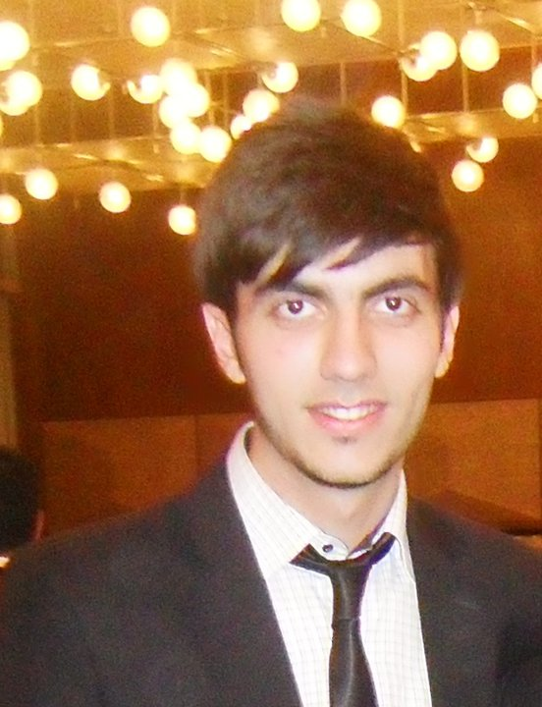

**Contact Number +994 (55) 8494202**

E-mail:____________ sarkhan.piriyev@hotmail.com

Address**:__________** Baku,Khatai,Qachaq Nabi street 1/2

Date of birth______ 06 february 1991

_____________________________________________________________

Education

Student of ACCA

-Passed Financial accounting and ethic exams

**Finance (bachelor) - Azerbaijan State Economic University, 2009-2013**

(GPA(grade point average) - 83 out of 100)

Courses included : Financial accounting, Finance management,Money and Banking, İnternational Relations, World Economy, Bussines administration, Bussines analyst, Human resources **,** Econometrics, Budget systems, Marketing Managment, Accounting, Statistics, Government taxes.

**Baku Lyceum School №210** - Achieved average grade 4.9 out of 5.0 overall

High School diploma**,** 1998-2009

* Achieved score 606 out of 700 in university entrance examination

______________________________________________________________________

**Skills**

**IT:**  Windows 7,XP, Internet Explorer; Microsoft Office package, including Word, Excel, PowerPoint, Web Outlook, Unity, Vps

**Language Capabilities:**

English (Perfect), Azerbaijani (Native), Turkish (Perfect), Russian (intermediate)

**Work Experience and Activities**

From 2013 (Jule) to now I am working for Veyseloglu group in finance department as a accountant

Internship - Nexia International audit company , Baku 2012 from September 1 to September 20. I had to do inventory for Azersu company with Nexia auditors

Internship- NBC Bank ASC(finance department, Assist to summarize all basic documents)

**Internship-** Junior Achievment Azerbaijan

**Social Activities**

-Participant of Young Leaders Change Program between Turkey and Azerbaijan (2011, 13-30 jule)

-Participant of  [International Summer School, Public Choice: Economics of Politics in Tbilisi, Georgia](http://www.facebook.com/events/406925502670208/)

-Participant of Lidership summer school in Lekaran Azerbaijan (2010, 28 jule-4 August)

-Coordinator of Busisess worker group in Azerbaijan Student Young Union(2009)

-Member of Sife team of Az.state Economic University(2012)

**Interests**

**Sport -** In my spare time I play football with friends. I am also curious about swimming and volleyball.

**Special Abilities-** Photography, Playing the guitar,