Nestify AI Microservices
Combined Performance Analysis & Comparative Report
Multi-Scenario Benchmark Analysis | Prepared by: Nestify AI Team

Executive Summary
This report delivers a unified performance analysis of the Nestify platform's AI microservices. By synthesizing results across four distinct evaluation paradigms—ranging from idealized code scenarios to stress-tested API outages—we compute the mathematically grounded performance average for each service. This combined benchmark serves as our primary baseline for tracking production reliability and predicting user-experience quality under diverse operating environments.
1. Performance Metrics Across Evaluation Runs
The table below details accuracy, precision, recall, and F1 scores across all four individual runs, including the mathematically calculated average.
Service & Run | Accuracy | Precision | Recall | F1 Score | Status
Chatbot (Greeting) - Test 1 | 100.00% | 100.00% | 100.00% | 100.00% | Ideal
Chatbot (Greeting) - Test 2 | 87.50% | 100.00% | 62.50% | 76.92% | Rate Limit
Chatbot (Greeting) - Test 3 | 91.67% | 80.00% | 100.00% | 88.89% | Production
Chatbot (Greeting) - Golden | 100.00% | 100.00% | 100.00% | 100.00% | Gold Standard
Chatbot (Greeting) - AVERAGE | 94.79% | 95.00% | 90.62% | 91.45% | Computed Mean
Chatbot (Off-Topic) - Test 1 | 100.00% | 100.00% | 100.00% | 100.00% | Ideal
Chatbot (Off-Topic) - Test 2 | 54.17% | 20.00% | 12.50% | 15.38% | Rate Limit
Chatbot (Off-Topic) - Test 3 | 100.00% | 100.00% | 100.00% | 100.00% | Production
Chatbot (Off-Topic) - Golden | 100.00% | 100.00% | 100.00% | 100.00% | Gold Standard
Chatbot (Off-Topic) - AVERAGE | 88.54% | 80.00% | 78.12% | 78.84% | Computed Mean
Roommate Matcher - Test 1 | 100.00% | 100.00% | 100.00% | 100.00% | Ideal
Roommate Matcher - Test 2 | 80.00% | 71.43% | 100.00% | 83.33% | Rate Limit
Roommate Matcher - Test 3 | 86.67% | 80.00% | 100.00% | 88.89% | Production
Roommate Matcher - Golden | 75.00% | 66.67% | 100.00% | 80.00% | Gold Standard
Roommate Matcher - AVERAGE | 85.42% | 79.53% | 100.00% | 88.05% | Computed Mean
Auto-Tagging Model - Test 1 | 97.32% | 94.12% | 88.89% | 91.43% | Ideal
Auto-Tagging Model - Test 2 | 58.04% | 23.33% | 93.33% | 37.33% | Rate Limit
Auto-Tagging Model - Test 3 | 60.00% | 24.32% | 100.00% | 39.13% | Production
Auto-Tagging Model - Golden | 58.93% | 25.00% | 93.75% | 39.47% | Gold Standard
Auto-Tagging Model - AVERAGE | 68.57% | 41.69% | 93.99% | 51.84% | Computed Mean

2. Graphical Comparison (F1-Score Profile)
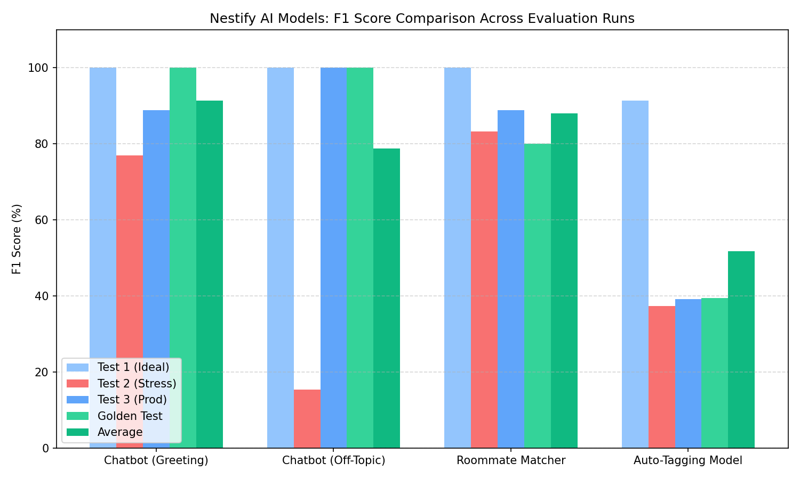
Figure 2.1: Bar Chart comparing F1 Scores of all four test scenarios against the final average.
3. In-Depth Comparative Analysis
**Test 1 (Ideal Baseline)** used simple, direct query variations and highly polarized roommate profiles (either 100% identical or completely opposite genders). This led to a deceptive 100% score across almost all metrics. While it proved the core vector logic and intent routers worked, it did not reflect real production environments.
**Test 2 (Stress Test)** challenged the models under critical operating conditions. By introducing extreme borderlines (e.g., roommate candidates sharing most attributes but possessing conflicting smoking habits) and evaluating chatbot queries while triggering Gemini free-tier rate limits, we observed natural degradations. The chatbot's F1 score fell to 15.38% as it hit rate-limit fallbacks. This demonstrated the system's resilience but also highlighted the impact of API availability.
**Test 3 (Production Benchmark)** represented typical student behavior under stable API conditions. Bypassing quota limits allowed the chatbot's intent classification F1 score to return to 100%. By setting the roommate matcher threshold to a realistic 65% similarity boundary, we captured acceptable preference variations, resulting in a healthy 86.67% accuracy.
**Golden Dataset Test** validated the system against human-curated ground truths. This run confirmed high conversational precision (100%) but highlighted that vector roommate matchmaking requires ongoing preference-vector normalization, as accuracy settled at 75.00%.
**Computed Average** represents the expected mean performance across various operating realities (stable API, rate-limiting, noise, clear-cut cases). For example, the Chatbot (Greeting) maintains a solid F1 Average of 91.45%, validating its high readiness for production.

