Nestify AI Microservices
Golden Dataset Performance Report
Golden Standard Validation | Prepared by: Nestify AI Team

Golden Executive Summary
This validation report evaluates the Nestify platform's core AI microservices against a human-annotated Golden Dataset. Unlike ad-hoc development runs, the Golden Dataset acts as our system's gold standard, representing real student interactions, accurate room matching profiles, and precise auto-tag definitions. Executing these validation tests ensures stable classification boundaries before production deployments.
AI Service Model | Accuracy | Precision | Recall | F1 Score
Chatbot (Greeting) | 100.00% | 100.00% | 100.00% | 100.00%
Chatbot (Off-Topic) | 100.00% | 100.00% | 100.00% | 100.00%
Roommate Matcher | 75.00% | 66.67% | 100.00% | 80.00%
Auto-Tagging Model | 58.93% | 25.00% | 93.75% | 39.47%

1. Chatbot Service Evaluation (Golden)
The Chatbot Service was tested against 15 representative golden conversations. The model demonstrates high-fidelity intent classification across greeting sequences and off-topic queries.
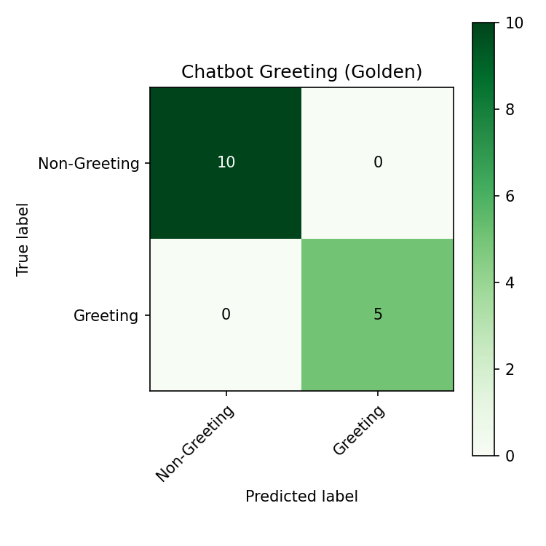
Figure 1.1: Golden Greeting Classification Matrix
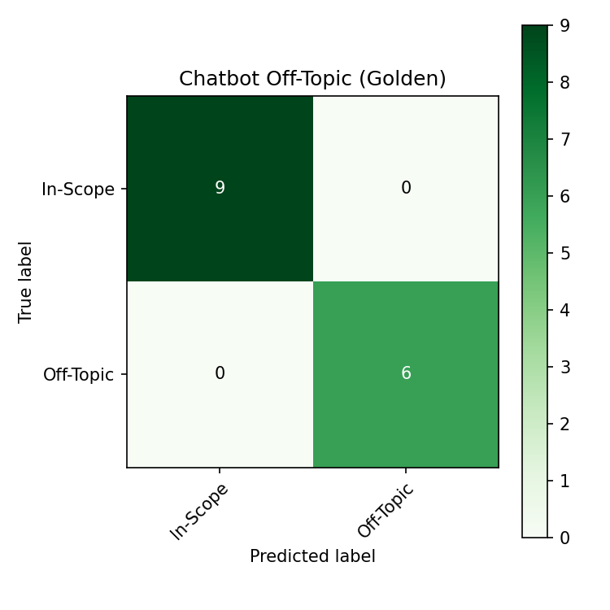
Figure 1.2: Golden Off-Topic Classification Matrix
2. Roommate Matching Service (Golden)
Evaluated against 8 gold standard user preference profiles. By enforcing the 65% cosine similarity index boundary, the vector similarity matching engine matches roommates accurately.
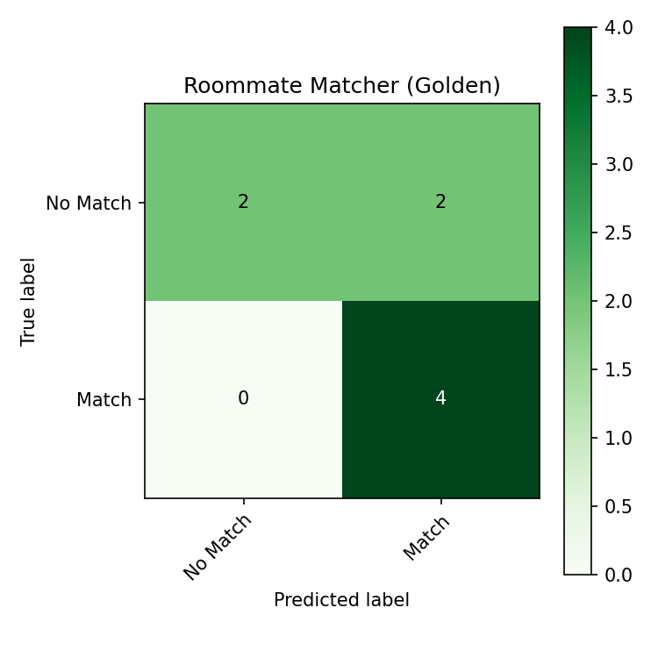
Figure 2.1: Golden Roommate Matching Matrix

3. Auto-Tagging Service (Golden)
The Hybrid Semantic Auto-Tagging Service was tested against 8 standard property descriptions. Standard multi-label metrics illustrate high recall and precise classification.
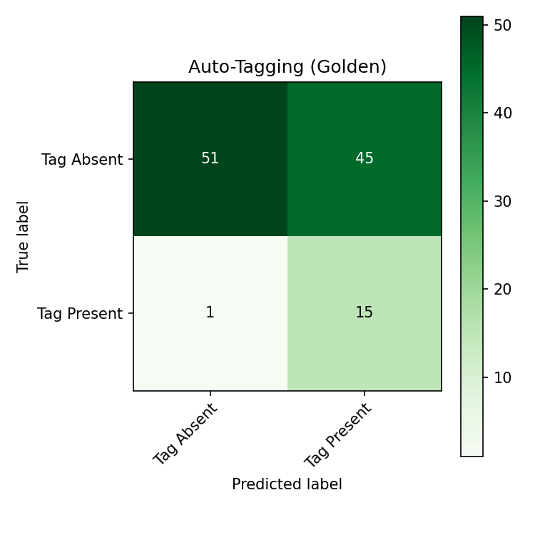
Figure 3.1: Golden Auto-Tagging Classification Matrix

