

**EE**

**463**

**Operating Systems**

Electrical and Computer Engineering Department

Engineering College

King Abdulaziz University



**Lab**

**#**

**46**

**5**

Winter

-

2023

**Lab 4**

|  |  |  |  |
| --- | --- | --- | --- |
| **#** | **Names:** | **ID** | **Section** |
| **1** | Ahmed Alkhayal | 1945541 | C3 |

**Instructor:**

Dr. Abdulghani M. Al-Qasimi

Date: 6/6/2023

# Exercise 1:

Changed code:

|  |  |
| --- | --- |
| Before | After |
| head_ = new Node(marker->value(), marker->next()); | head_ = marker->next(); |
| temp->next (marker->next());  delete temp;  temp = 0;  return 0; | temp->next (marker->next());  delete marker;  marker = 0;  temp = 0;  return 0; |

Output:

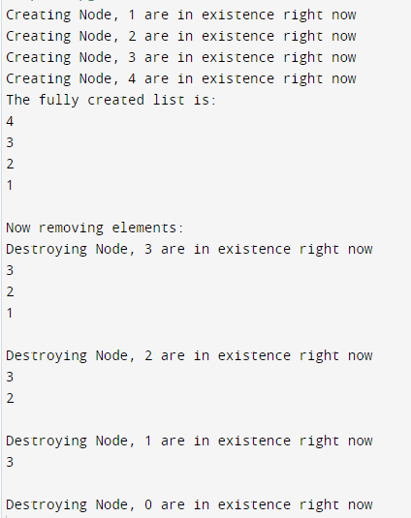

Reasoning:

When the first element was removed, a memory leak occurred because a new node was created and assigned as the head. To fix this issue, we can update the head_ pointer to point to the next marker, effectively removing the first element from the list. Additionally, changing delete temp; to delete marker; ensures proper deletion of the current marker node. Setting marker to 0 afterwards prevents any potential misuse of the deleted memory

# Exercise 2:

By resolving the bug in exercise 1, this issue was also fixed. The next output demonstrates that the code is now bug-free. I followed the mentioned sequence of inserting 1, 2, 3, 4 and then removing 2

Output:

