**CentOS 7 VM Setup**

Contents

Objective 1

Prerequisites 1

Create the srv1 VM 2

O.S Installation Steps 7

Basic setup steps on first start 19

1. Login as root user and complete the final setup steps 19

2. Enable the auto-connect for the Host-only network interface () 21

3. Verify the network setting 24

4. Install bash completion package by executing the following command: 24

Final take a VirtualBox snapshot of the VM 25

# Objective

Describe the steps required to create the CentOS 7 Virtual Box VM

# Prerequisites

* Oracle Virtual-Box
* 30 GB of free disk space
* 8 GB of RAM
* Virtualization technologies (VT-x or AMD-V) are support and enabled
* CentOS-7-x86_64-DVD-XXXX.iso (can be downloaded from <https://www.centos.org/download/> )

# Create the srv1 VM

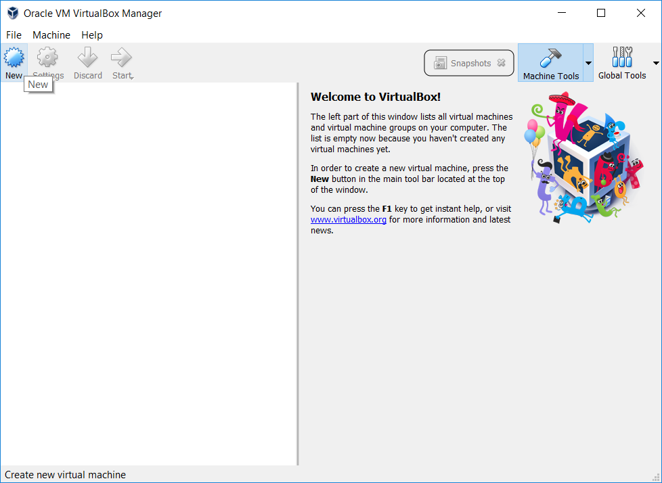

|  |  |
| --- | --- |
|  |  |

|  |  |
| --- | --- |
|  |  |

|  |  |
| --- | --- |
|  |  |

Update the network setting to make use of 2 network adapters.

Adapter 1 => NAT mode

Adapter 2 => Host-only Adapter

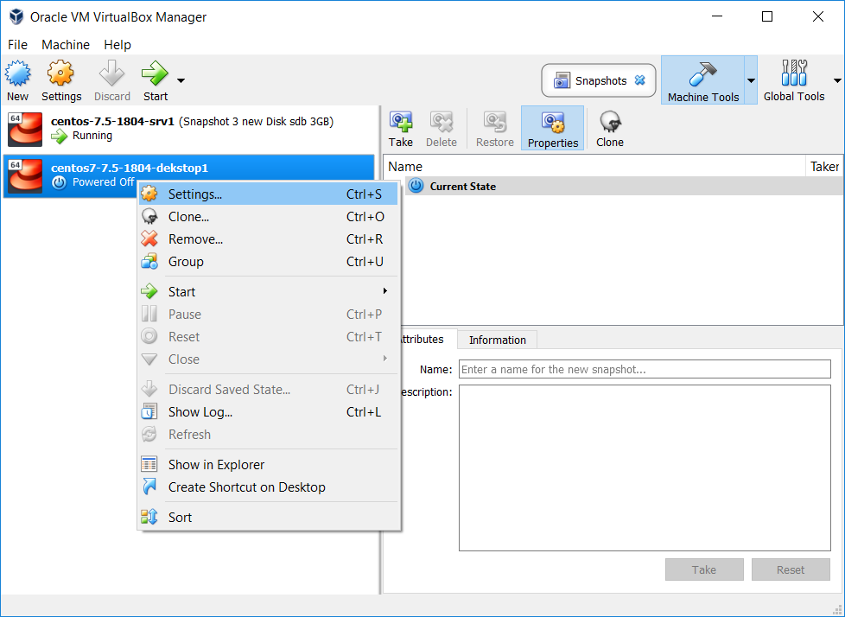

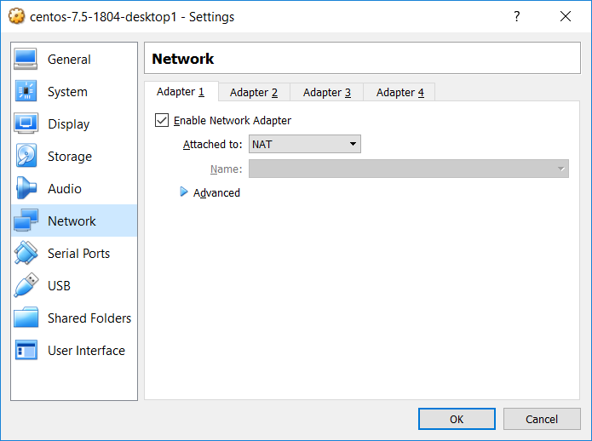

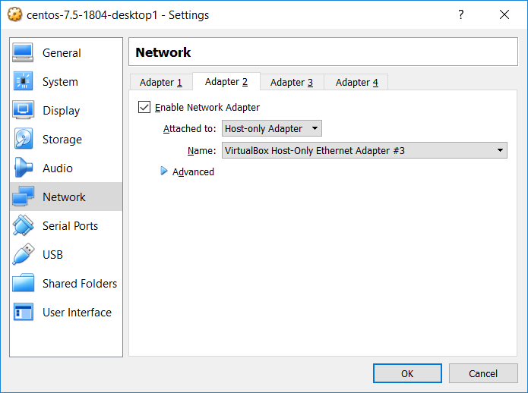

Insert the “CentOS-7-x86_64-DVD-1804.iso” in the virtual DVD-ROM

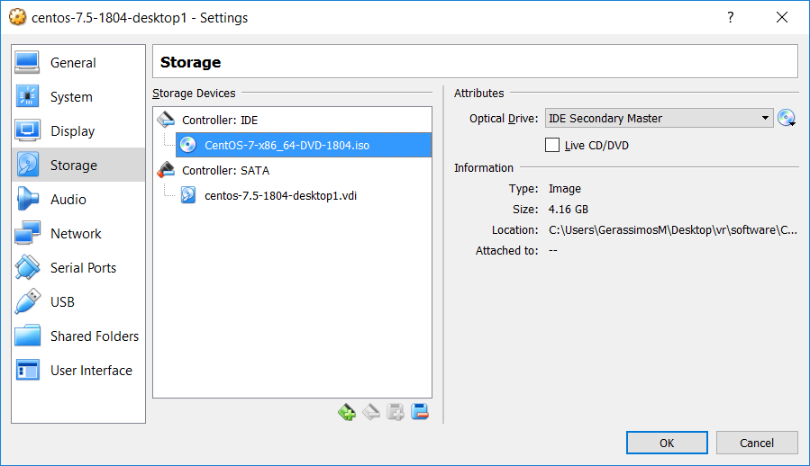

# O.S Installation Steps

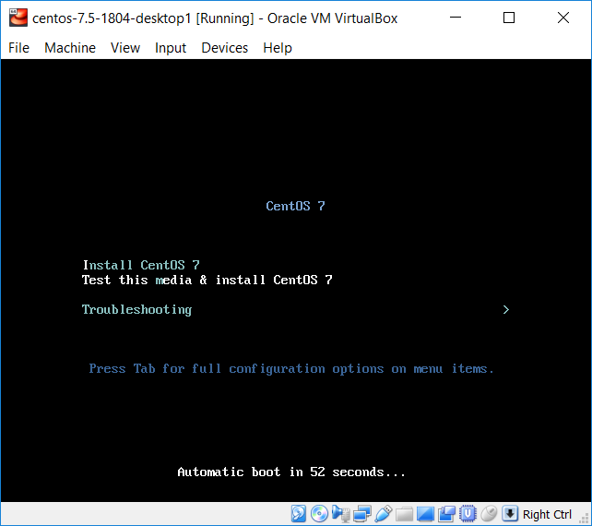

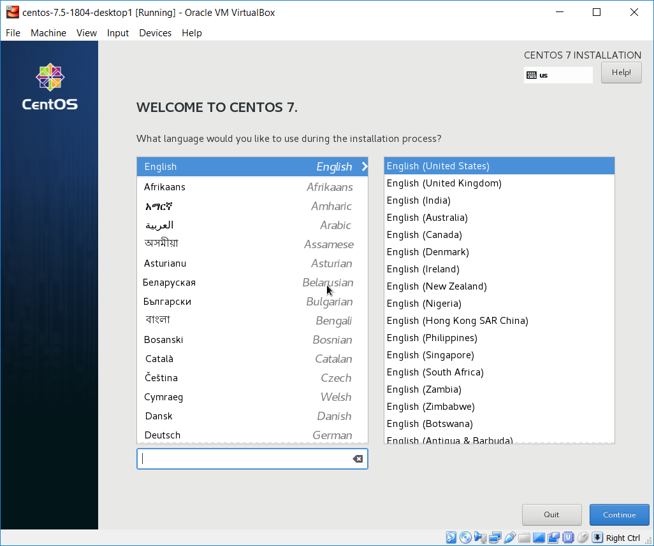

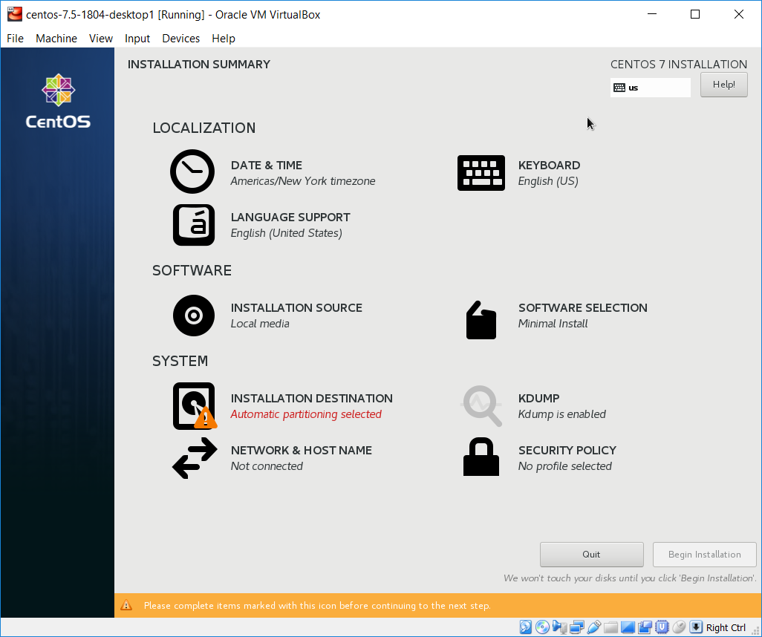

Select “Date & Time” and then select your time zone

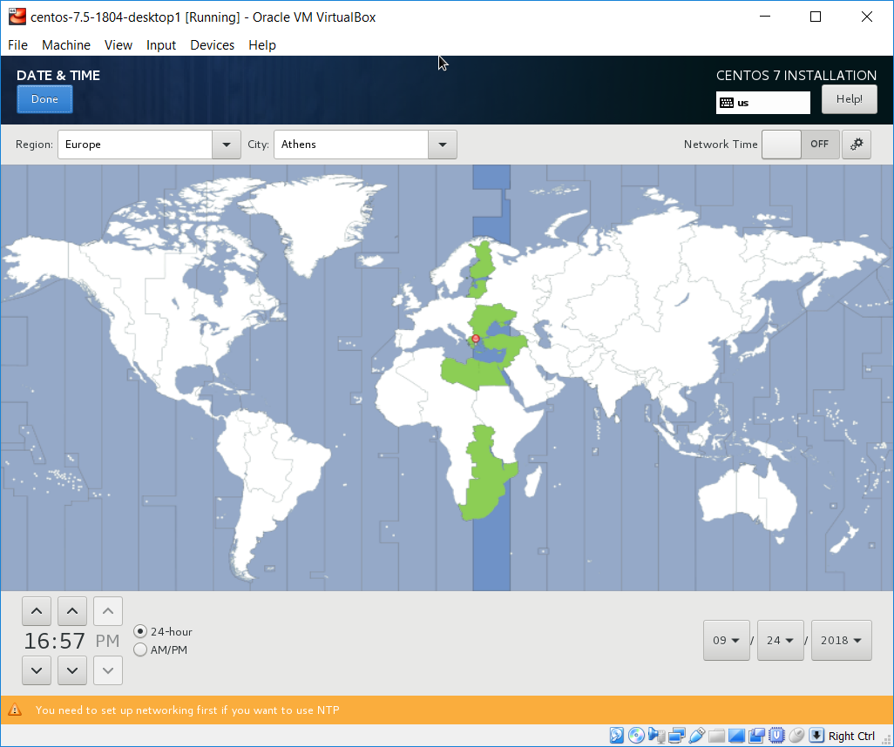

Select “Software Selection” and the select “Minimal Install”

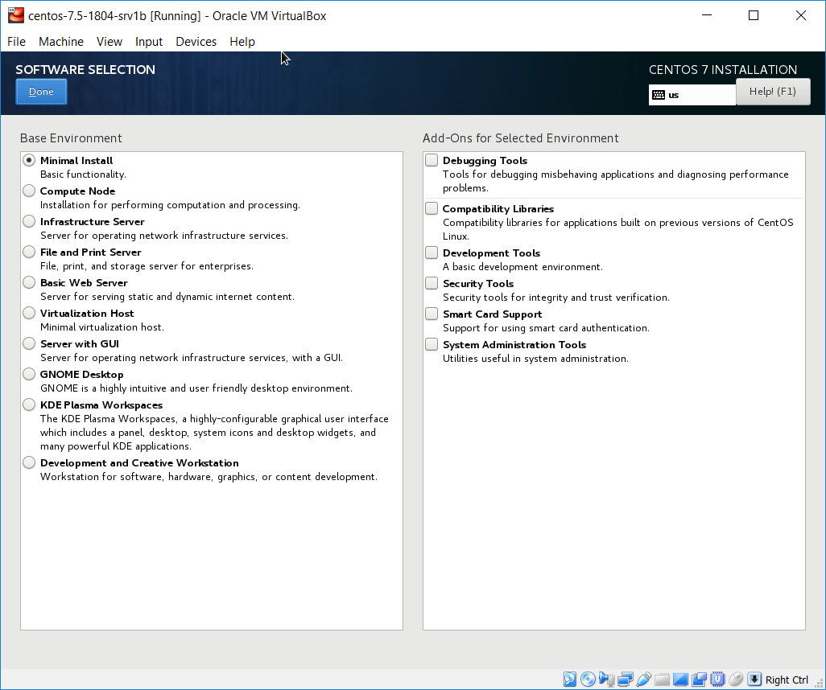

Select the “Network & Hostname”

* Set the “Host name” field (srv1)
* Turn on all network interfaces

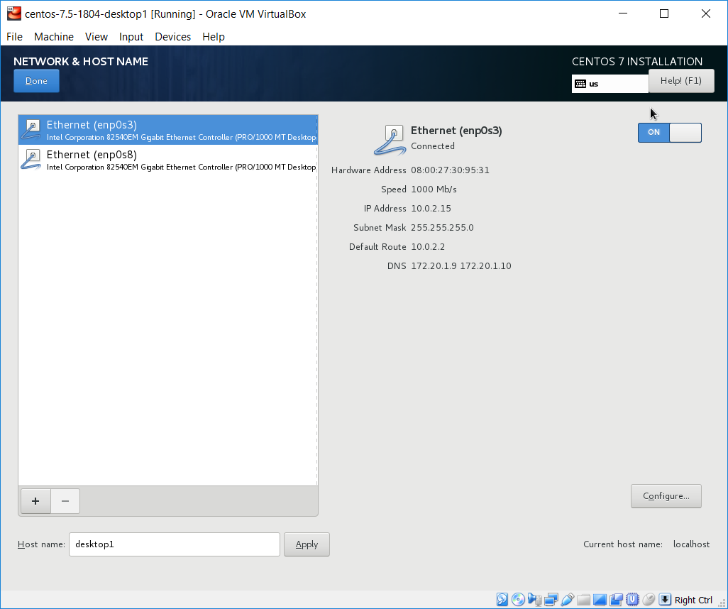

Select the “INSTALLATION DESTINATION” leave all the default selections and press Done

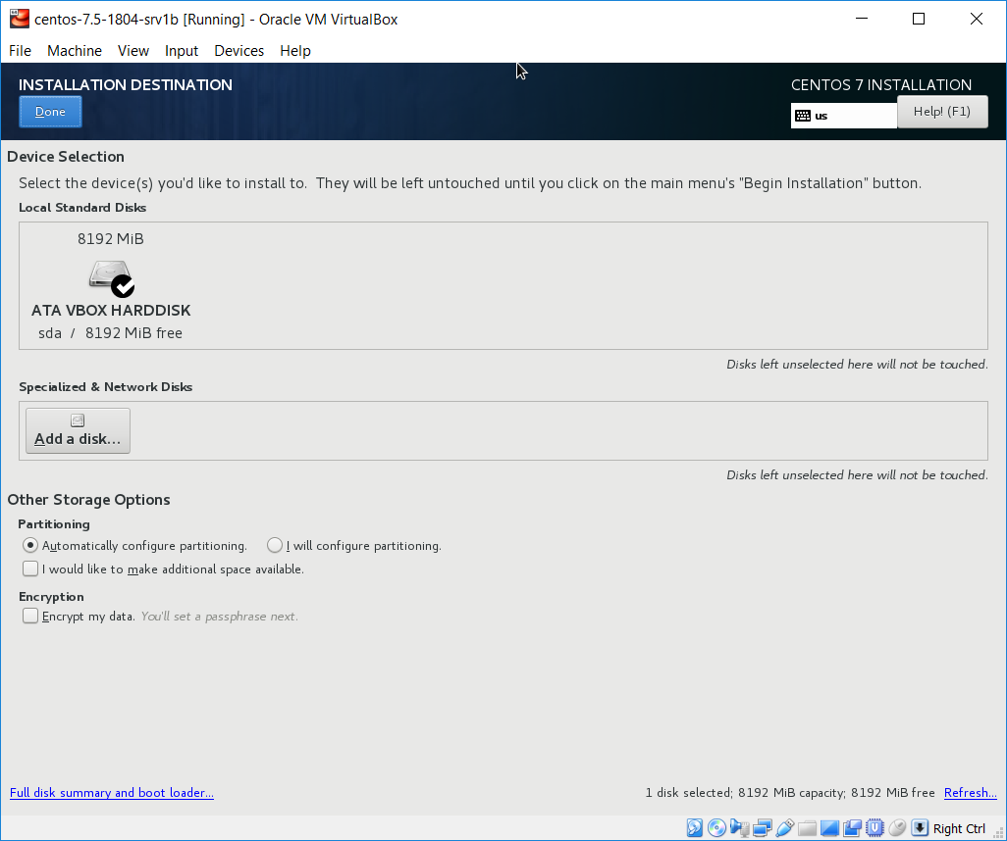

Press the “Begin Installation” button

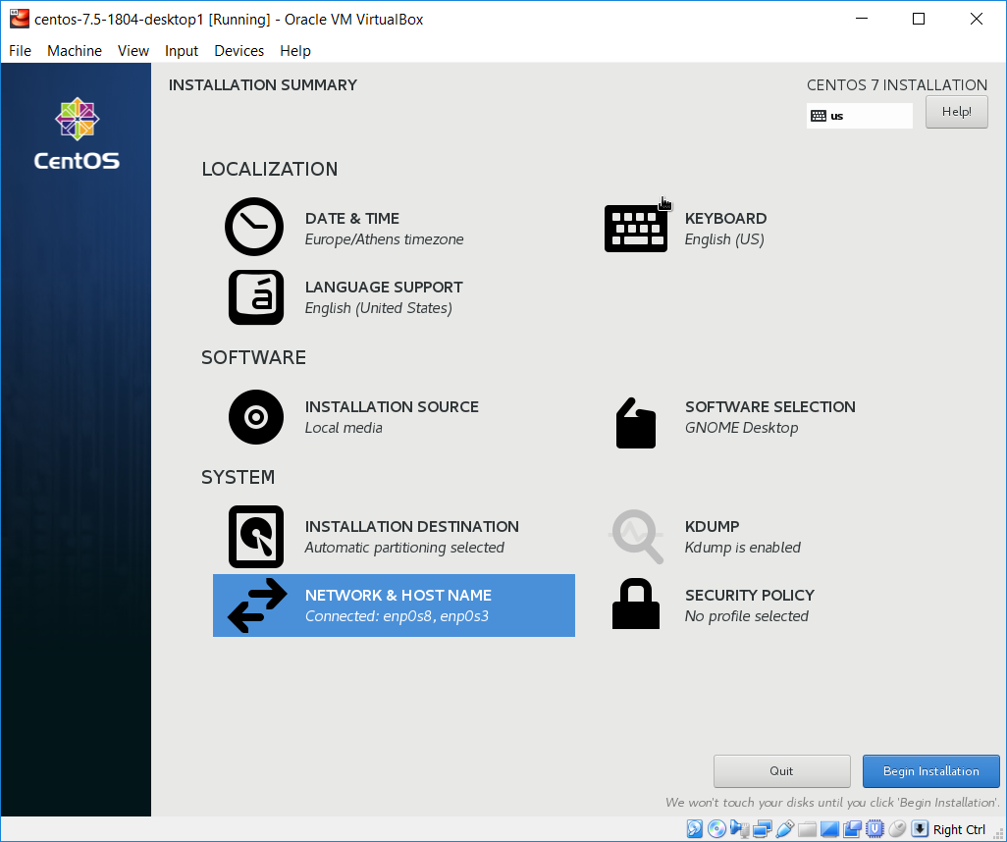

Set password for root user and create a regular user

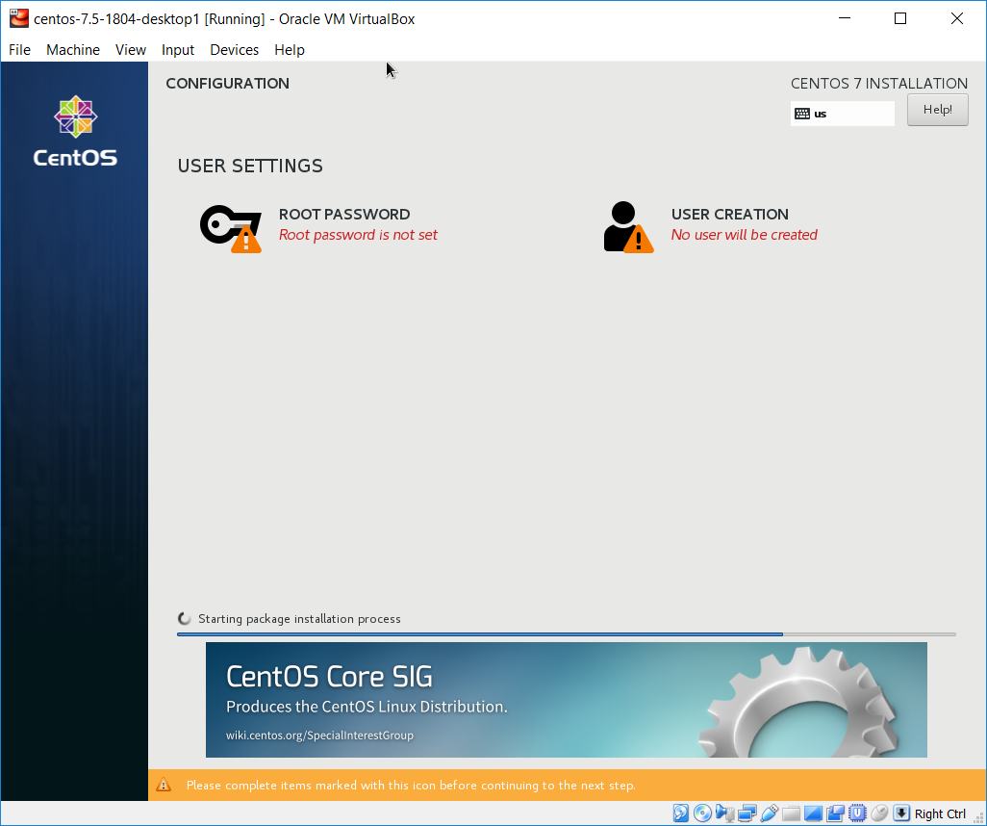

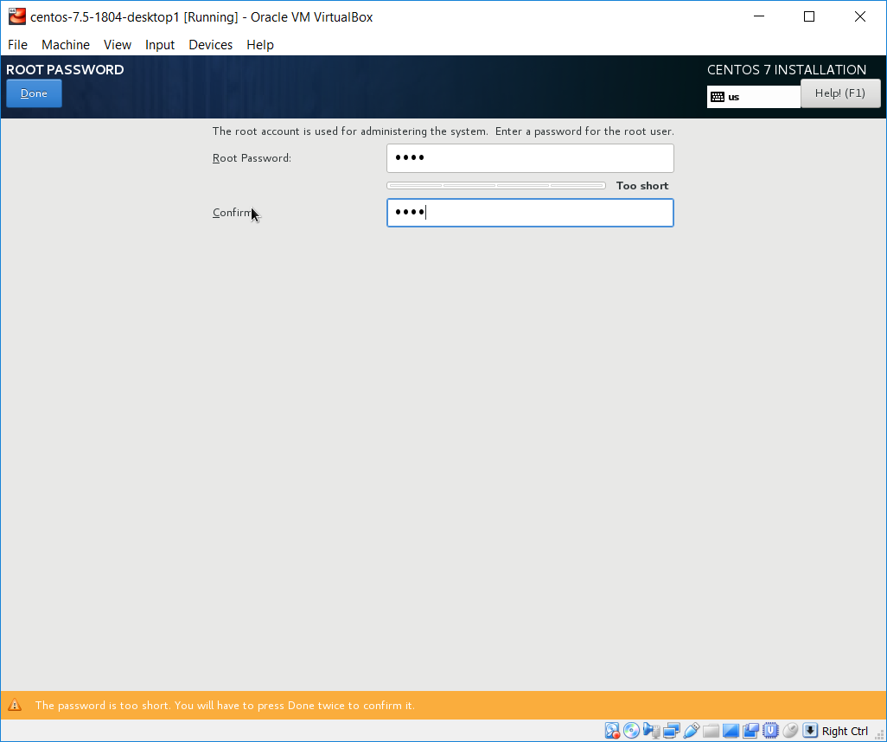

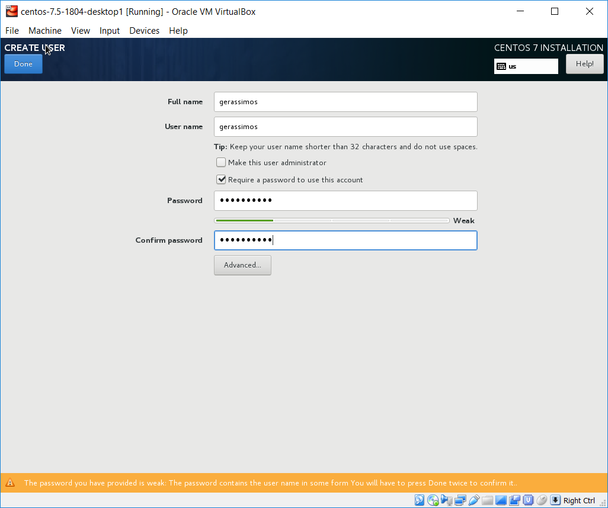

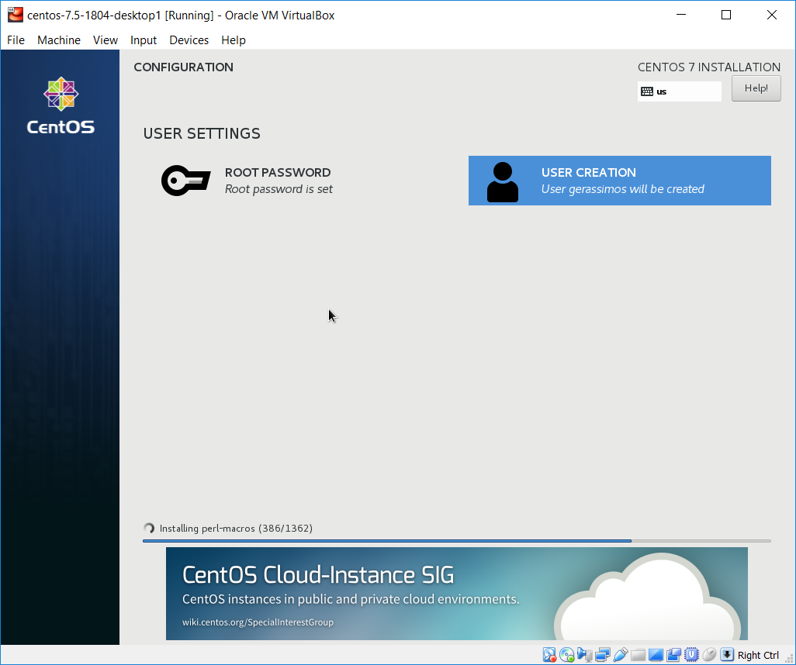

When the installation process is completed press the “Reboot” button

**Note:**

After the “Reboot” operation complete the steps about keyboard and localization that may appears.

# Basic setup steps on first start

### Login as root user and complete the final setup steps

Boot the vm and login as root user from the terminal window:

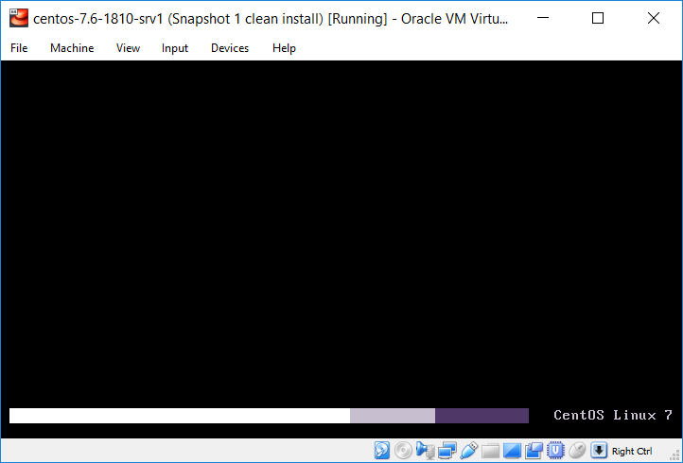

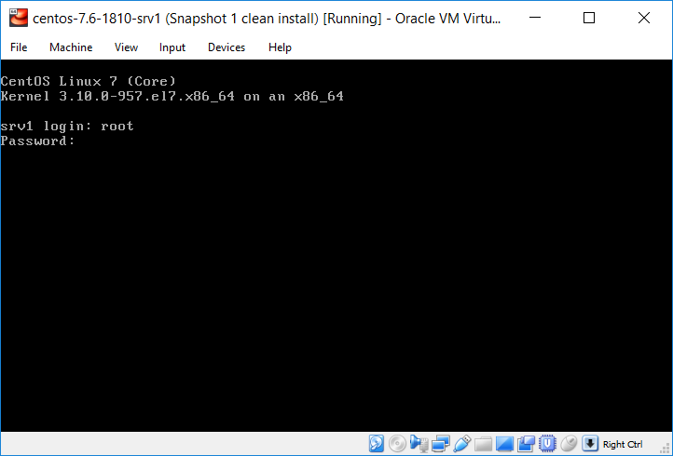

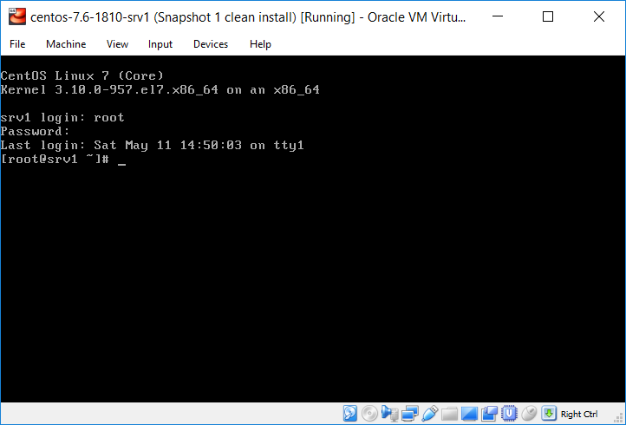

## Enable the auto-connect for the Host-only network interface ()

From the terminal window execute the “nmtui” command to start the “text” graphical interface of the “Network Manager”

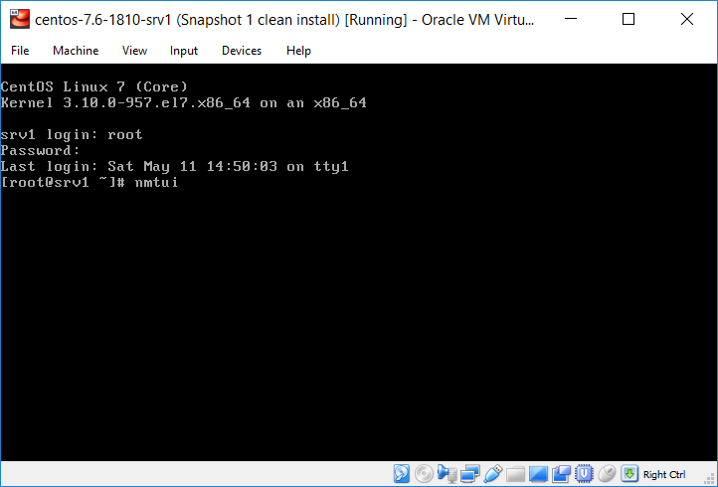

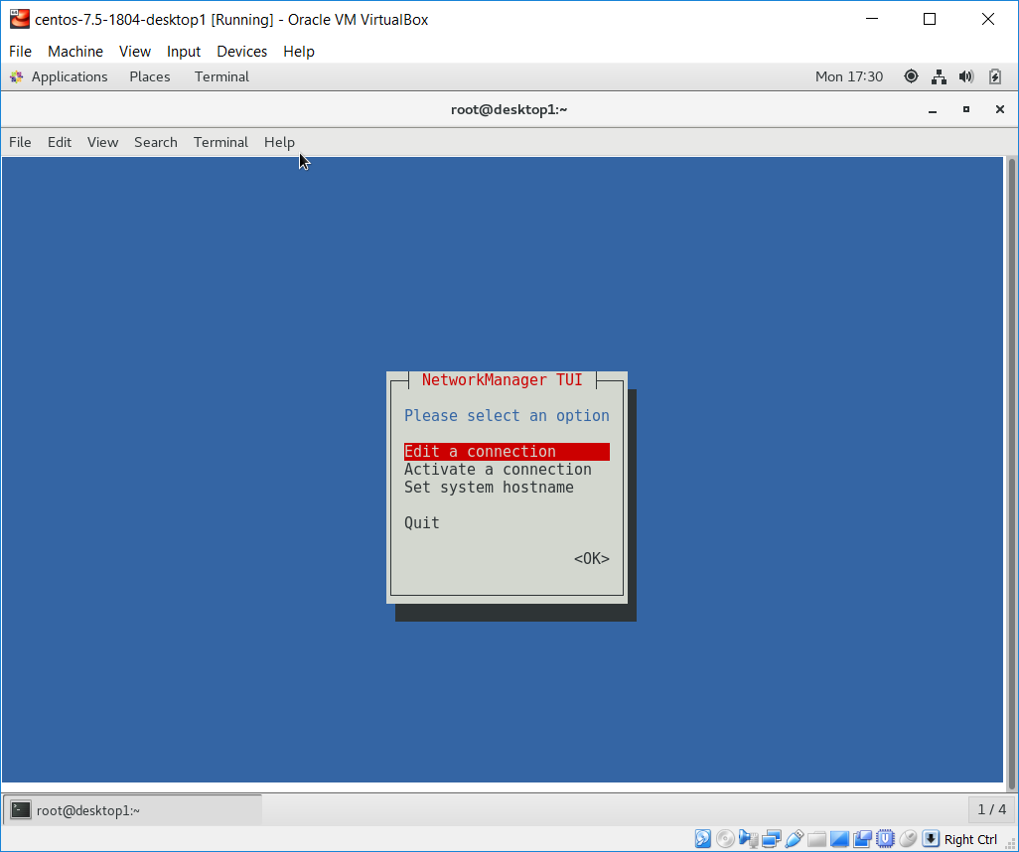

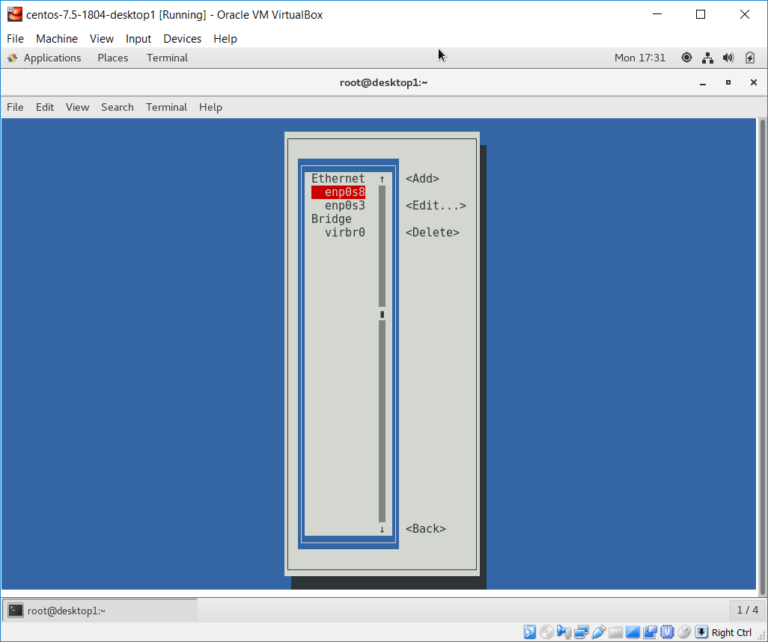

Enable the “Automatically connect” check box and press OK

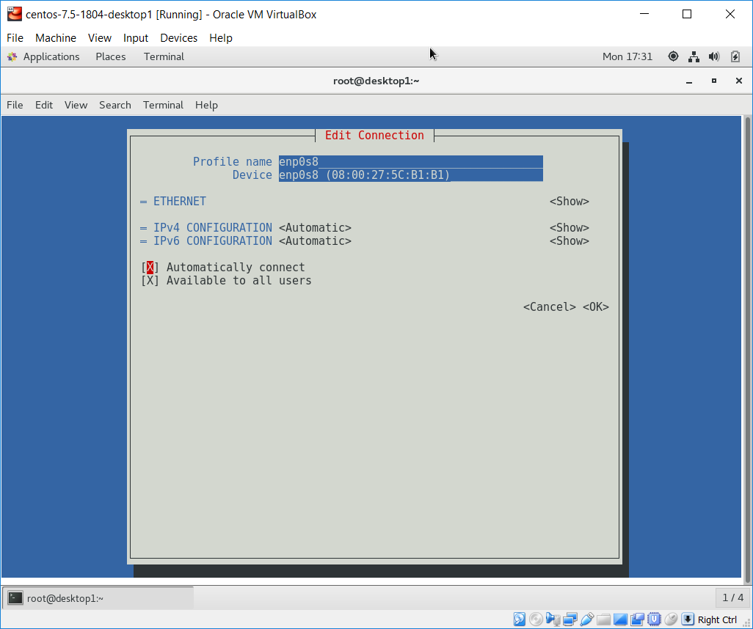

Use the navigation buttons (“Back” and “Quit”) to exit the “text” graphical interface of the “Network Manager”

## Verify the network setting

From the terminal windows execute the “ip a” to display the network settings

|  |
| --- |
| # ip a | grep "inet "  inet 127.0.0.1/8 scope host lo  inet 10.0.2.15/24 brd 10.0.2.255 scope global noprefixroute dynamic enp0s3  inet 192.168.99.100/24 brd 192.168.99.255 scope global noprefixroute enp0s8 |

We can now use the IP address (192.168.99.100) of the host-only network interface from the host system to connect to the VM using an ssh client such as “putty”

## Install bash completion package by executing the following command:

|  |
| --- |
| root@srv1 # yum install -y bash-completion  … |

# Final take a VirtualBox snapshot of the VM

Note;

This will store the current state if the VM in a file, later this state can be restored.

From the Virtual Box main window selected the VM, then press the “Snapshots” button, then right click on the “Current Sate” tree item from the upper right panel and

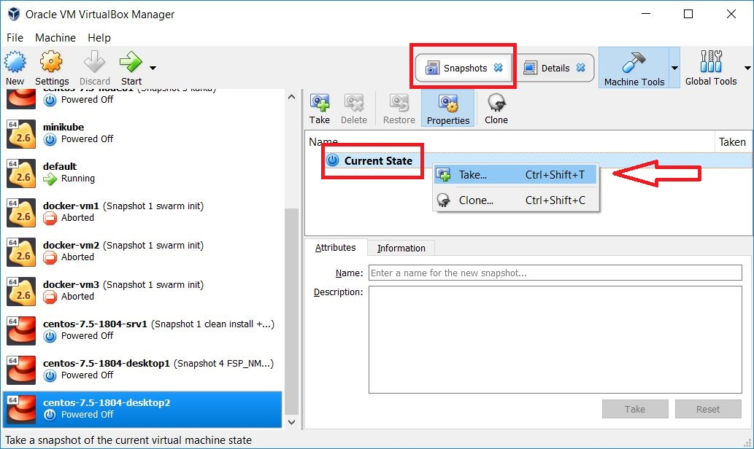

From the popup window fill the “Snapshot Name” and optionally the “Snapshot Description” fields and press the “OK” button

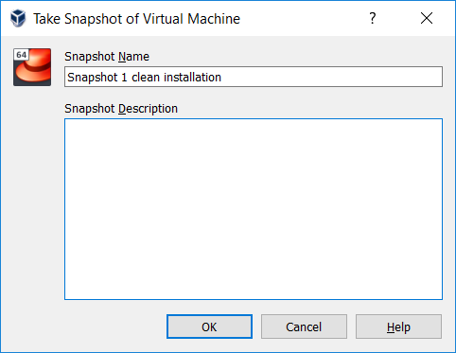

Verify that the Snapshot has been successfully created, the Snapshot tree will look like the following:

