StackBuilder Batch Processor

## Goals

The command line executable TreeDim.StackBuilder.XmlFileProcessor allows processing batch jobs as described in an xml file.

## File description and Xml schema

This files must comply with the XML schema available at the following path:  
C:\Program Files (x86)\treeDiM\PLMPack\StackBuilder\XML Schemas\StackBuilderSchema.xsd

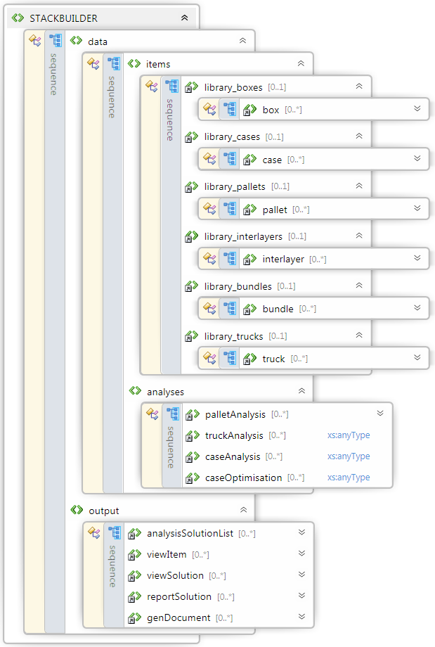

Hence, a job file will typically be arranged in 2 different sections: data and outputs.

1. Input data (<data>) consist of two different groups:

Items is gathers libraries of different object:

* Boxes under element <library_boxes>,
* Cases under element <library_cases>,
* Interlayers under element <library_interlayers>,
* Bundles under element <library_bundles>,
* Trucks under element <library_trucks>.

Analyses describes analyses to be performed using item data as:

* case/pallet analyses (palletAnalysis),
* truck analyses (truckAnalysis),
* box/case analyses (caseAnalysis),
* box/case/pallet optimisations (case optimisations).

1. Outputs gathers all types of output that can be obtained from data:

* Generate a list of analysis solution <analysisSolutionList>,
* Generate an image of oneview item <viewItem>,
* Generate an image of an analysis solution (<viewSolution>),
* Generate solution report (<reportSolution>),
* Generate a stackbuilder file with the required analysis(<genDocument>)

## Xml file structure

<?xml version="1.0" encoding="utf-8" ?>

<STACKBUILDER xmlns="http://www.treedim.com/StackBuilderSchema.xsd">

<data>

<items>

<library_boxes/>

<library_cases/>

<library_pallets/>

<library_interlayers/>

<library_bundles/>

<library_trucks/>

</items>

<analyses>

<palletAnalysis/>

<truckAnalysis/>

<caseAnalysis/>

<caseOptimisation/>

</analyses>

</data>

<output>

<analysisSolutionList/>

<viewItem/>

<viewSolution/>

<reportSolution/>

<genDocument/>

</output>

</STACKBUILDER>

## Tools you might need to write your own XML files

* A file edit with XML syntax highlighting  
  You might use Nodepad++ which can be downloaded for free at:  
  <https://notepad-plus-plus.org/>
* A free online guid generator can be found here:  
  <https://www.guidgenerator.com/online-guid-generator.aspx>  
  Check the option hyphems

## Tutorial 1:

In the following tutorial, we will:

* Describe a case, a pallet, an interlayer,
* Describe a case/pallet analysis,
* Obtain a view of case, pallet and interlayer,
* Obtain a list of the 20 best solutions,
* Obtain a corner view image of the first solution,
* Obtain a front view of the first solution,
* Obtain a word report of the first solution,
* Obtain a StackBuilder file containing the analysis,

1. Using a text editor (preferably with XML syntax coloring), open a new text file and save it as Input1.xml,  
2. Copy and paste the following file grounding:

<?xml version="1.0" encoding="utf-8" ?>

<STACKBUILDER xmlns="http://www.treedim.com/StackBuilderSchema.xsd">

<data>

<items>

<library_boxes/>

<library_cases/>

<library_pallets/>

<library_interlayers/>

<library_bundles/>

<library_trucks/>

</items>

<analyses>

</analyses>

</data>

<output>

</output>

</STACKBUILDER>

3. Define a case with outer dimension = 220*140*145, inner dimensions = 217*137*139 and weight 0.5kg,  
**id** is a GUID that will be used to refer the case when creating an analysis,  
Face colors are define using **<faceColor>** elements where:  
- **faceNormal** define the face by its normal,  
- **attribute color** is defined by its ARGB components in hexadecimal each ranging from 0 to FF,

Insert the following element under the **<library_cases>** element:

<case id="_19AA39B9-AC36-447b-B187-FDF922F57370"

name="Case 440x280x290"

description="Case with length=440, width=280 and height=290 + thickness 3"

outerdimensions="220.0 140.0 145.0"

innerDimensions="217.0 137.0 139.0"

weight="0.5">

<faceColors>

<faceColor faceNormal="XN" color="FFD2691E"/>

<faceColor faceNormal="XP" color="FFD2691E"/>

<faceColor faceNormal="YN" color="FFDEB887"/>

<faceColor faceNormal="YP" color="FFDEB887"/>

<faceColor faceNormal="ZN" color="FF6495ED"/>

<faceColor faceNormal="ZP" color="FF6495ED"/>

</faceColors>

</case>

4. Define an EUR2 pallet with dimensions 1200*1000*144 and weight 20kg.

Insert the following element under the **<library_pallets>** element:

<pallet id="_CEAA9FC4-66C9-4497-BFD2-88511E1C7C29"

name="EUR2"

description="EUR2-EPAL (European Pallet Association)"

dimensions="1200 1000 144"

weight="20"

type="EUR2"

color="FFFFFFE0"/>

5. Define an interlayer with dimensions 1200*1000*2:

The following element shall be inserted under the **<library_interlayers>** element:

<interlayer id="_94902708-7355-4df0-9340-6526662A7A3E"

name="Interlayer 1200 x 1000"

description="1200 x 1000 x 2 mm interlayer"

dimensions="1200.0 1000.0 2.0"

weight="0.75"

color="FFD3D3D3"/>

6. Define a new case/pallet analysis. Use attributes **caseId**, **palletId** and **interlayerId** to refer the previously defined case, pallet and interlayer with their GUIDs.  
The overhang should be null in both directions.  
All 6 layer patterns should be evaluated.  
All layer arrangement shoud be evaluated (Aligned, rotated 90° and rotated 180°).  
Stacking should be interrupted when height reaches 1200 mm or when weight reaches 1000 kg.

Insert the following element under the **<analyses>** element.

<palletAnalysis id="_4BEFC735-276A-430f-BDFF-C2C790D1AE4B"

name="Pallet analysis 440x280x290"

description="Case 440x280x290 on pallet EUR2"

caseId="_19AA39B9-AC36-447b-B187-FDF922F57370"

palletId="_CEAA9FC4-66C9-4497-BFD2-88511E1C7C29"

interlayerId="_94902708-7355-4df0-9340-6526662A7A3E"

overhang="0.0 0.0"

allowedLayerPatterns ="COLUMN INTERLOCK TRILOCK DIAGONAL SPIRAL ENLARGED_SPIRAL"

allowedLayerArrangements= "ALIGNED ROTATED90 ROTATED180" >

<stackingStopCriterions>

<stopMaxHeight maxHeight="1200"/>

<stopMaxWeight maxWeight="1000"/>

</stackingStopCriterions>

</palletAnalysis>

7. Define your request for a list of solutions.  
**analysisId** refers to the previously defined analysis.  
The result file will be placed in directory **K:\Output1** and will be named **palletAnalysisSolutionList.xml**.  
The maximum number of solutions written in the file should be 20.  
The following element has to be inserted under the **<output>** element.

<analysisSolutionList path="K:\Output1\palletAnalysisSolutionList.xml"

analysisId="_4BEFC735-276A-430f-BDFF-C2C790D1AE4B"

maxNumberOfSolutions="20"/>

**Note:** A schema of the generated xml file is available here:  
C:\Program Files (x86)\treeDiM\PLMPack\StackBuilder\XML Schemas\SolutionListSchema.xsd

8. Define your request for an image of the case by creating a <viewItem> element under the <output> element.  
Under the <viewItem> element, the <viewParameters> element allows describing the image to be generated:  
- Its size ought to be 512 by 512,  
- its format ought to be bmp,  
- the file ought to be created in the **K:\Output1** directory and named **case_440_280_290.bmp**.  
- dimensions ought to be shown on the drawing,  
- the case ought to be drawn from CORNER0 point of view.

The same work can

<viewItem itemId="_19AA39B9-AC36-447b-B187-FDF922F57370">

<viewParameters

imageSize="512 512"

path="K:\Output1\case_440_280_290.bmp"

format="BMP"

showDimensions="true"

predefinedPointOfView="CORNER0"/>

The same work can be undertaken for the pallet and the interlayer.

</viewItem>

<viewItem itemId="_CEAA9FC4-66C9-4497-BFD2-88511E1C7C29">

<viewParameters

imageSize="1024 1024"

path="K:\Output1\pallet_EUR2.bmp"

format="BMP"

showDimensions="true"

predefinedPointOfView="CORNER0"/>

</viewItem>

<viewItem itemId="_94902708-7355-4df0-9340-6526662A7A3E">

<viewParameters

imageSize="512 512"

path="K:\Output1\interlayer_1200_1000.bmp"

format="BMP"

showDimensions="true"

predefinedPointOfView="CORNER0"/>

</viewItem>

9. Define your request for an image of the case/pallet analysis best solution by creating an element <viewSolution> under the <output> element.  
- The solution is referred to by using both analysisId and index,  
- The image size ought to be 1024 by 1024,  
- The format is BMP,  
- The dimensions ought to be shown,  
- The solution ought to be draw from CORNER0 point of view.

<viewSolution>

<solutionRef analysisId="_4BEFC735-276A-430f-BDFF-C2C790D1AE4B" index="0"/>

<viewParameters

imageSize="1024 1024"

format="BMP"

path="K:\Output1\solution_0_CORNER0.bmp"

showDimensions="true"

predefinedPointOfView="CORNER0"/>

</viewSolution>

10. Define the report solution:

<reportSolution>

<solutionRef analysisId="_4BEFC735-276A-430f-BDFF-C2C790D1AE4B" index="0"/>

<reportParameters name="Case 440x280x290"  
 description="Case 440x280x290 / Pallet EUR2 -> best solution"  
 author="treeDiM"  
 templateFilePath="C:\Program Files (x86)\treeDiM\PLMPack\StackBuilder\ReportTemplates\ReportTemplateHtml.xsl"  
 outputPath="K:\Output1\case_0_report.doc"  
 format="WORDML"/>

</reportSolution>

11. Finally, define a request to generate a StackBuilder document.  
- Provide name, description and author of project,  
- The element <analysisRef> allows defining the analysis using its GUID and the solution that ought to be selected in the analysis

<genDocument name="Case 440x280x290"  
 description="Document automatically generated by XmlFileProcessor for Case 440x280x290"  
 author="treeDiM"  
 path="K:\Output1\Case 440x280x290.stb"  
 open="true">  
 <analysisRef analysisId="_4BEFC735-276A-430f-BDFF-C2C790D1AE4B"  
 selectedSolutionIndex="0"/>  
</genDocument>

12. Before executing your batch job, please compare with the sample provided here:  
C:\Program Files (x86)\treeDiM\PLMPack\StackBuilder\Samples\Input1.xml

Execute XML file processor with your file as input argument, using a similar command line:  
C:\Program Files (x86)\treeDiM\PLMPack\StackBuilder\Bin\TreeDim.StackBuilder.XmlFileProcessor.exe /i "K:\Input1.xml"

After execution, open your output directory and check that all the following files were correctly generated:

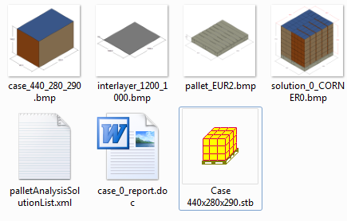

## Annexe

### Solution schema

