**Tasck3**

**Doctors**

Insert Into Doctors values

(0,'Osama','Physical treatment')

,(1,'Ahmad','Bones')

,(2,'Mohammed','Chemotherapy')

,(3,'Musa','Nursing')

,(4,'Ali','Skin Diseases');

select * from Doctors;

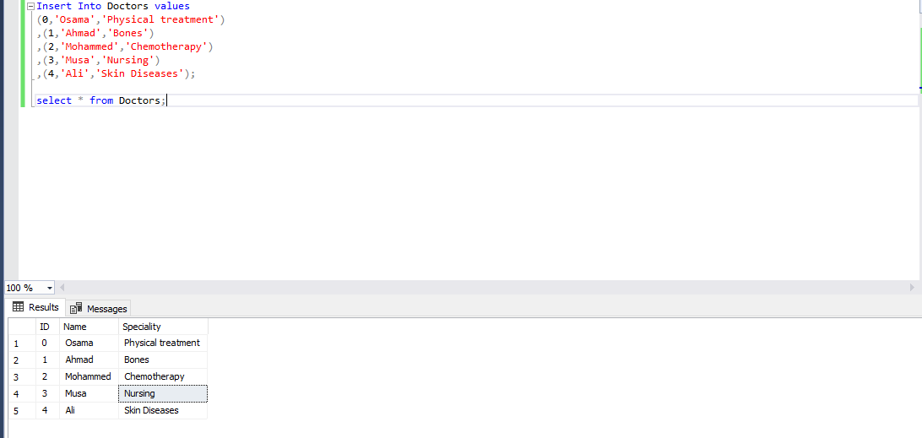

**Patient**

Insert Into Patient

values(0,'Thamer','0787765466','Amman','1986-08-17','Male')

,(1,'Hamza','0799988677','Ajloun','1980-06-01','Male')

,(2,'Maseud','0788790961','Irbid','1990-12-28','Male')

,(3,'Adam','0777558901','Zarqa','1984-03-14','Male')

,(4,'Akram','0788899021','Amman','1970-04-22','Male');

select * from Patient;

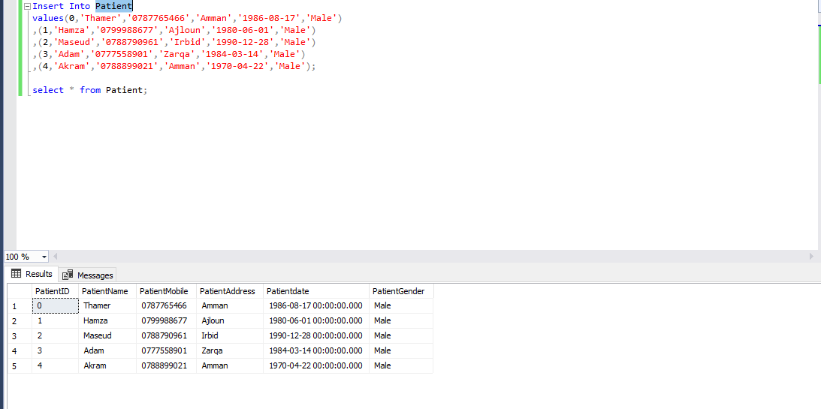

**Requests**

Insert Into Requests

values(0,'2020-08-11','Requests0','IMG0.png',0,0)

,(1,'2020-08-11','Requests1','IMG1.png',1,2)

,(2,'2020-08-11','Requests2','IMG2.png',2,1)

,(3,'2020-08-11','Requests3','IMG3.png',3,4)

,(4,'2020-08-11','Requests4','IMG4.png',4,2);

select * from Requests;

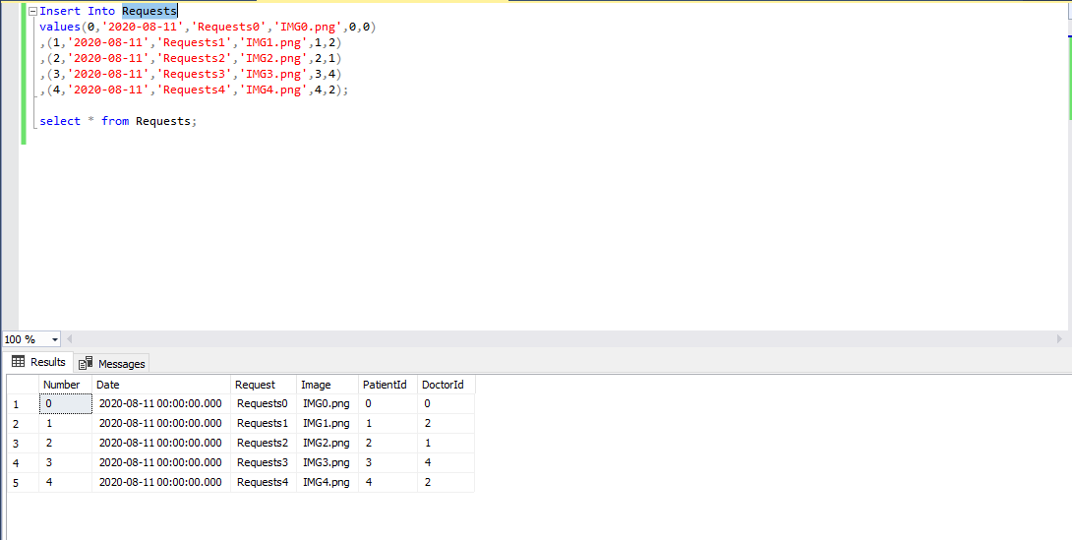

**Recommendation**

Insert Into Recommendation

values(0,'2020-08-11','Recommendation0',0,0,0)

,(1,'2020-08-11','Recommendation0',1,2,1)

,(2,'2020-08-11','Recommendation0',2,1,2)

,(3,'2020-08-11','Recommendation0',3,4,3)

,(4,'2020-08-11','Recommendation0',4,4,2)

select * from Recommendation;

select P.PatientID,P.PatientName,P.PatientAddress,P.PatientMobile,R.Date,R.Recommendation from Recommendation R

Right Join Patient P

on P.PatientID = R.RequestId

select * from Recommendation R

Full Join Patient P

on P.PatientID = R.RequestId

Full Join Doctors D

on D.ID = R.DoctorId

Full Join Requests RE

on RE.Number = R.RequestId

select *

from Recommendation R

inner join Patient P

on R.PatientId = P.PatientID

