**Task 4**

**Admin Table**

* Parameter

create proc GetAdminByUserName

@UserName varchar(50)

as

select * from Admins where UserName like '%'+@UserName+'%'

exec GetAdminByUserName 'Osa';

drop proc GetAdminByUserName;

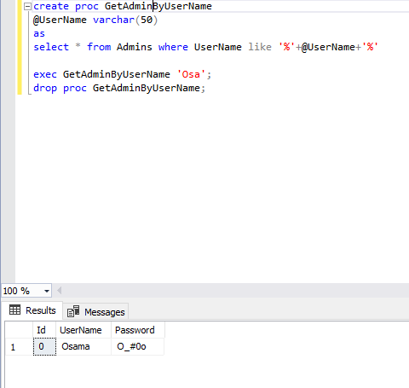

* Without Parameter

create proc GetAdminsByIdMore0

AS

SELECT * from Admins where ID > 0;

exec GetAdminsByIdMore0;

drop proc GetAdminsByIdMore0;

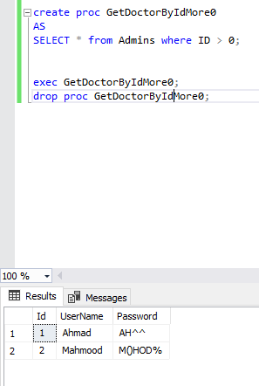

**Doctors Table**

* Parameter

create proc GetDoctorBySpeciality

@Speciality varchar(50)

as

select * from Doctors where Speciality = @Speciality

exec GetDoctorBySpeciality 'Physical treatment';

drop proc GetDoctorBySpeciality;

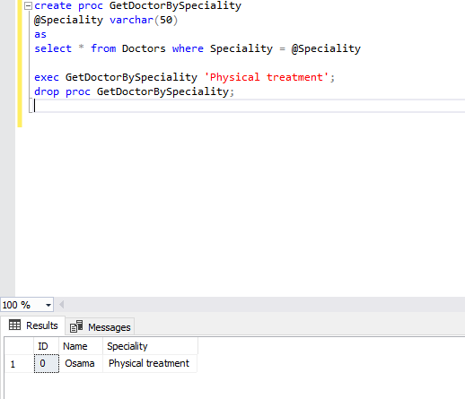

* Without Parameter

create proc GetDoctorByIdEqual1

AS

SELECT * from Doctors where ID = 1;

exec GetDoctorByIdEqual1;

drop proc GetDoctorByIdMore0;

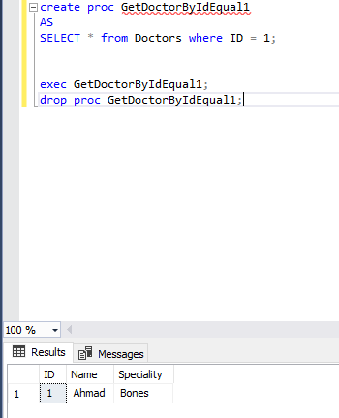

**Patient Table**

* Parameter

create proc GetPatientByDate

@Start datetime,

@End datetime

as

select * from Patient where Patientdate BETWEEN @Start and @End

exec GetPatientByDate '1970-01-01' ,'2021-01-01';

drop proc GetPatientByDate;

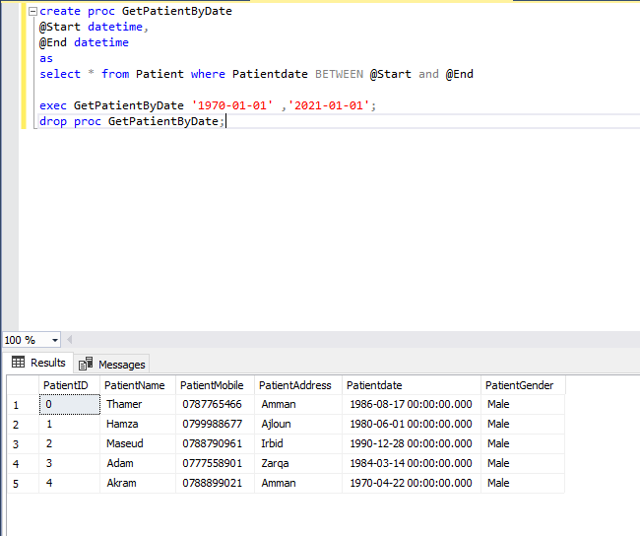

* Without Parameter

create proc GetPatientByMobileZain

AS

SELECT * from Patient where PatientMobile like '079%';

exec GetPatientByMobileZain;

drop proc GetPatientByMobileZain;

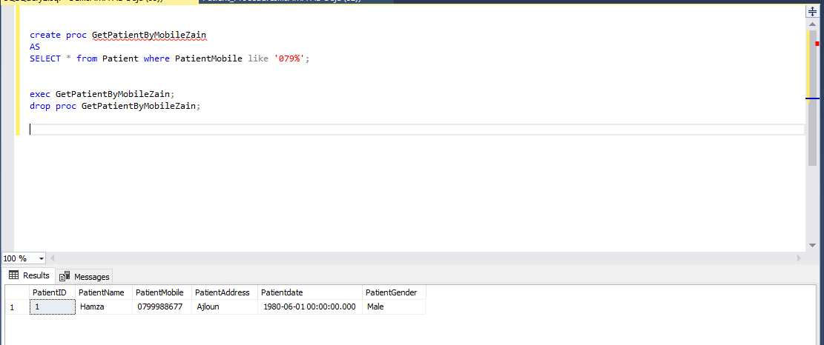

**Recommendation Table**

* Parameter

create proc GetRecommendationByDoctorId

@Id int

as

select

RE.Number as Id,

RE.Date as Date,

RE.Recommendation as Recommendation,

ISNULL(R.Date,'2020-01-01 00:00:00.000') as DateRequests,

ISNULL(R.Request,'Empty') as Request,

ISNULL(R.Image,'Empty') as Image,

ISNULL(P.PatientName,'Empty')as PatientName,

ISNULL(P.Patientdate,'2020-01-01 00:00:00.000') as PatientDate,

ISNULL(P.PatientAddress,'Empty') as PatientAddress,

ISNULL(P.PatientGender,'Empty') as PatientGender,

ISNULL(P.PatientMobile,'Empty') as PatientMobile,

D.Name as DoctorName,

D.Speciality as DoctorSpeciality

from Recommendation RE full join Patient P

on RE.PatientId = P.PatientID

full join Doctors D

on RE.DoctorId = D.ID

full join Requests R

on RE.RequestId = R.Number

where RE.DoctorId = @Id;

exec GetRecommendationByDoctorId 0;

drop proc GetRecommendationByDoctorId;

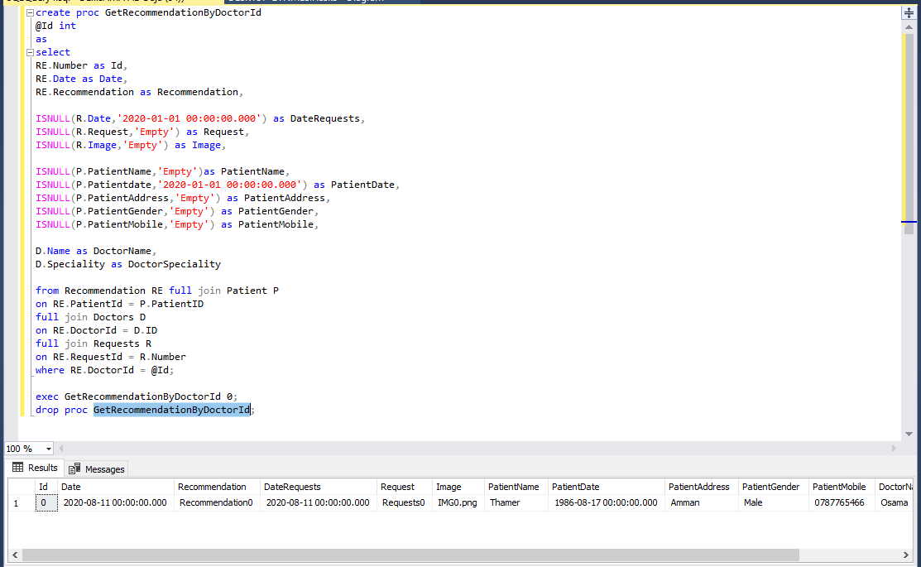

* Without Parameter

create proc GetRecommendationByDate

as

select

RE.Number as Id,

RE.Date as Date,

RE.Recommendation as Recommendation,

ISNULL(R.Date,'2020-01-01 00:00:00.000') as DateRequests,

ISNULL(R.Request,'Empty') as Request,

ISNULL(R.Image,'Empty') as Image,

ISNULL(P.PatientName,'Empty')as PatientName,

ISNULL(P.Patientdate,'2020-01-01 00:00:00.000') as PatientDate,

ISNULL(P.PatientAddress,'Empty') as PatientAddress,

ISNULL(P.PatientGender,'Empty') as PatientGender,

ISNULL(P.PatientMobile,'Empty') as PatientMobile,

D.Name as DoctorName,

D.Speciality as DoctorSpeciality

from Recommendation RE full join Patient P

on RE.PatientId = P.PatientID

full join Doctors D

on RE.DoctorId = D.ID

full join Requests R

on RE.RequestId = R.Number

where RE.Date between '2020-01-01' and '2022-01-01';

exec GetRecommendationByDate;

drop proc GetRecommendationByDate;

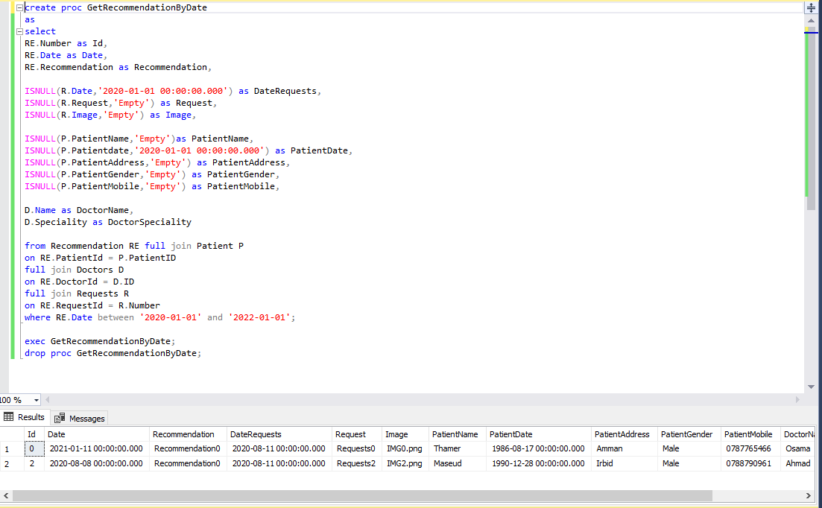

**Requests Table**

* Parameter

create proc GetRequestsByPatientId

@Id int

as

select

ISNULL(R.Number,0) as Number,

ISNULL(R.Date,'2020-01-01 00:00:00.000') as Date,

ISNULL(R.Request,'Empty') as Request,

ISNULL(R.Image,'Empty') as Image,

ISNULL(P.PatientName,'Empty')as Name,

ISNULL(P.Patientdate,'2020-01-01 00:00:00.000') as PatientDate,

ISNULL(P.PatientAddress,'Empty') as PatientAddress,

ISNULL(P.PatientGender,'Empty') as PatientGender,

ISNULL(P.PatientMobile,'Empty') as PatientMobile,

D.Name as DoctorName,

D.Speciality as DoctorSpeciality

from Requests R full join Patient P

on R.PatientId = P.PatientID

full join Doctors D

on R.DoctorId = D.ID

where P.PatientID = @Id;

exec GetRequestsByPatientId 3;

drop proc GetRequestsByPatientId;

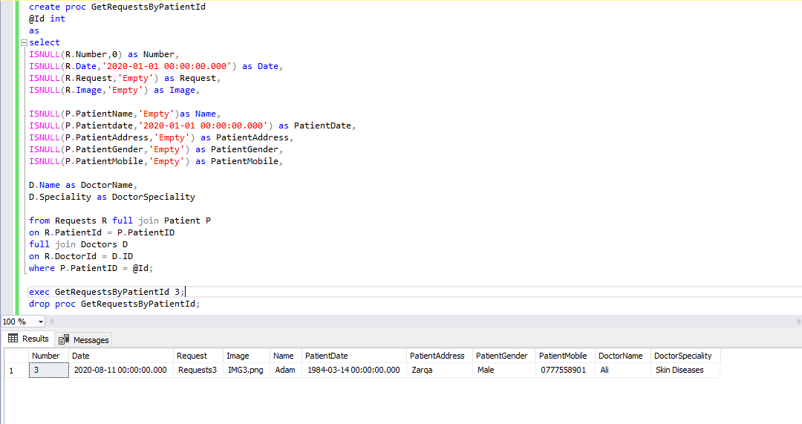

* Without Parameter

create proc GetRequestsByDectorId

as

select

ISNULL(R.Number,0) as Number,

ISNULL(R.Date,'2020-01-01 00:00:00.000') as Date,

ISNULL(R.Request,'Empty') as Request,

ISNULL(R.Image,'Empty') as Image,

ISNULL(P.PatientName,'Empty')as Name,

ISNULL(P.Patientdate,'2020-01-01 00:00:00.000') as PatientDate,

ISNULL(P.PatientAddress,'Empty') as PatientAddress,

ISNULL(P.PatientGender,'Empty') as PatientGender,

ISNULL(P.PatientMobile,'Empty') as PatientMobile,

D.Name as DoctorName,

D.Speciality as DoctorSpeciality

from Requests R full join Patient P

on R.PatientId = P.PatientID

full join Doctors D

on R.DoctorId = D.ID

where DoctorId = 2;

exec GetRequestsByDectorId;

drop proc GetRequestsByDectorId;

